2011年10月高等教育自学考试全国统一命题考试
英语写作 试卷
(课程代码00603)
I.Supplythemissingparagraph.(20points)
Thefollowingpassageisincompletewithonebodyparagraphmissing.Studythepassagecarefullyandwritethemissingparagraphinabout100words.Makesurethatyourtoneanddictionareinunitywiththepassageprovide
D.
LifeExpectancy
Agreaternumberofpeoplearenowhittingtheeighty-yearmarkthantenyearsago.Infact,thelifeexpectancyoftheaveragehumanhasgoneupconsiderablyandisrisingstill.Thisencouragingphenomenonistheresultofmanyfactors.Advancementintechnology,improvedqualityoflife,andpeople’srisingawarenessabouthealthareallconducivetoprolongedlives.
Scientificandmedicalbreakthroughsensurethatpatientsreceiveproperandtimelytreatment.Aspeoplelearnmoreaboutthehumanbody,medicalinstitutionsandservicesbecomebetterequippedtotacklevarioushealthproblems.Diseasessuchascancer,whichusedtoresultalmostinevitablyindeath,arenowlargelycurable,providedtheyarediagnosedatanearlystag
E.Tuberculosisandcholeranowcausefewerdeathsthaninthepast.Thankstonewdrugs,therapiesandvaccines,fewerpeoplefailvictimtothediseasesthatoncethreatenedhumanlives.Withadvancedfacilities,infectiousdiseasesarestrictlymonitoredandcontrolle
D.Therateofmortalitynolongerreachesanalarmingheightevenaidertheoutbreakofanepidemi
C.[[微信公众号：ikaoti]
Inadditiontobetterhealthcare,theimprovedqualityoflifedefinitelycontributestothelongerlifeexpectancy.Peopleengageinlesshazardousoccupations.Asfarasfoodisconcerned,theydon’tsimplyenjoythetaste,butalsogoodnutrition.Mineralwater,fruitjuicerichinvitamins,varietiesofvegetablesanddairyproductsarenolongerluxuries.Thegeneralhygienestandardhasgoneupconsiderablyaswell.Itislittlesurprisingtofindairyandsunnyhomeswithshiningkitchensinksandshowerheads.

Toconclude,advancementinmedicineandtechnology,improvedqualityoflifeandheightenedpublicawarenessofgoodhealthaccountfortheextendedhumanlifespan.Itcanbesafelypredictedthatthenumberofpeoplewholivelongerandhealthierwillcontinuetogoup.
II.Writeanoutlin
E.(20points)
Readthefollowingpassagecarefullyandcomposea“topicoutline”forit.
E-mail—ReturntoSender?
Formanyofus,turningonthecomputerandcheckingfore-mailmessageshasbecomeapartofourdailyroutin
E.Thegrowingpopularityofe-mailmakesuswonderhowweeversurvivedwithoutit.In.ourenthusiasmfore-mail,weshouldrealizethate-mailisapoorsubstituteforregularmailbothinourpersonallivesandinthebusinessworl
D.
Thereisnodenyingthate-mailhasmanymerits.Themostobviousoneisspee
D.Wecansende-mailaroundtheworldinamatterofminutes.Itisthisspeedthathasledtoourcallingregularmail“snailmail.”E-mailinvolveslessexpense,formostpeople,thanregularmail.Manypeoplehaveaccesstoe-mailforfreethroughtheirworkorschool.Andwhilesomepeoplemaypayfore-mailthroughanonlineservice,thereisnoincreaseincostrelativetothenumberofmessagessent.Admittedly,e-mailisconvenient.Itallowsustosendthesamemessagetomanypeopleatthesametimewithlittlemoreeffortthanittakestosendamessagetooneperson.Whensendingmultiplecopiesofamessage,weavoidthetroubleofphotocopyingtheletter,printingoutadditionalcopies,addressingenvelopes,andpostingthemail.
Despiteitsmanybenefits,e-mailisnotalwaysappropriat
E.Beforedashingoffanotherpieceofe-mail—inourprivatelivesorinthebusinessworld—weneedtopauseandconsiderwhetherthepostofficeoracardermightbemorefitting.
Itwouldbesadtothinkthatlettersfromfriendsmightbecomeobsolet
E.Withe-mail,unfortunately,allmessageslookverymuchalike,andthissamenessremovessomeofthewonderofgettingamessageinthefirstplac
E.Wehavenohandwritingtoscrutinize,noperfumedenvelopetosmell,nocolorsortexturestoenjoy.Forthesemorepersonalthingswemuststillrelyonregularmail.Besides,openingoldcomputerfilesisneverasmuchfunaspullingadustyshoeboxoutoftheclosettobrowsethrougholdlettersandphotos.
Inthebusinessworld,asinourpersonallives,e-mailisnotalwaysanappropriatemedium.Theissueofprivacyrequiresseriousconsideration.Becauseofitselectronictransmissioninnetworkedsystems,e-mailmaybeaccessibletoco-workersandsupervisors.It’sprobablynotagoodideatocomplainaboutthebossonthecompanye-mailortowriteanythingthatshouldn’tbesharedwithstrangersorpotentialenemies.Theinformalityofe-mailmayaswellaffecttheimageofthesender.Formuchcompanybusiness,acertainlevelofcourtesyandformalityisdesirable;e-mailcanseeminappropriatebecauseofitsrelativelyslapdasnquality．Olien，becauseOfitsspeed，e-mailencourages“flaming，”sendingOffrapid-fireemotionalmessagesthatcangetabusinesspersoninserioustrouble．
Whilee-mailgiyesustheabilitytosendmessageswithconvenience，speed，andlitteexpense，it1acksthepersonalityandauthorityofregulaurmail．Luckily，however,weneedn’talwayschooseoneovermeother.Instead，weshouldtakeadvantageofboth，usingeachtoitsbestadvantage．

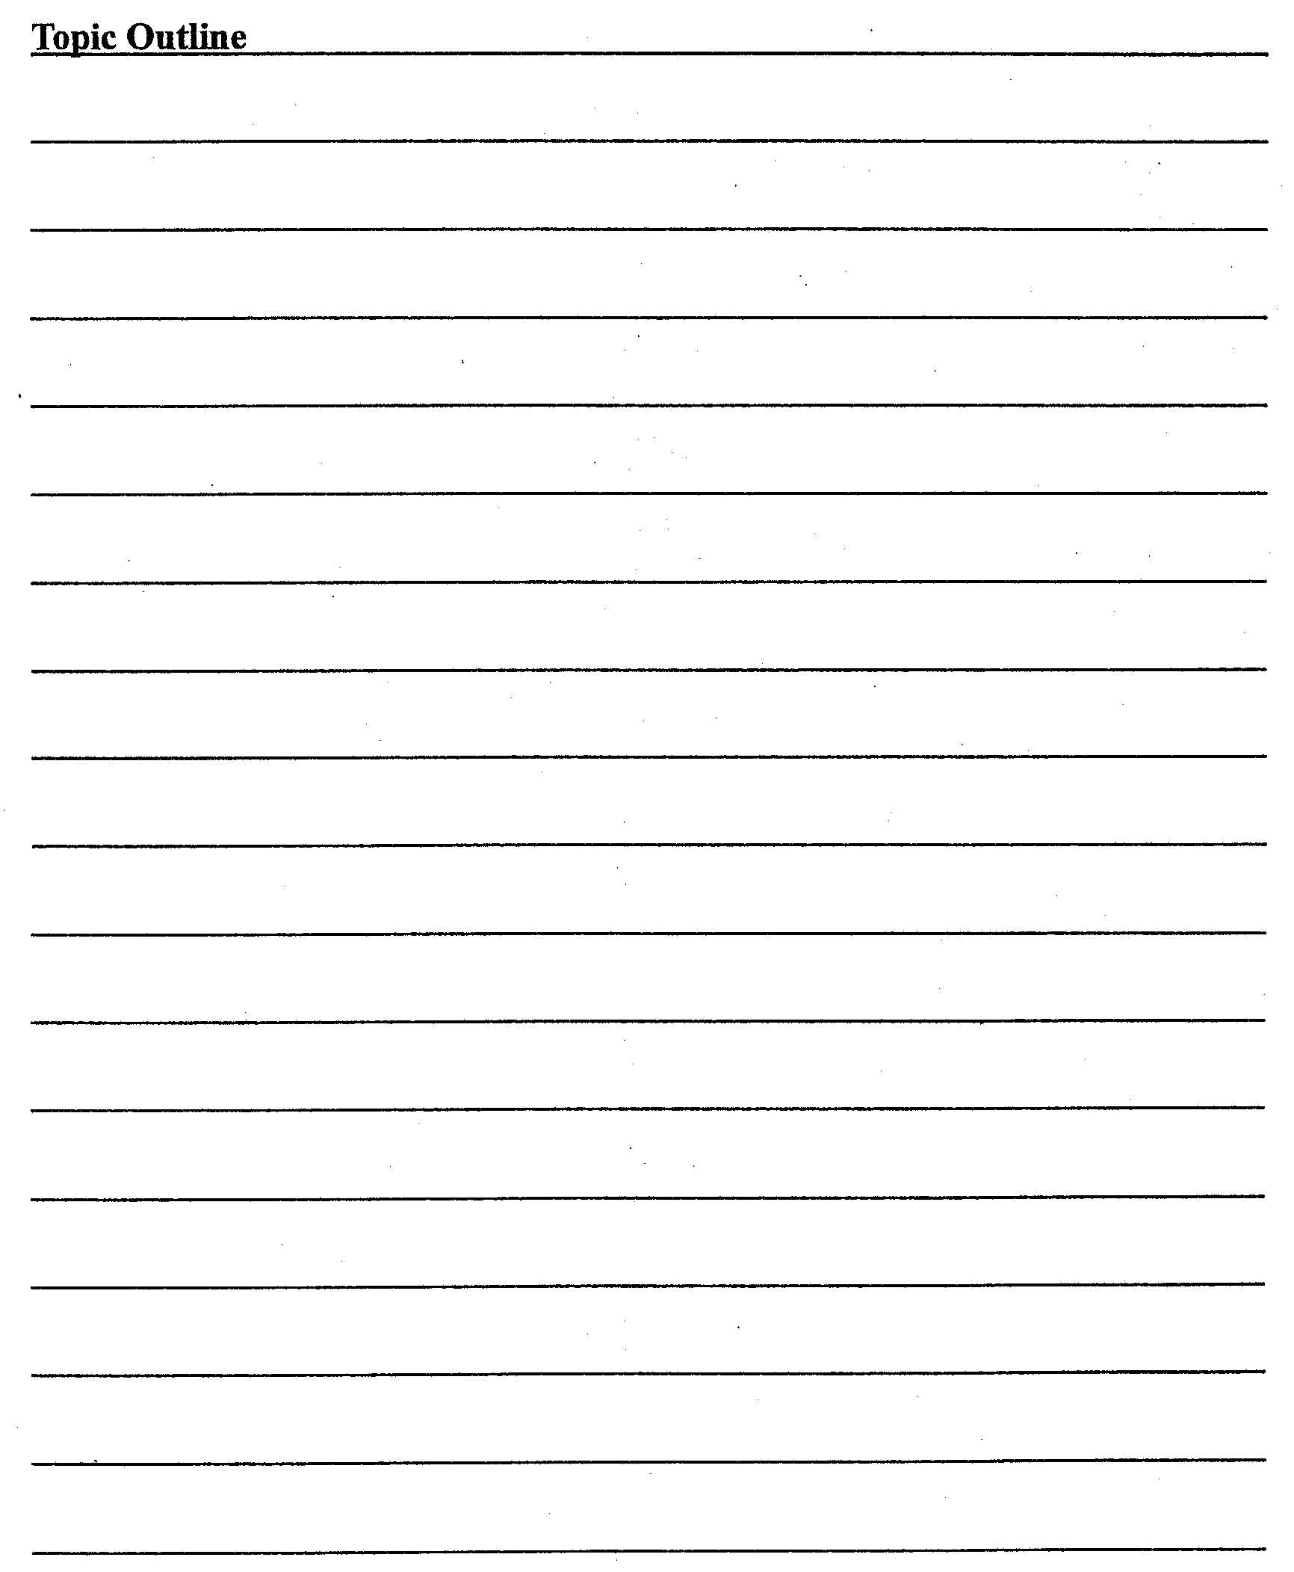
III.Composeanessay.(60points)
IfyouaregoingtotravelasatouristtoaplaceofinterestinChina,wouldyouliketogowithatouristgrouporonyourown?Writea300-wordexpositoryessaystatingyourviews.

