2012年10月高等教育自学考试全国统一命题考试

英语写作试题

课程代码：00603
请考生按规定用笔将所有试题的答案写在答题纸上。
1.答题前，考生务必将自己的考试课程名称、姓名、准考证号用黑色字迹的签字笔或钢笔填写在答题纸规定的位置上。
2.[[微信公众号：ikaoti]
Ⅰ.Supplythemissingparagraph.(20points)
Thefollowingpassageisincompletewithonebodyparagraphmissing.Studythepassagecarefullyandwritethemissingparagraphinabout100words.Makesurethatyourtoneanddictionareinunitywiththepassageprovide
D.
TheMagicofMusic
Musicisoneofthemostcommonformsofentertainment.Icanhardlythinkofanyonewhodoesn’tlikemusi
C.Itappearsthatwhereveryougo,musicisplayingorsomeoneislisteningtohisorherMP3orCDplayer.Frommiddleschoolstudentstobusinessexecutives,almosteveryoneseemstobeakeenmusiclover.Whydopeopleenjoymusicsomuch?Ibelievemusicworkslikemagic:itpleasesoursenses,lightensourmoods,andhelpstodevelopfriendship.
Tobeginwith,musicappealstousgreatlybecauseheatingisoneofourmostreceptiveandpleasure-feelingsenses.Ourearsarecapableofheatingandinterpretinganextremelybroadrangeofpitchandtones.Yet,otherthanmusic,theday-to-daysoundsweusuallyhearareascatteredandunrelatedseriesofoverlappingmiddletones,forexample,voicesandconstructionnois
E.Thelackofharmonyandvariationinthesesoundwavescancauseaheadach[[微信公众号：ikaoti]
E.Conversely,musicistheonlykindofsoundthatiscomprisedofaharmonizedandlogicalsequenceofhighandlowtones.Itissimplyandnaturallypleasingtooursenses.
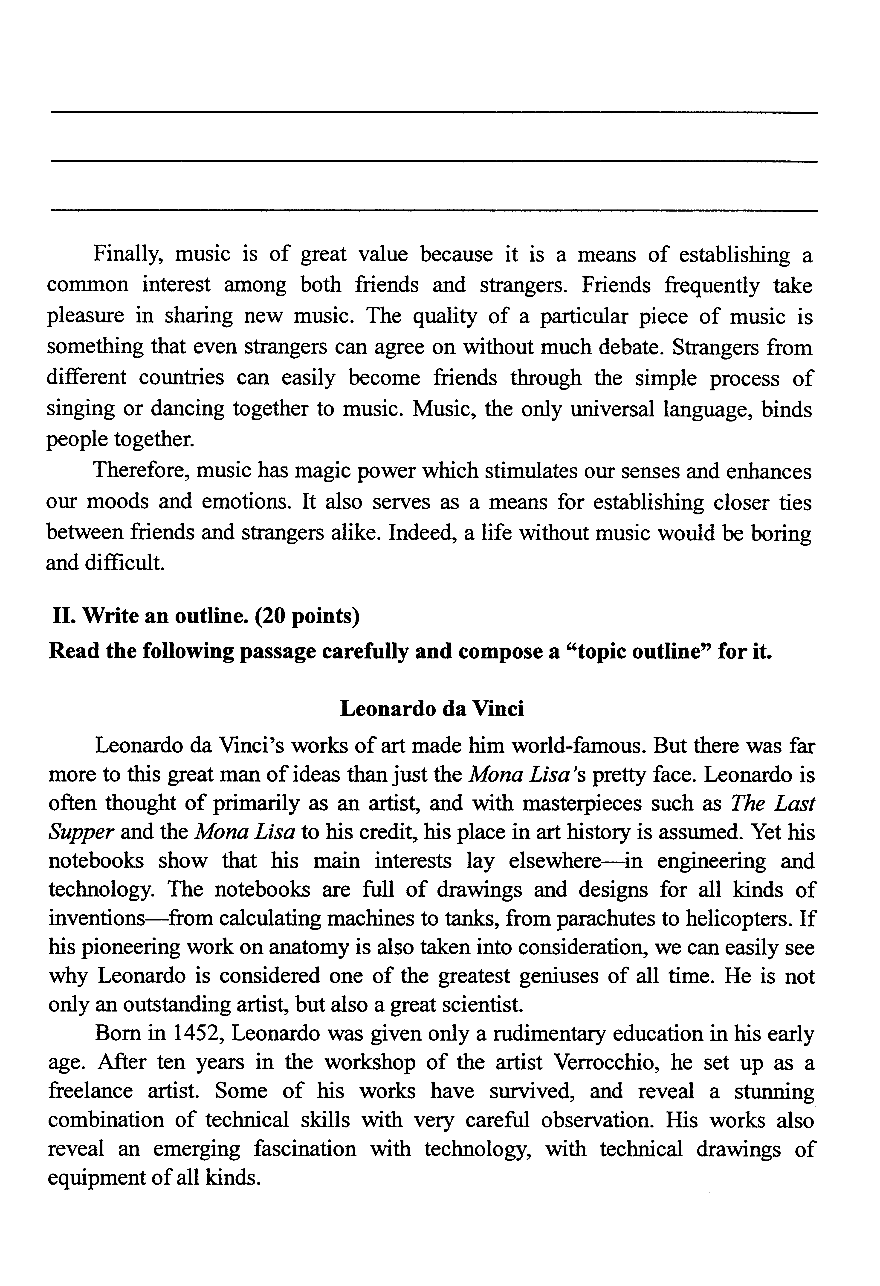
Finally,musicisofgreatvaluebecauseitisameansofestablishingacommoninterestamongbothfriendsandstrangers.Friendsfrequentlytakepleasureinsharingnewmusi
C.Thequalityofaparticularpieceofmusicissomethingthatevenstrangerscanagreeonwithoutmuchdebat
E.Strangersfromdifferentcountriescaneasilybecomefriendsthroughthesimpleprocessofsingingordancingtogethertomusi
C.Music,theonlyuniversallanguage,bindspeopletogether.
Therefore,musichasmagicpowerwhichstimulatesoursensesandenhancesourmoodsandemotions.Italsoservesasameansforestablishingclosertiesbetweenfriendsandstrangersalik
E.Indeed,alifewithoutmusicwouldbeboringanddifficult.[本科目答案页面导航：http://zk.ikaoti.cn/zikao.htm]
Ⅱ.Writeanoutlin
E.(20points)
Readthefollowingpassagecarefullyandcomposea“topicoutline”forit.[[微信公众号：ikaoti]
LeonardodaVinci
LeonardodaVinci’sworksofartmadehimworld-famous.ButtherewasfarmoretothisgreatmanofideasthanjusttheMonaLisa’sprettyfac
E.Leonardoisoftenthoughtofprimarilyasanartist,andwithmasterpiecessuchasTheLastSupperandtheMonaLisatohiscredit,hisplaceinarthistoryisassume
D.Yethisnotebooksshowthathismaininterestslayelsewhere—inengineeringandtechnology.Thenotebooksarefullofdrawingsanddesignsforallkindsofinventions—fromcalculatingmachinestotanks,fromparachutestohelicopters.Ifhispioneeringworkonanatomyisalsotakenintoconsideration,wecaneasilyseewhyLeonardoisconsideredoneofthegreatestgeniusesofalltim
E.Heisnotonlyanoutstandingartist,butalsoagreatscientist.
Bornin1452,Leonardowasgivenonlyarudimentaryeducationinhisearlyag
E.AftertenyearsintheworkshopoftheartistVerrocchio,hesetupasafreelanceartist.Someofhisworkshavesurvived,andrevealastunningcombinationoftechnicalskillswithverycarefulobservation.Hisworksalsorevealanemergingfascinationwithtechnology,withtechnicaldrawingsofequipmentofallkinds.
Leonardowasparticularlyfascinatedbythetechnologyofwarfar[最新年份咨询qq593777558]
E.Atthistime,FlorencewasatwarwiththePope,andLeonardorealizedthatthiswasanopportunitytomakeuseofhisnewinventionsforbettergunsandothermilitaryequipment.However,thewarendedbeforeanythingcouldcomeofhisplanandhereturnedtohispainting.
Attheageofthirty,helefthishometownandeventuallymovedtoMilan,wherehespentseventeenyearsunderthepatronageofLudovicoSforza,theDukeofMilan.Herehecontinuedtocombinehisscientificandtechnologicalworkwithhispainting,whichwasofperspectiveandproportion.Duringthisperiod,hepaintedTheLastSupperanddevelopedhisideasforchemicalweaponsandflame-throwers.
WhenSforzawasdrivenfrompowerbytheFrench,LeonardoreturnedtoFlorenceandspentfouryearsworkingforCesareBorgiaasanengineerandmilitaryarchitect.Henowbecamefascinatedwithflight.Hestudiedbirdsforcluesabouthowtoflyanddrewsketchesofmachinesresemblinghelicopters.
In1506,hereturnedtoMilanandbecameincreasinglyfocusedonscienc
E.Hebegantostudyhumananatomyandthecirculationofbloo
D.Healsodrewupacomprehensiveguidetotheworkingoflivingcreatures.
HediedatAmboiseinFrance,wherehewaswelcomedbyKingFrancoisI.Hecontinuedtodotheoccasionalsketch,afewdesignsandplansforbuildings,butmostofhistimewasdevotedtosortingouthisscientificpapers.
Onlytwenty-oneofhisdozensofnotebookssurviv
E.Justseventeenpaintingshavebeenascribedtohimwithcertainty,andsomeofthosearetunfinishe
D.Leonardomaynothaveachievedtheperfectionthatheaspiredtobuthecameclosertoitinmorefieldsthananyonebeforeorsinc
E.
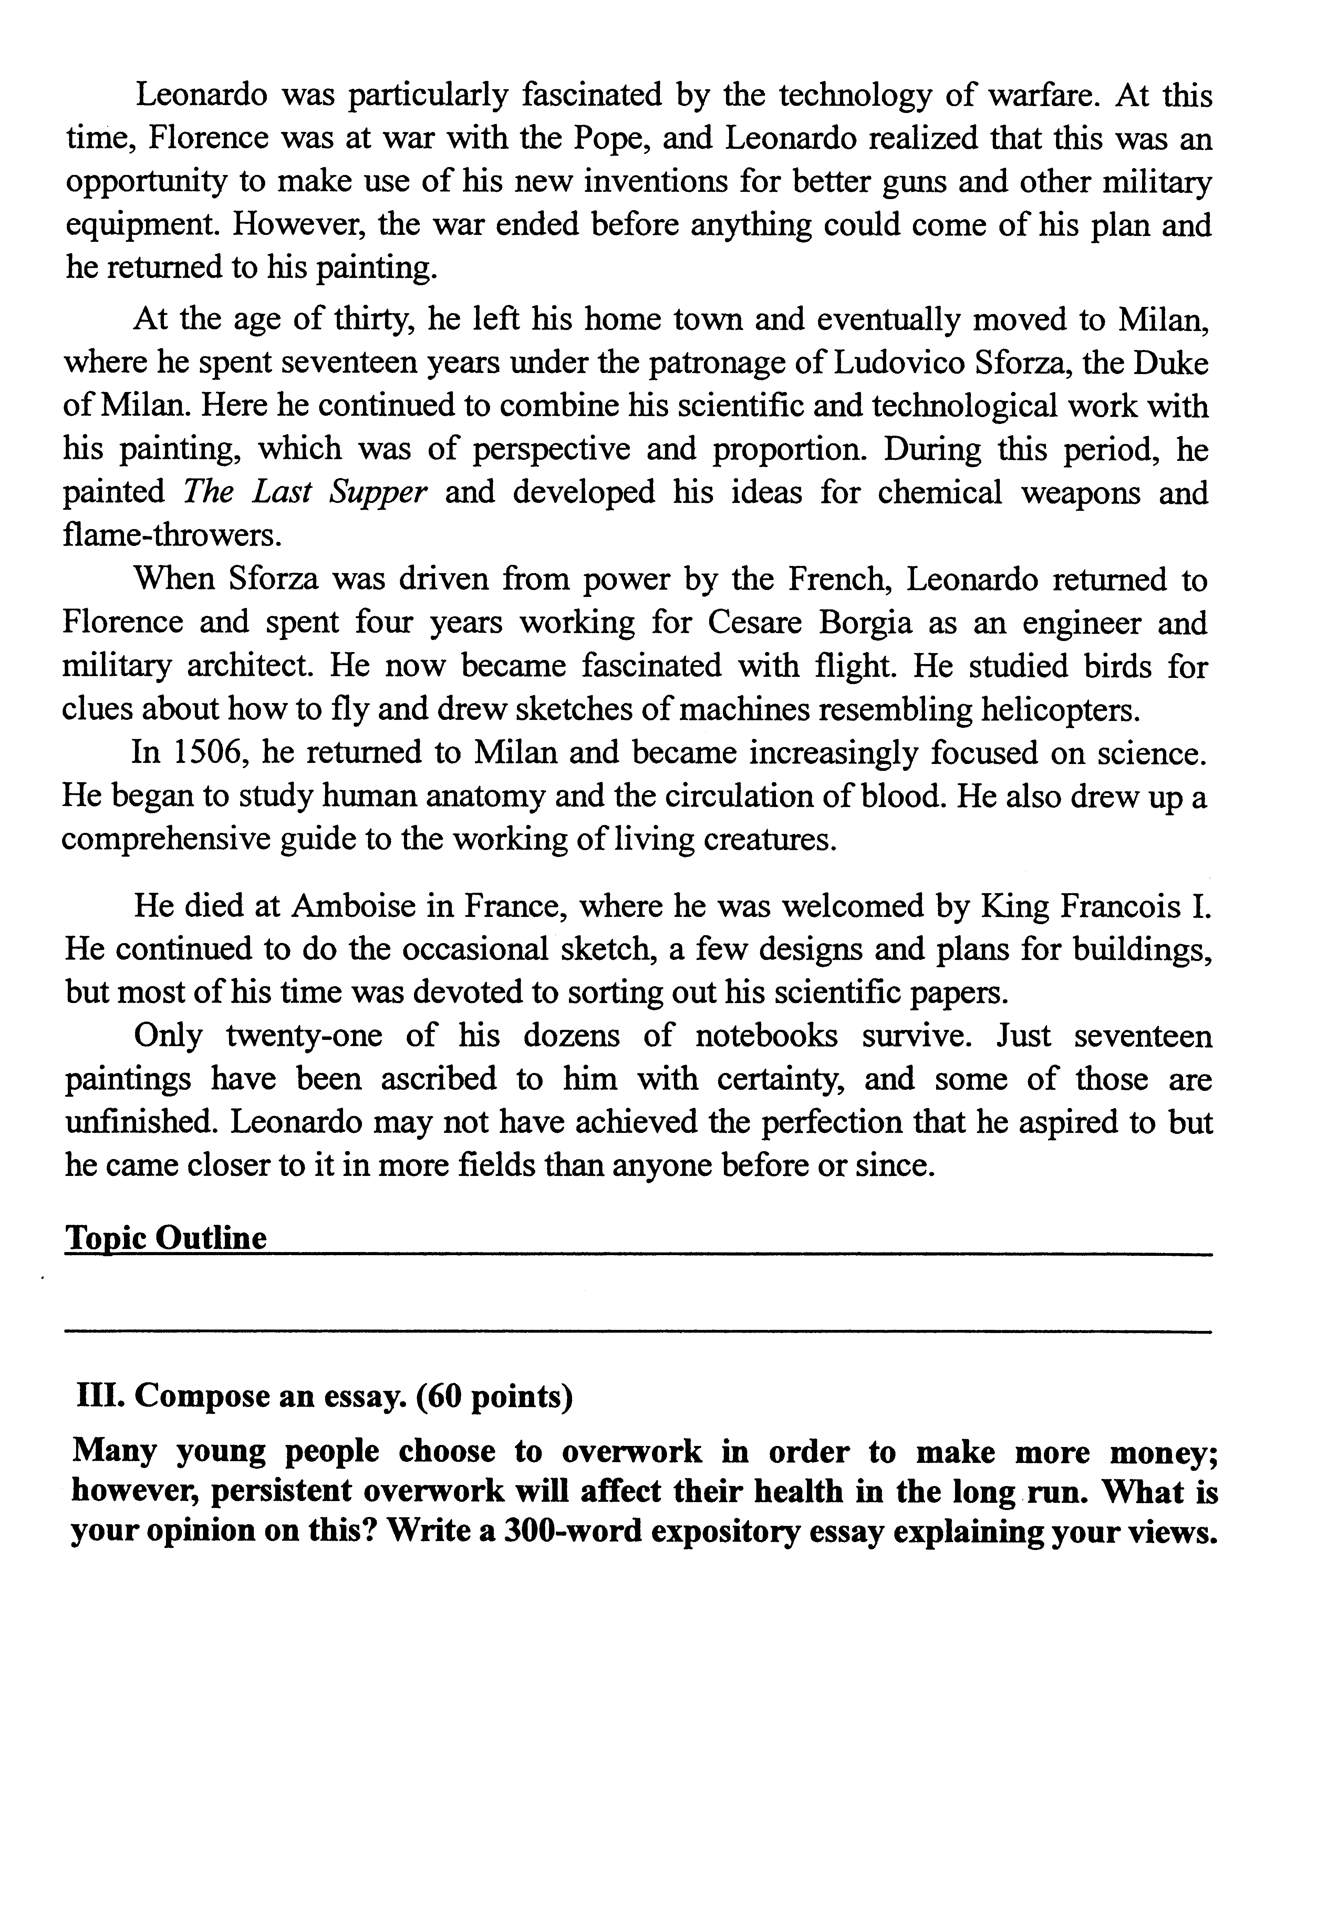
Ⅲ.Composeanessay.(60points)
Manyyoungpeoplechoosetooverworkinordertomakemoremoney;however,persistentoverworkwillaffecttheirhealthinthelong,run.Whatisyouropiniononthis?Writea300-wordexpositoryessayexplainingyourviews.

