全国2011年10月高等教育自学考试
外语教学法试题
课程代码：00833
请将答案填在答题纸相应的位置上
Ⅰ.MultipleChoices:(15%)
Directions:Inthissection，youaregiven15questions，beneatheachofwhicharefourchoicesmarkedA，B，C，and
D.Youaretomakethebestchoiceeithertocompletetheincompletestatementortoanswerthequestion.Onepointisgiventoeachcorrectchoic
E.
1.Inthe19thcentury，foreignlanguageteachersusuallyadoptedthestrategyofcombininggrammarroleswith______.[[微信公众号：ikaoti]
A.reading
B.speaking
C.writing
D.translating
2.Teachersina/an______classroomareencouragedtoshowapprovalforeachandeverycorrectperformancebytheirstudents，andthedrillsaredesignedtoproducesuccessforthestudents.
A.Grammar-Translation
B.Situational
C.Audiolingual
D.Communicative
3.English900isatypicalexampleoftextbookswhichprovidematerialsforteachingandlearningadopting______Metho
D.[最新年份咨询qq593777558]
A.Grammar-Translation
B.Audiolingual
C.Direct[[微信公众号：ikaoti]
D.Situational
4.OneoftheobjectivesbytheNaturalApproachistoenablethestudentstomakethemeaningclearbutnotnecessarilybe______inalldetailsofgrammar.
A.correct
B.accurate
C.brief
D.concise
5.TheCognitiveApproachholdsthatstudents’mistakesare______inthecreativeuseoflanguag
E.
A.useful
B.understandable
C.unavoidable
D.reasonable
6.AccordingtotheNaturalApproach，______playsonlytheinsignificantfunctiontoconveymeaning.
A.form
B.vocabulary
C.grammar
D.phonetics[[微信公众号：ikaoti]
7.EnglishteachinginChinadidn’tenterintotheformaleducationalsystemuntilthe______century.
A.late19th
B.early20th
C.mid-20th
D.late20th
8.Palmerandhisfellowlinguistsbelievedthatamasteryofsome______wordswouldgreatlyassistforeignlanguagelearning.
A.1,000
B.2,000[本科目答案页面导航：http://zk.ikaoti.cn/zikao.htm]
C.3,000
D.4,000
9.TheCommunicativeApproachlaysemphasisonlearningtocommunicatethrough______inthetargetlanguag
E.
A.listeningandnote-taking
B.interaction
C.roleplay
D.oralpresentation
10.Thebest-knownreformerinthemid-19thcenturyis______，whodevelopedanapproachtoteachingaforeignlanguageonthebasisofhisobservationsofchildfirstlanguagelearning.
A.M.
D.Berlitz
B.W.M.Wundt[本科目答案页面导航：http://zk.ikaoti.cn/zikao.htm]
C.J.A.Comenius
D.F.Gouin
11.Inforeignlanguageteaching，thetargetlanguagewasinterpretedasasystemofrulestobeobservedintextsandsentences，andtoberelatedtothefirstlanguage______andmeaning.
A.words
B.rules
C.sentences
D.context
12.IntheDirectMethod，teachersencouragelearnersto______rulesofgrammarthroughactiveuseofthetargetlanguageintheclassroom.[最新年份咨询qq593777558]
A.apply
B.analyze
C.induce
D.paraphrase
13.WhichofthefollowingdictionariesisagreatcontributionmadebyHombytoEFLteaching?
A.LongmanDictionaryofContemporaryEnglish.
B.TheConciseOxfordDictionary.
C.Everyman’sEnglishPronouncingDictionary.
D.TheAdvancedLearner’sDictionaryofCurrentEnglish.
14.Thegenerativelinguistisinterestednotonlyin______languagebutalsoinexplaininglanguag
E.
A.teaching[本科目答案页面导航：http://zk.ikaoti.cn/zikao.htm]
B.describing
C.using
D.understanding[本科目答案页面导航：http://zk.ikaoti.cn/zikao.htm]
15.AccordingtoM.A.K.Halliday，whichofthefollowingshouldNOTbeaccountedforintermsoflinguisticevents?
A.Form.
B.Context.
C.Substanc
E.
D.Cultur
E.
Ⅱ.FillingBlanks:(20%)
Directions:Inthissection，thereare20statementswith20blanks.YouaretofilleachblankwithONEappropriatewor
D.Onepointisgiventoeachblank.
16.BloomfieldandFrieswereknownastherepresentativesofthe______linguistics.
17.TheNaturalApproachadvocatesthatlanguageteachingshouldemphasize______ratherthanform.
18.AccordingtoSkinner，arenownedbehavioristpsychologist，______wasmuchmoreeffectivethanpunishmentinateachingsituation.
19.TheDirectMethodgotitsnamefromtheassumptionthat______aretobeconnecteddirectlywiththetargetlanguage，withoutgoingthroughtheprocessoftranslatingintothestudents’nativelanguag
E.
20.Amajorfeatureof______code-learningistheemphasisonexplanationsofgrammaticalfunctioning.
21.Asher，theadvocateoftheTotalPhysicalResponsemethod，viewstheverb，andparticularlytheverbinthe______，asthecentralelementaroundwhichlanguageuseandlearningareorganize
D.
22.Krashenregardsprovisionofcomprehensible______andreductionofstressaskeystosuccessfullanguageacquisition.
23.Theestablishmentofalaboratoryof______psychologyannouncedtheofficialbirthofthescienc
E.
24.Theneogrammarians，representedbyHermannPaul，formedthemainlinguisticbasisofthe______Metho
D.
25.Theexpertsingrammaranalysisandtranslationapproachbelievedthatthehumanmindscouldbetrainedbylogicalanalysisoftheclassiclanguage，memorizationofcomplicatedrules，and______betweenlanguages.
26.BookssuchasAGrammarofSpokenEnglishonaStrictlyPhoneticBasis，AHandbookofEnglishGrammar，GuidetoPatternsandUsageinEnglishservedasastandard______sourceofbasicEnglishsentencepatternsfortextbookwriters.
27.TheCognitiveApproachlaysemphasisoninnateorganizingprinciplesinhumanperceptionand______.
28.Notions，accordingtoVanEkandAlexander，aredomainsinwhichweuse______toexpressthoughtandfeeling.
29.Cognitivepsychologistsholdthatlanguagelearningisthediscoveryoftheunderlying______ofthelanguagebymeansofinductiveanddeductiveinferenc
E.
30.Chomskydividesthegrammarofa______languageintocoregrammarandperipheralgrammar.
31.ThefundamentalpurposeoflearningLatinwastostudythe______culturewhichwasworshippedintheRenaissanc
E.
32.IntheNaturalApproach，to______stress，learnersarenotrequiredtospeakuntiltheyfeelready，buttheyareexpectedtomakeresponsesinotherways.
33.SomeBritishlinguistsemphasizedthecloserelationshipbetweenthe______ofalanguageandthecontextandsituationinwhichthelanguagewasuse
D.[最新年份咨询qq593777558]
34.TheNaturalApproachconsiders______asthemostimportantelementofanylanguageteachingprogram.
35.TwoindispensablepartsofCommunicativeLanguageTeachingaresupposedtobediscourseanalysisand______.
Ⅲ.Matching:(15%)
Directions:Thissectionconsistsofthreegroupsofpairslistedintwocolumns，Aand
B.Youaretomatchtheonemarked①，②，③，④or⑤inColumnAwiththeonemarkeda，b，c，doreinColumn
B.Onepointisgiventoeachpairyoumatchcorrectly.
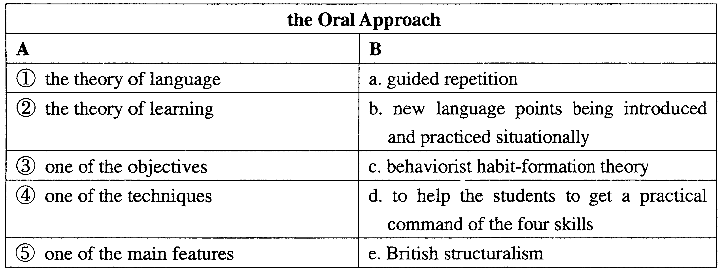
36.
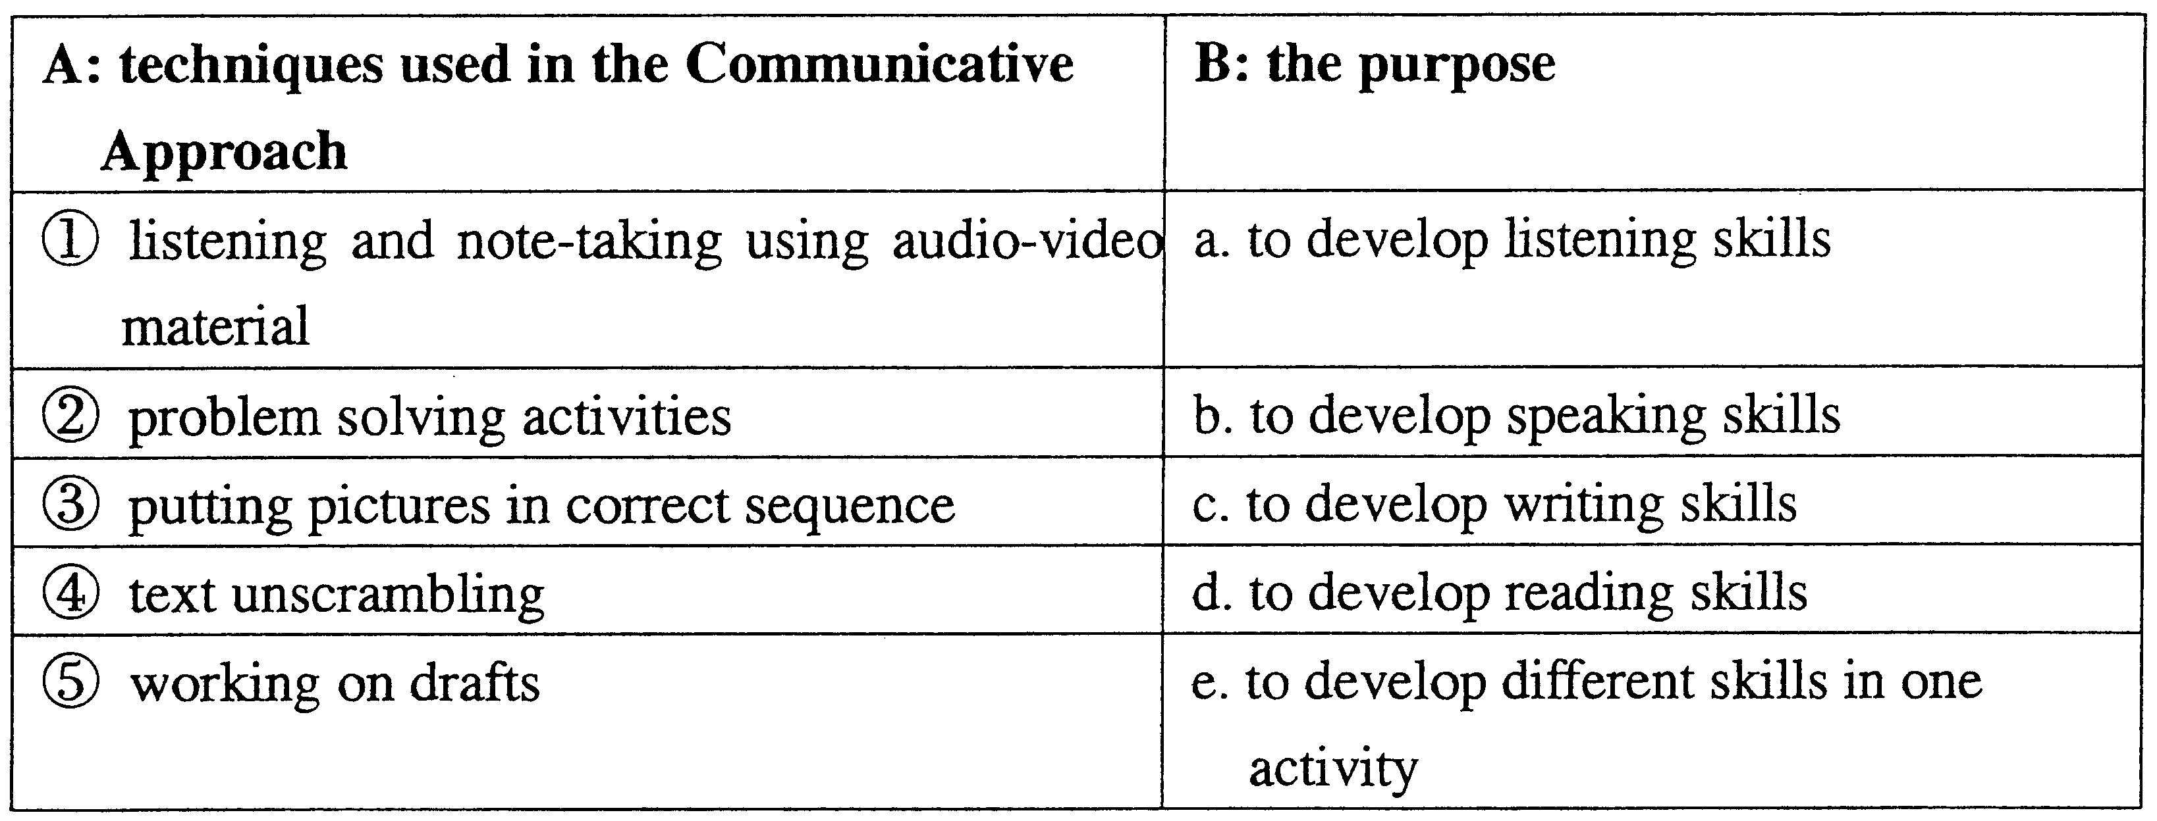
37.
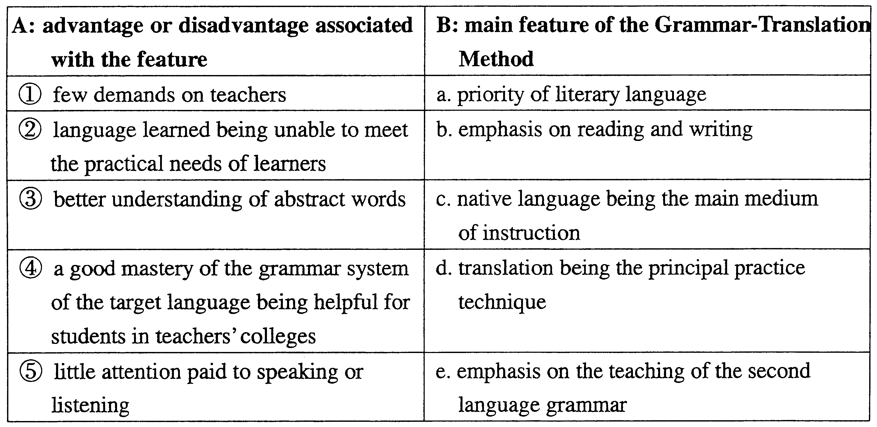
38.
Ⅳ.QuestionsforBriefAnswers:(30%)
Directions:Thissectionhassixquestions.Youaretoanswerthembriefly.Fivepointsaregiventoeachquestion.
39.CouldyoupleasenameanytwoofDanielJones’worksonEnglishphonetics?
40.WhatisthelearningtheoryoftheDirectMethodaccordingtoJ.A.Comenius?
41.HowdoestheteachermatpracticestheOralApproachdealwithstudents’errors?
42.WhatislanguageinChomsky’sopinion?
43.WhatistheprimarygoaloftheNaturalApproach?
44.WhatarethefourpointssummarizedbyTangLixingonthemethodologicaldevelopmentbeforethe1980sinChina?
Ⅴ.QuestionsforLongAnswers:(20%)
Directions:Thetwoquestionsinthissectionaretobeansweredonthebasisofyourownteachingexperienceaswellasthetheoreticalknowledgeyou’velearne
D.Tenpointsaregiventoeachquestion.
45.DiscussinyourownwordstheadvantagesoftheDirectMetho
D.
46.WhataretheprinciplesthatAsherbelievesin?

