2007年10月高等教育自学考试全国统一命题考试
外语教学法试卷
(课程代码0833)
本试卷共6页，满分100分，考试时间150分钟。
Ⅰ．MultipleChoices:(15%)
Directions:Inthissection,youaregiven15questionsbeneath,eachofwhicharefourchoicesmarkedA,B,C,and
D.Youaretomakethebestchoiceeithertocompletetheincompletestatementortoanswerthequestion.Onepointisgiventoeachcorrectchoic
E.
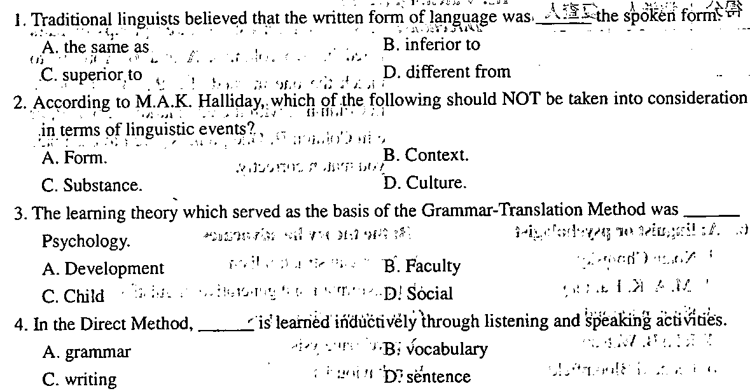
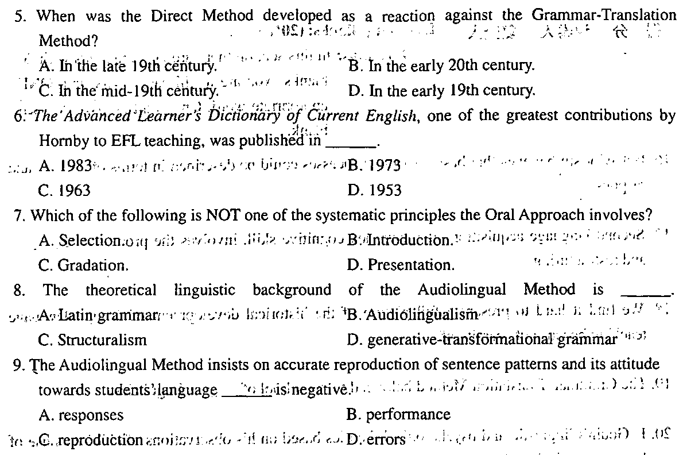
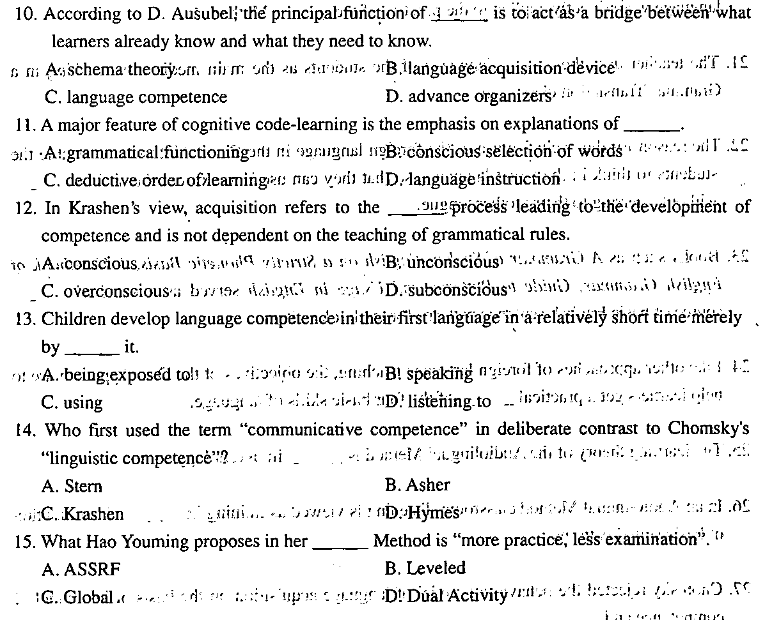
Ⅱ．Fillingblanks:(20%)
Directions:Inthissectionthereare20statementswith20blanks.YouaretofilleachblankwithONEappropriatewor
D.Onepointisgiventoeachblank.
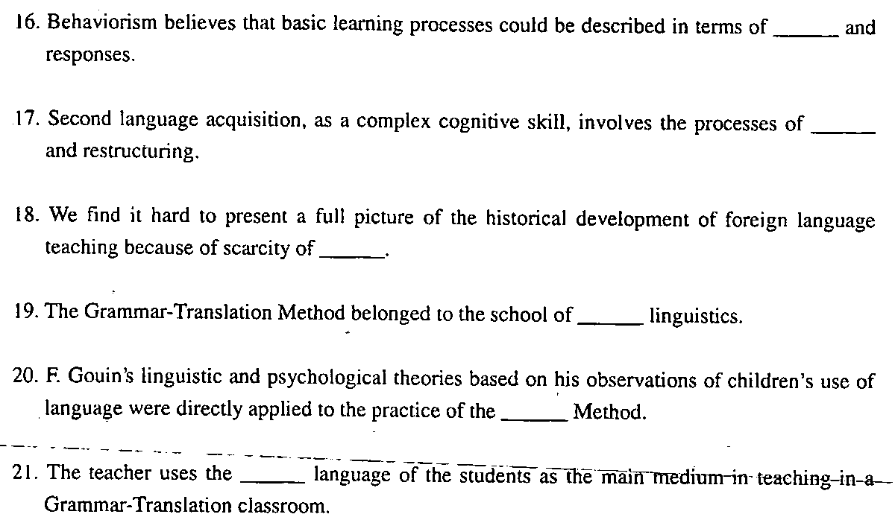
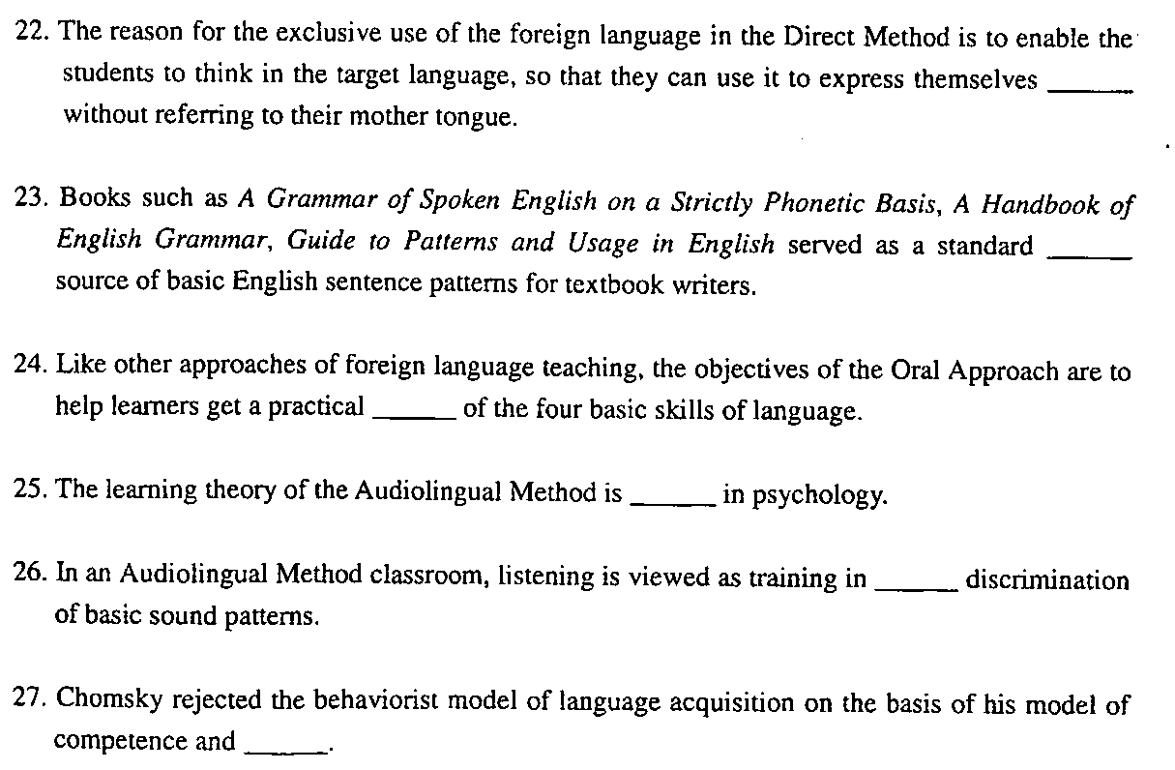[[微信公众号：ikaoti]
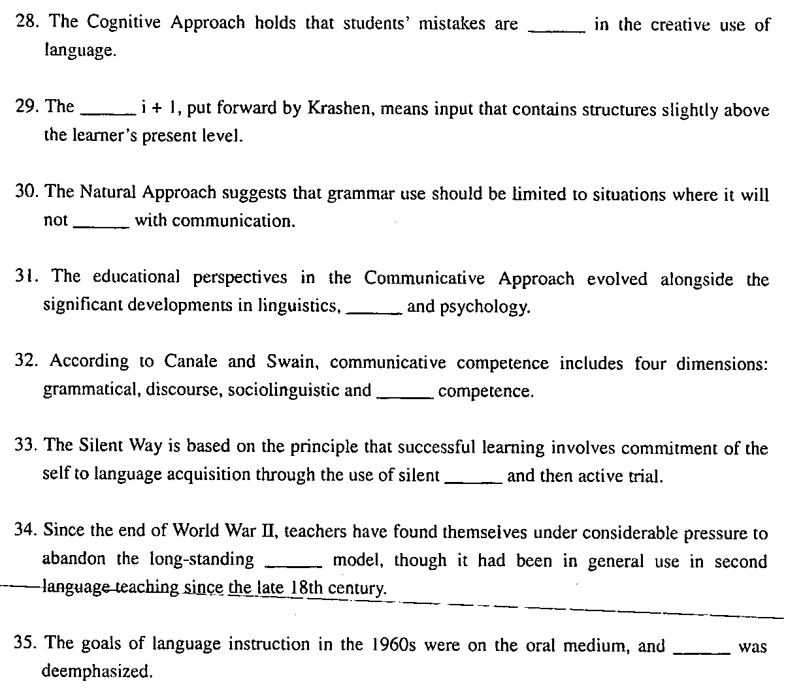
Ⅲ．Matching:(15%)
Directions:Thissectionconsistsofthreegroupsofpairslistedintwocolumns,Aand
B.Youaretomatchtheonemarked①,②,③,④,or⑤inColumnAwiththeonemarkeda,b,c,d,oreinColumn
B.Onepointisgiventoeachpairyoumatchcorrectly.
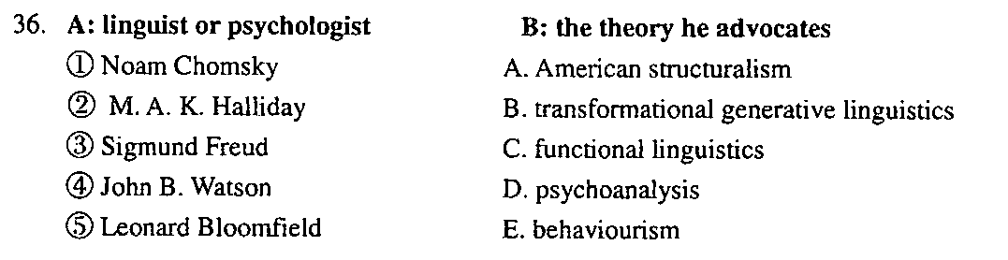
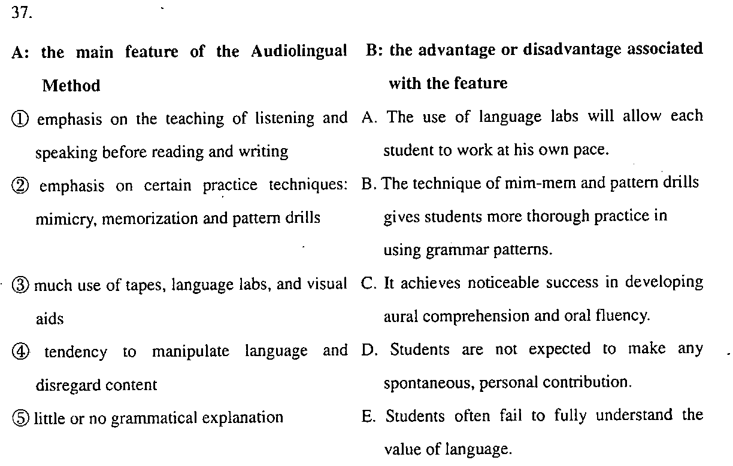
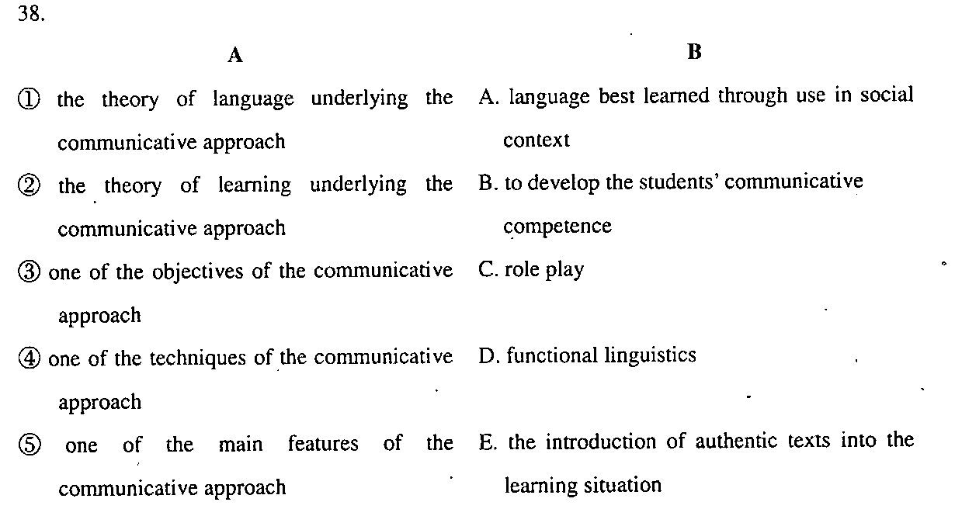
Ⅳ．QuestionsforBriefAnswers:(30%)
Directions:Thissectionhassixquestions.Youaretobrieflyanswerthem.Fivepointsaregiventoeachquestion.
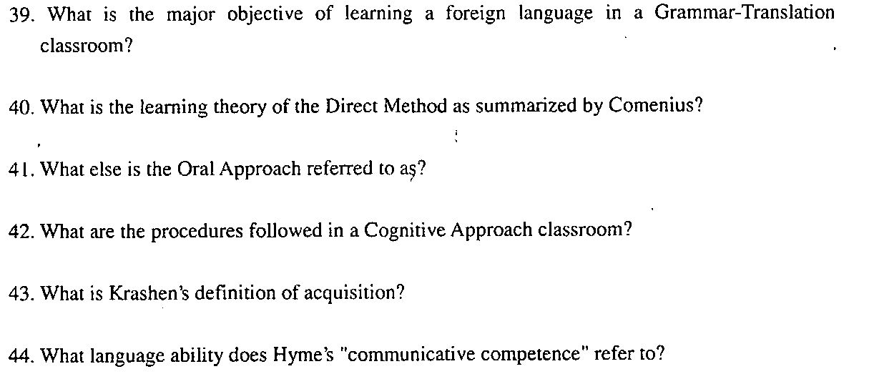
Ⅴ．QuestionsforLongAnswers:(20%)
Directions:Thetwoquestionsinthissectionaretobeansweredonthebasisofyourownteachingexperienceaswellasthetheoreticalknowledgeyou’velearne
D.Tenpointsaregiventoeachquestion.
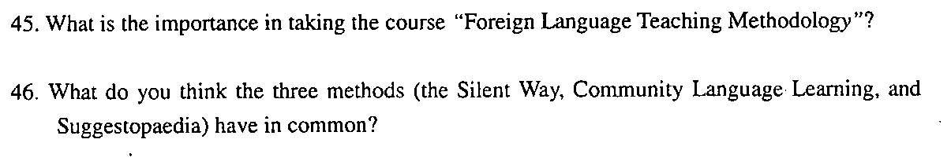
2007年10月高等教育自学考试全国统一命题考试
外语教学法答题纸
(课程代码0833)
Ⅰ．MultipleChoices:(15%)
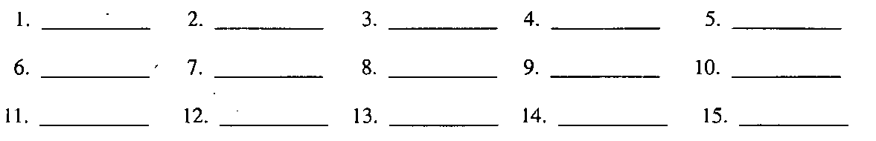
Ⅱ．Fillingblanks:(20%)
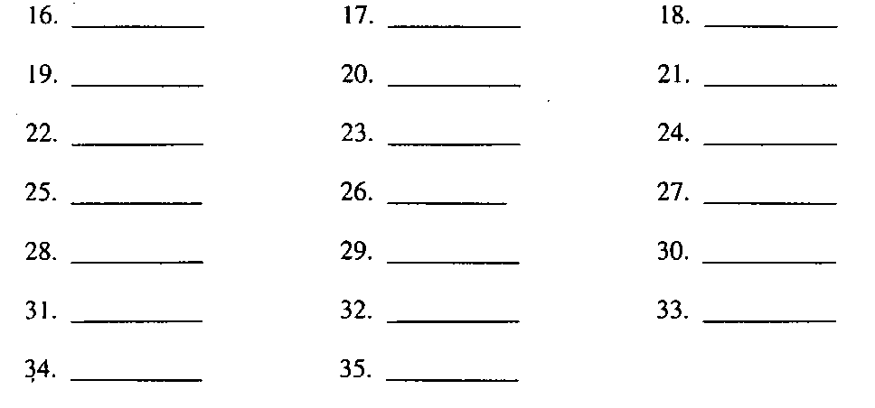
Ⅲ．Matching:(15%)
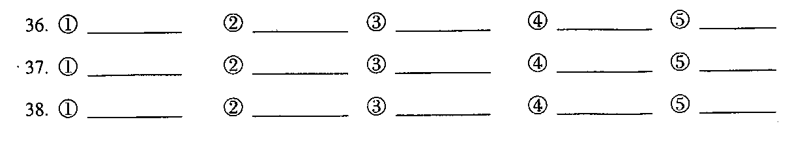
Ⅳ．QuestionsforBriefAnswers:(30%)
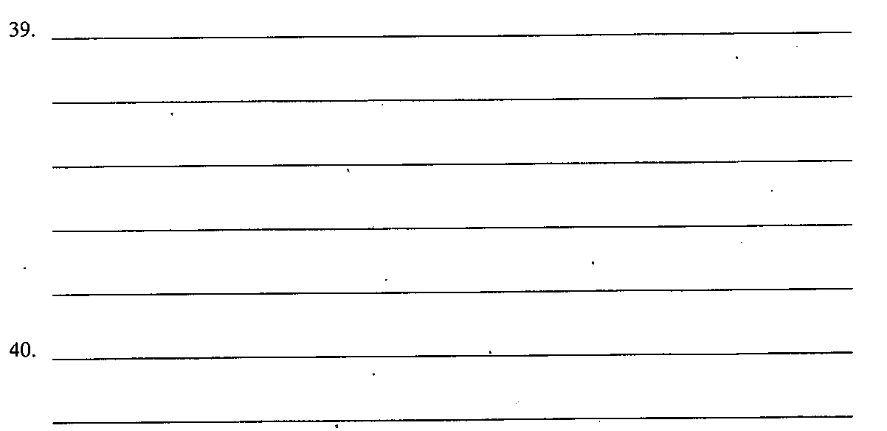
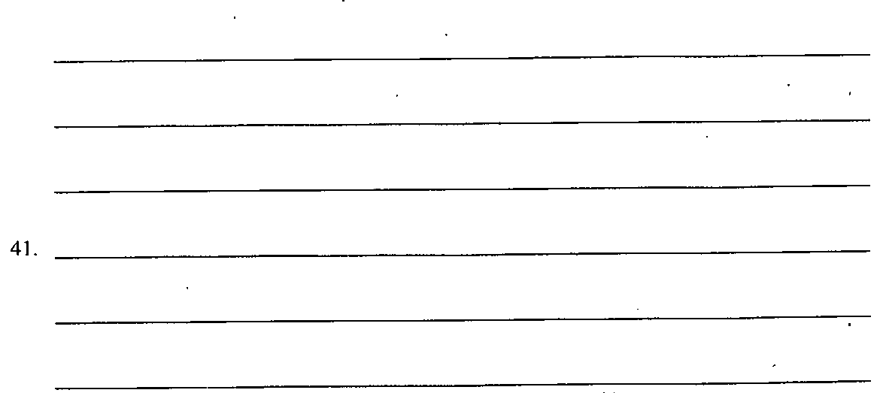[最新年份咨询qq593777558]
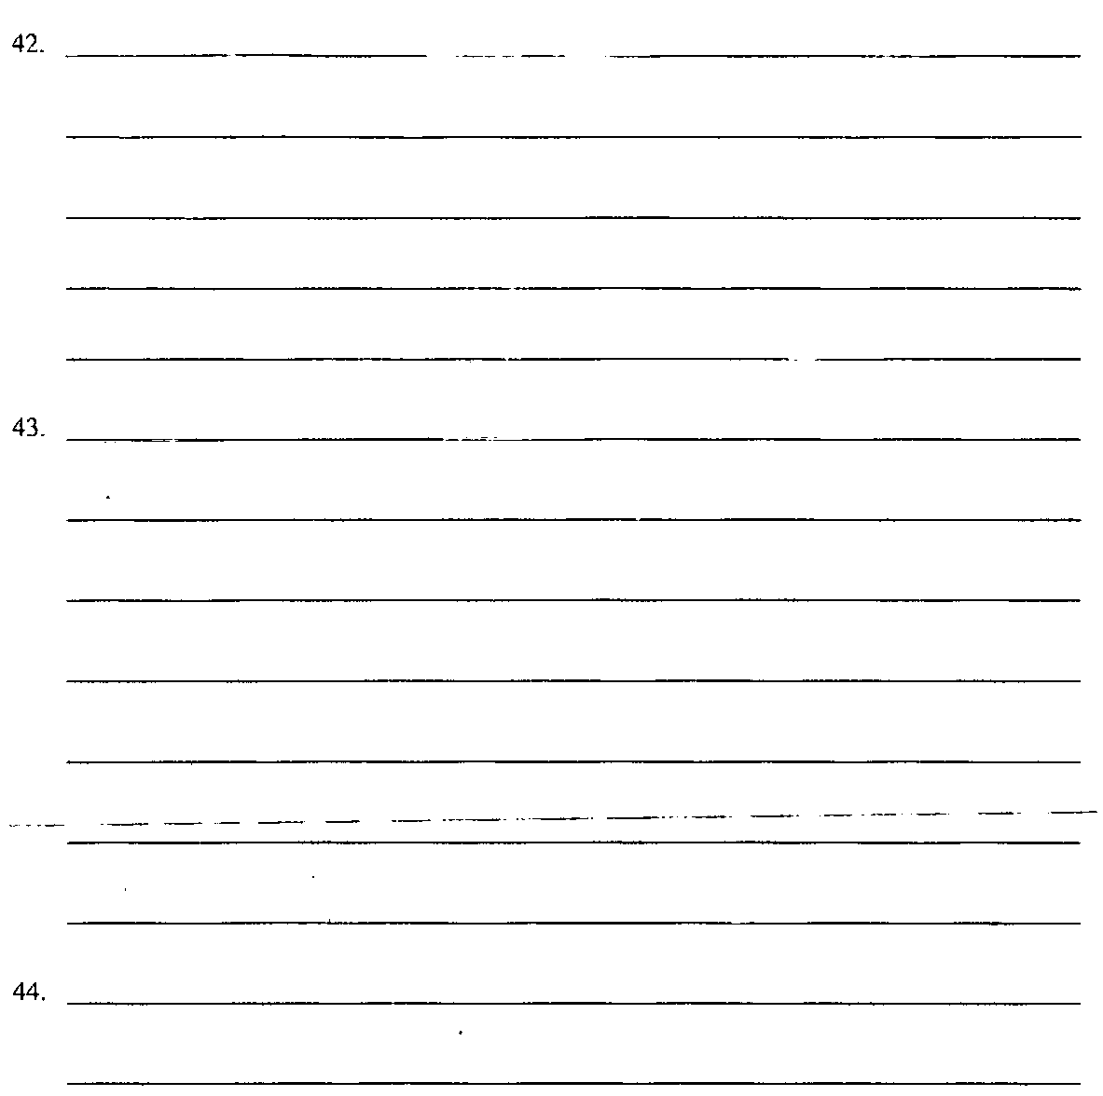
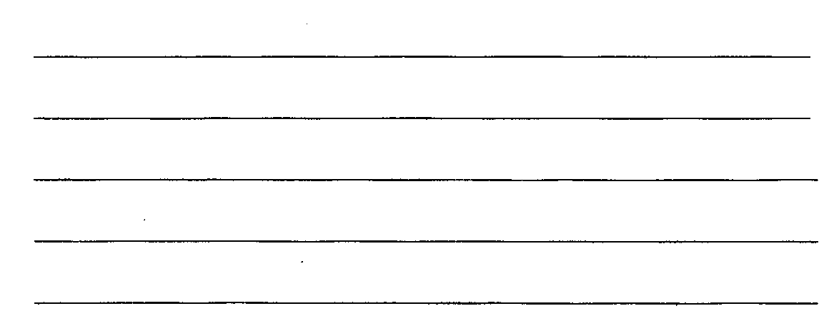
Ⅴ．QuestionsforLongAnswers:(20%)
