2007年10月高等教育自学考试全国统一命题考试
语言与文化试卷
(课程代码0838)
本试卷共7页，满分100分，考试时间150分钟。
Ⅰ．Eachofthefollowingincompletestatementsisfollowedbyfouralternatives.Readeachstatementandthefouralternativescarefullyanddecidewhichofthefouralternativesbestcompletesthestatement.(20%)
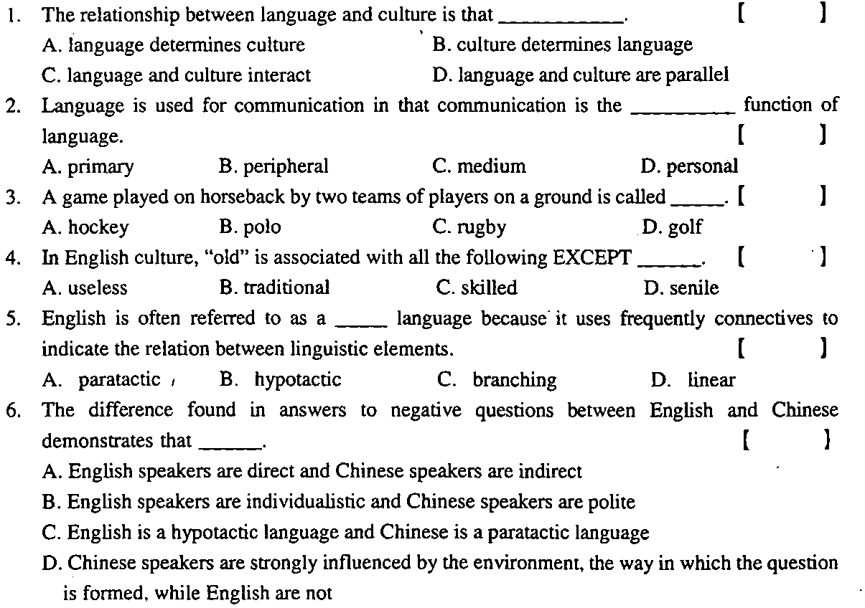
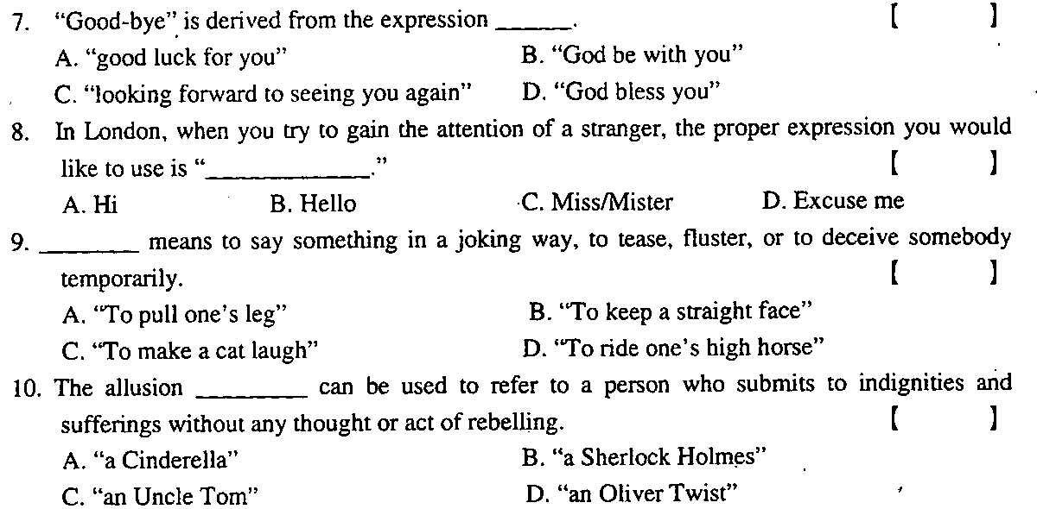
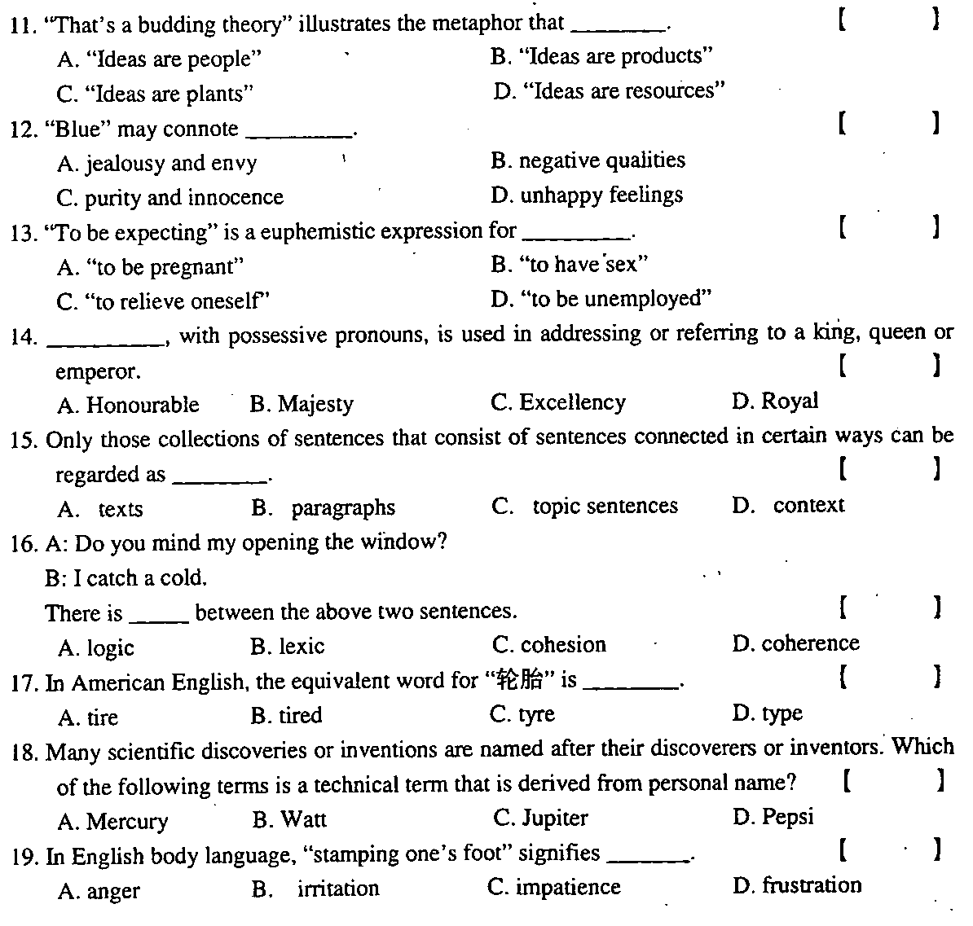
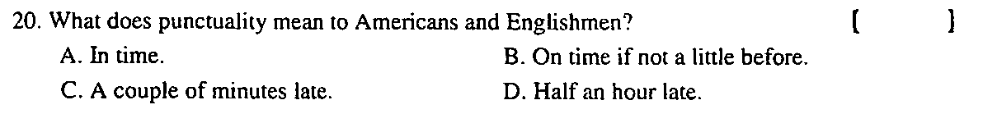
Ⅱ．Eachofthefollowingincompletestatementsisfollowedbyfouralternatives.Readeachstatementandthefouralternativescarefullyanddecidewhatalternativescancompletethestatement.Theremightbemorethanonecorrectanswer.(10%)
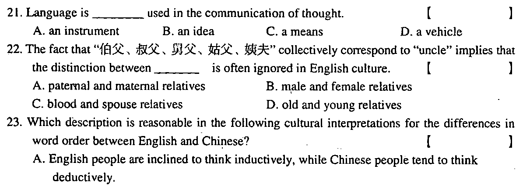
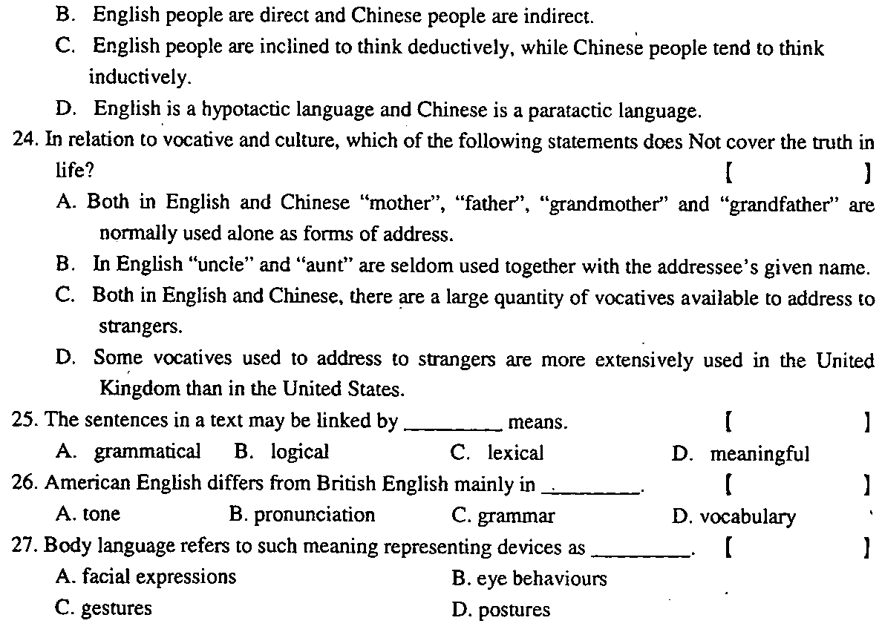
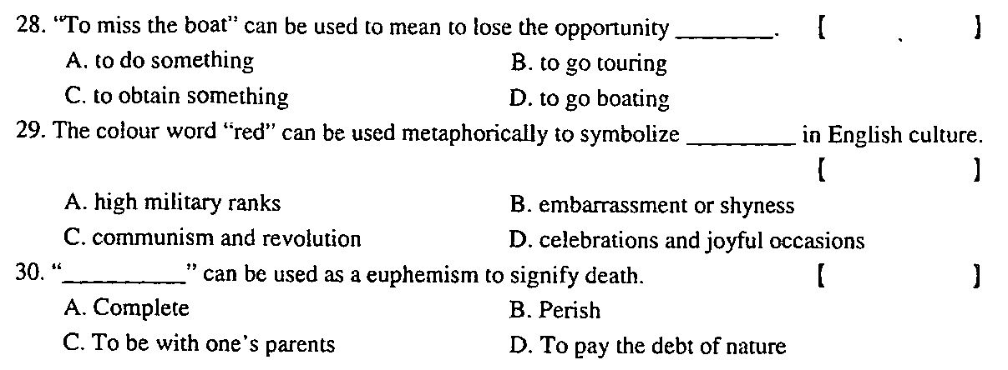
Ⅲ．Fillineachunderlinedspacewithaproperexpression.(20%)
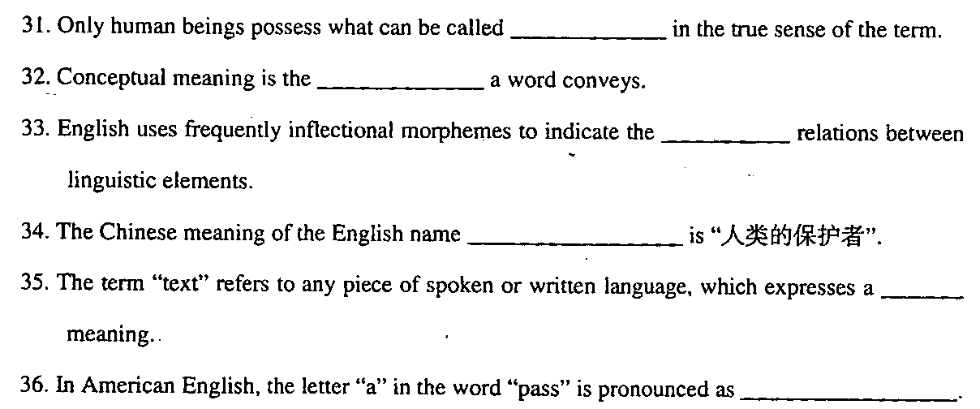
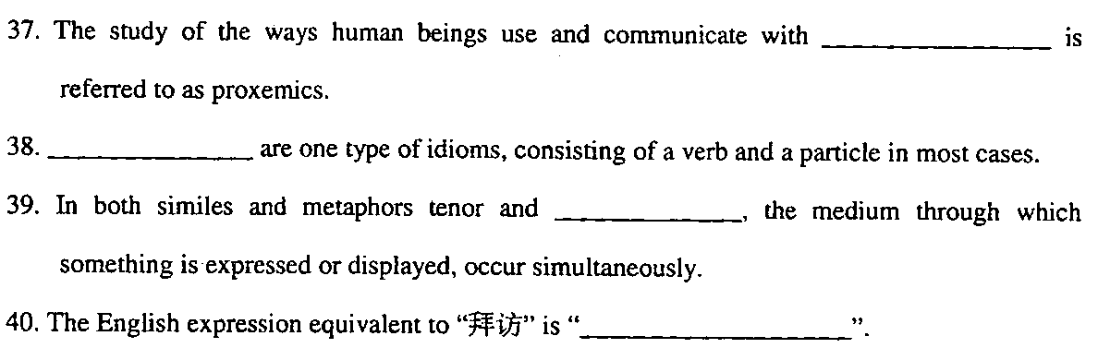
Ⅳ．Answerthefollowingquestionsbriefly.(12%)
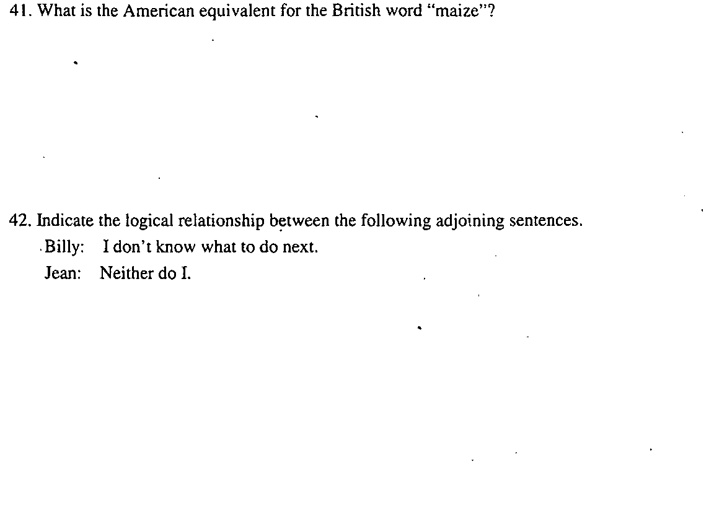
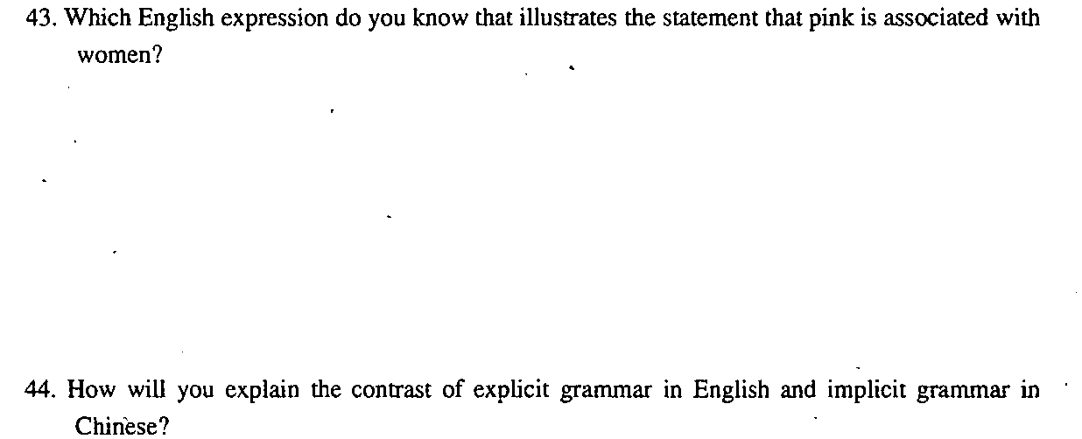

Ⅴ．Translation.(18%)
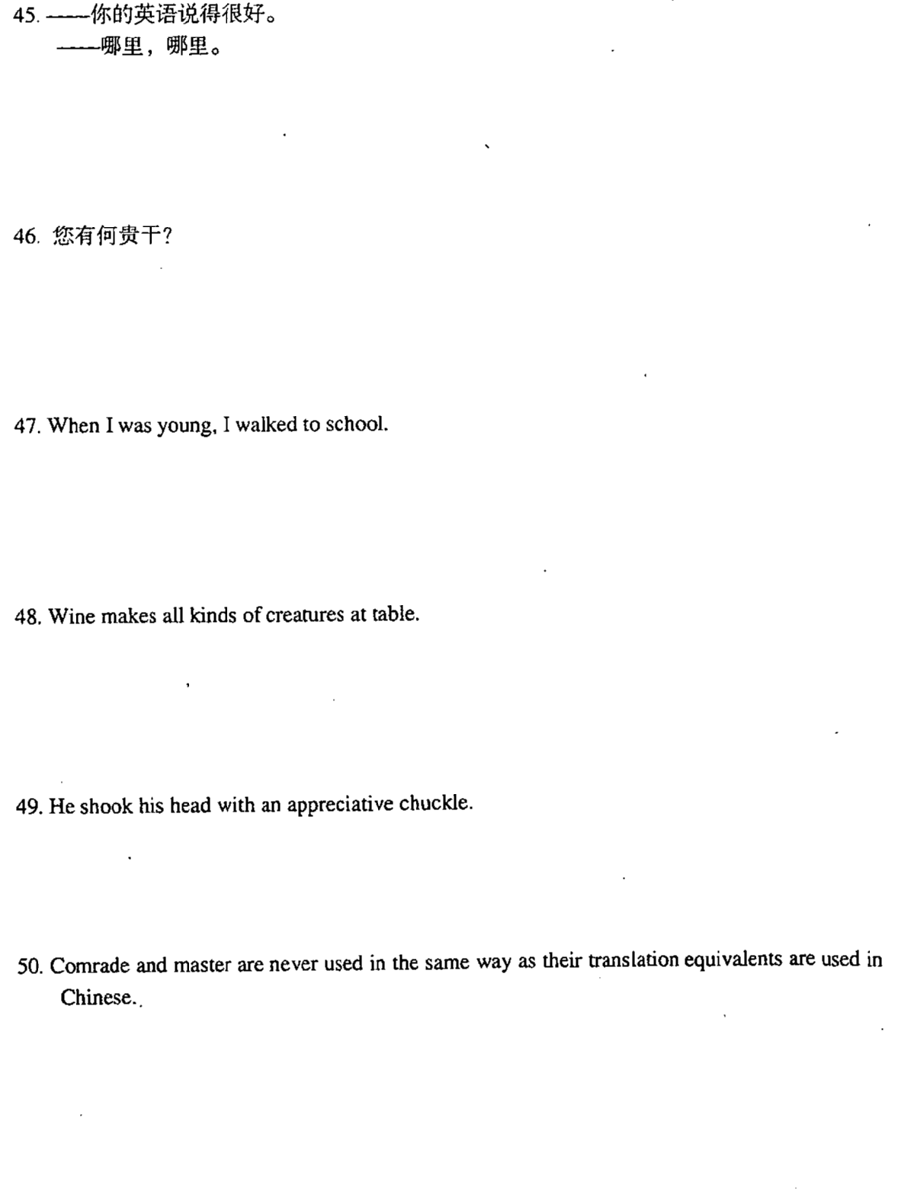
Ⅵ．Discussthefollowingtopics.(20%)
