2011年4月高等教育自学考试福建省统一命题考试
商务英语沟通试卷
（课程代码05002）
一、Questionandanswer(本大题共8小题，每小题10分，共80分)
1．What＇simportantwhenmeetingthecolleaguesforthefirsttime?
2．What＇simportantwhenpresidingoverameeting?
3．What＇simportantwhentakingamessage?
4．What＇simportantwhenimprovingcustomerrelations?
5．What＇simportantwhenplanningaletter?
6．What＇simportantwhengivingapresentation?
7．What＇simportantwhenattendingabusinessmeeting?
8．What＇simportantwhenselectingapplicantsforajoboremployeesforpromotion?
二、Writing(本大题共2小题，每小题10分，共20分)
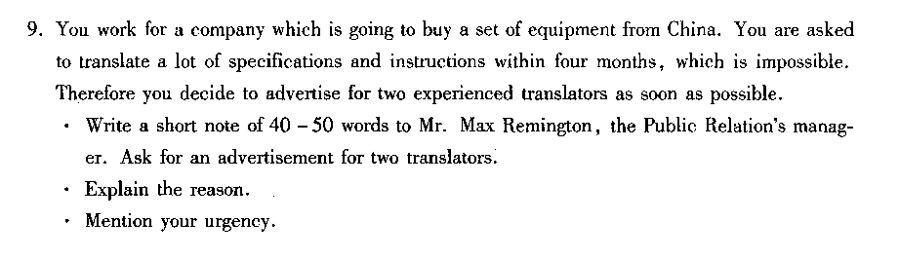[[微信公众号：ikaoti]
