Unit 13 People

教学计划：
目标：14次课的基本目标是巩固和提升教材内容。
内容：巩固和落实课内每个单元的基础知识点；提高的目标是将单元中的知识点与考纲衔接，进一步落实在单元中出现的高考要点。
具体方法：细化课本语言现象，从词到句在到篇章结构；梳理语法知识，使语法知识网络化、系统化。
具体安排：（基本与学校教学同步）
高二上学期英语2个模块---模块5、6，共计6个单元，每个单元2次课时，即2X6=12。
2次课时总复习。
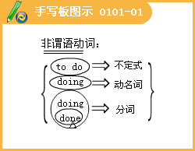
Unit 5
Lesson l EQ:IQ
1.Analyze your problems and come up with a plan to improve your grade.
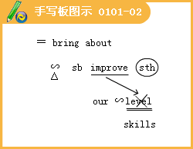
2.Tell yourself this course does not really matter and concentrate on other courses.
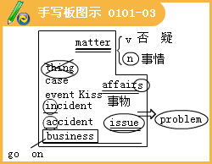
3.You and your parents have got into an argument during a discussion.
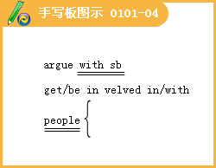
4.Stop for a moment, collect your thoughts and then state your case as accurately as you can.
5.Your group is doing a project to find a solution to a problem.
6.Even if they never see their results, they fee[ that their IQ is what determines how well they are going to do in life.
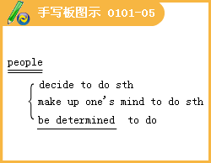
7.When they see other students doing better than them, they usually believe that those students have a higher IQ and that there is nothing they can do to change facts.
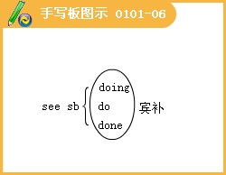
8.However, new research into EQ suggests that success is not simply the result of a high IQ.
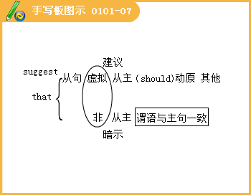
9.While your IQ tells you how intelligent you are, your EQ tells you how well you use your intelligence.
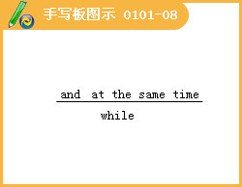
10.Professor Salovey, who invented the term EQ, gives the following description.
At Work, it is IQ that gets you hired but it is EQ that gets you promoted.
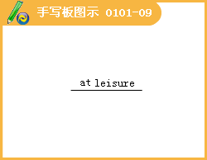
11.Supported by his academic research, Professor Salovey suggests that when predicting someone's future success, their character, as measured by EQ tests, might actually matter more than their IQ.
12.For example, have you ever wondered why some of the smartest students, in your class, who you think deserve good grades, sometimes end up failing exams?
13.People are often mistaken in thinking that those with high IQs always have
high EQs as well.
14.It is generally believed that people with high EQs are open to new idea and have positive attitudes towards life.
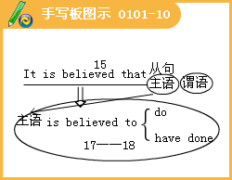
15.They are also less likely to be troubled by problems.
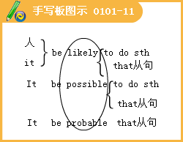
16.On the other hand, there is little doubt that people with low EQs often have problems getting on with other people and dealing with difficult situations; thus they have a harder time surviving in life.
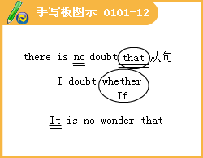
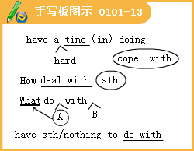
17.However, most social scientists agree that EQ has a lot to do with education.
18.Some are trying to study the possibility of improving a person's EQ, especially in terms of “people skills”, such as understanding and communication.

19.Professor Mayer, recognized by many as a leading expert in the study of changes to people’s EQs, recently announced the results of a study on senior high school students.
20.When normal students were introduced to .students with disabilities, they found that ,afterwards, the normal students were more willing to help people
with difficulties.
21.They also showed a better understanding of the disabled students’ feelings compared to students who had not been involved in the study.
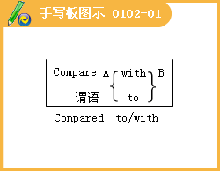
22.The results of studies such as these show that EQ is as important, if not more important than IQ.
23.To get ahead in the world and lead a happy successful life means getting on with other people and being able to understand and react to situations in the best way possible.
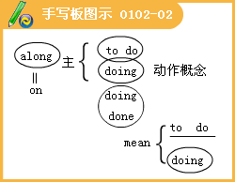
24.And the fact that it might be possible to raise EQs means that schools need to make sure that their students are receiving the education they really need, and know that their futures are not entirely determined by their IQs.
Lesson 3 Making Guesses about People
1.Or they could have gone exploring on their own and lost their way back to the group.
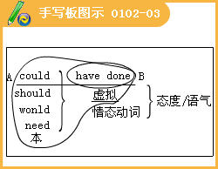
2.It's so cold at the moment.
Lesson 4 First Impressions
1.I was getting more and more annoyed and of course, the more upset I got, the less I was able to concentrate.
2.The last straw was when I heard someone singing behind me.
3.It was a tall girl about the same age as me and she had a big smile on her face.
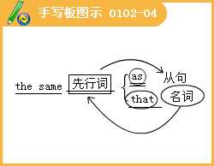
4.She was standing with a book in her hands near the “English Literature” section
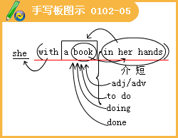



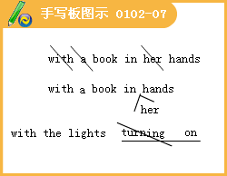
5.I picked up my books, glared at her and whispered angrily, "Thanks to your noise, I've been unable to study.You're so selfish!"
6.It was only when I got home two hours later that I realized I'd forgotten it and there was nothing I could do as the library was closed.
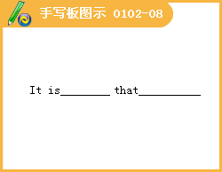

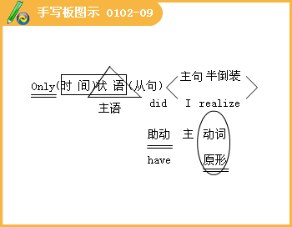
7.After confirming that I was, Jenny said that she had noticed I'd left my book in the library and as my name was in it, she’d asked a librarian to get my phone number from their files.
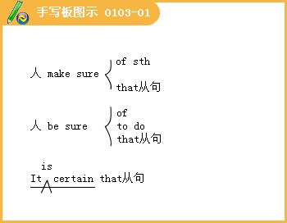
8.I felt so guilty, but Jenny just laughed and told me she was glad to see that I'd also left my glare in the library!
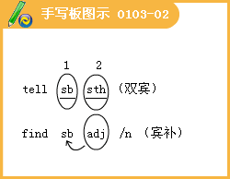
9.To be honest, I trust her more than anyone else.
10.If Jenny hadn't been a kind person who was willing to forgive my shortcomings, I would never have experienced such true friendship.
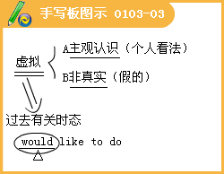

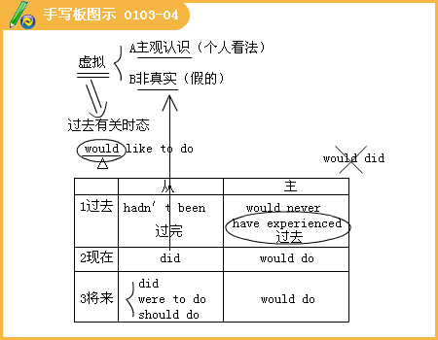

Communication Workshop
1.She never watches TV except for the news.
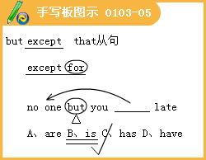
2.Grandma is very popular with her neighbors, maybe because she is so helpful.
Culture Corner
1.Of course, it is impossible that every person from a certain country has the same personality, but it seems that people of the same nationality do sometimes share certain personality characteristics.
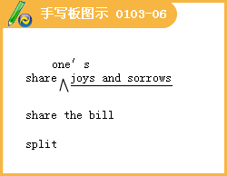

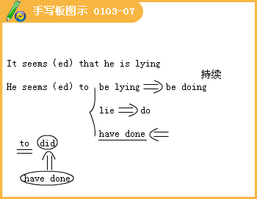
2.This has led to the idea of national types.
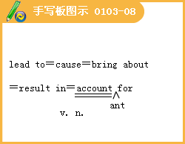

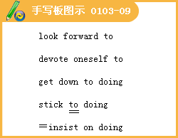
3.As long as national types are not taken too seriously, it's fun trying to guess a person's nationality from their personality.
4.They are usually dark-haired and dark-eyed, and are considered excellent singers and dancers.
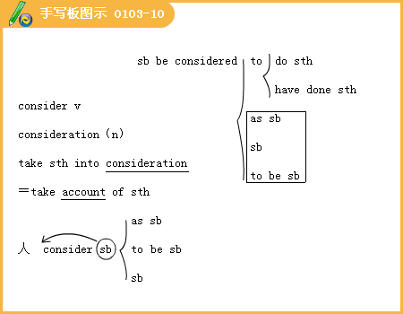
5.They are often described as being great lovers of food and wine and they never
hesitate to show how they feel.
6.They are also seen as very polite because of the fact that they are careful about “saving face” when dealing with other people.
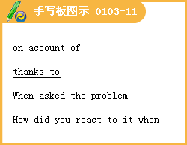
7.They are seen as hard workers who are very careful and pay a lot of attention to detail.
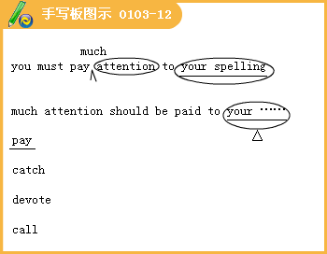
8.Nationalities may influence personalities, but at the end of the day, people are themselves, no matter where they come from.
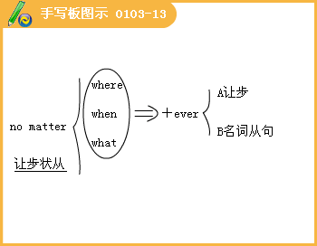
训练：
（一）
1. Some researchers believe that there is no doubt a cure for AIDS will be found.
A. which B. that C. what D. whether
[答疑编号911010401]
【答案】B
2 __ with the size of the whole earth, the biggest ocean does not seem big
at all.
A. Compare B. When comparing C. Comparing: D. When compared '
[答疑编号911010402]
【答案】D
3 __ Mr. Morgan appears extremely cheerful in public, he is in fact leading a very unhappy life.
A. While B. When C. As D. Since
[答疑编号911010403]
【答案】A
4 in the regulations that you should not tell other people the password of your email account.
A. What is required B. What requires C. It is required D. It requires
[答疑编号911010404]
【答案】C
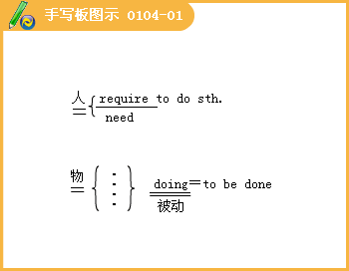
5.When you chat online with people you never see, you are to come across a next-door neighbor or even a workmate in the same office.
A. probable B. possible C. likely D. unlikely
[答疑编号911010405]
【答案】C
6. I would like a job which pays more, but I enjoy the work I'm doing at the moment.
A. in other words B. on the other hand
C. for one thing D. as a matter of fact
[答疑编号911010406]
【答案】B
7.Success on the college entrance examination means a good university education and being one step closer to a good job.
A. to get B. having got C. to have got D. getting
[答疑编号911010407]
【答案】D
8. How are you going to such problems?
A. do with B. deal with
C. deal D. do up
[答疑编号911010408]
【答案】B
9.It's believed that you work, result you'll get.
A. the harder, the better B. the more hard, the more better
C. the hard, a better D. more hard, more good
[答疑编号911010409]
【答案】A
10. two exams to worry about, I have to work really hard this weekend.
A. With B. Besides C. As for D. Because of
[答疑编号911010410]
【答案】A
11.The discovery of new evidence led to the thief
A. having caught B. having been caught C. being caught D. to be caught
[答疑编号911010411]
【答案】C
12. Much attention should be paid our environment.
A. protect B. protecting C. to protect D. to protecting
[答疑编号911010412]
【答案】D
（二）
1. --Robert is indeed a wise man.
--Oh, yes. How often I have regretted his advice!
A. to take B. taking C. not to take D. not taking
[答疑编号911010413]
【答案】D
2. It is not who is right but what is right is of importance.
A. which B. it C. that D. this
[答疑编号911010414]
【答案】C
3. Though he started late, Mr. Guo played the piano as well as,
if , Miss Liu.
A. not better than B. not better
C. no better than D. better
[答疑编号911010415]
【答案】A
4. I really don't like art, I find his work impressive.
A. As B. Since C. If D. While
[答疑编号911010416]
【答案】D
5. Some people choose jobs for other reasons money these days.
A. for B. except C. besides D. with
[答疑编号911010417]
【答案】C
6. Could I speak to is in charge of International Sales, please?
A. anyone B. someone C. whoever D. no matter who
[答疑编号911010418]
【答案】C
7. --Have you some new ideas?
--Yeah. I'll tell you later.
A. come about B. come into
C. come up with D. come out with
[答疑编号911010419]
【答案】C
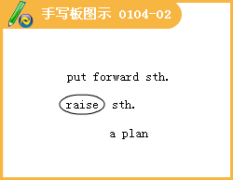
8. John received an invitation to dinner, and with his work
, he gladly accepted it.
A. finished B. finishing C. having finished D. was finished
[答疑编号911010420]
【答案】A
9. This magazine is very with young people, who like its content and style.
A. familiar B. popular C. similar D. particular
[答疑编号911010421]
【答案】B
10. We firmly believe that war never settles anything. It only violence.
A. runs into B. comes from
C. leads to D. begins with
[答疑编号911010422]
【答案】C
11. When different cultures, we often pay attention only to the differences without noticing the many similarities.
A. compared B. being compared
C. comparing D. having compared
[答疑编号911010423]
【答案】C
12. If you think that treating a woman well means always her permission for things, think again.
A. gets B. got C. to get D. getting
[答疑编号911010424]
【答案】D
13. A warm thought suddenly came to me I might use the pocket money to buy some flowers for my mother's birthday.
A. if B. when C. that D. which
[答疑编号911010425]
【答案】C
Past Participle过去分词（一）
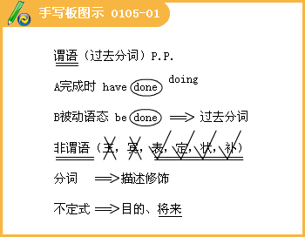

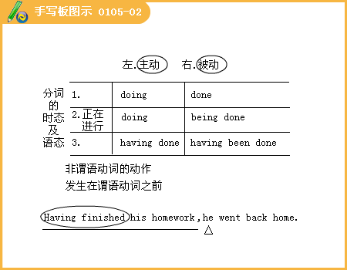

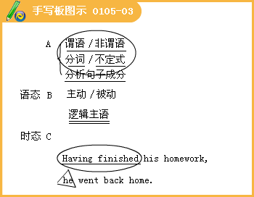

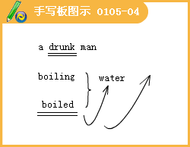

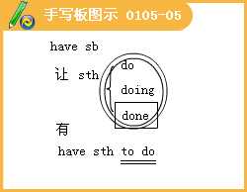
1.The Olympic Games, in 776 B. C. ,did not include women players until 1912.
A. first played B. to be first played C. first playing D. to be first playing
[答疑编号911010501]
【答案】A
2.Don't use words, expressions, or phrases only to people with specific knowledge.
A. being known B. having been known
C. to be known D. known
[答疑编号911010502]
【答案】D
