Unit 18 Beauty

Lesson 1 What Is Beauty？
*1.beauty.美，美丽；美人；美好的东西；极好的榜样；典型的例子；好处，优点
经典例句：
Joe Sanders has the most beautiful garden in our town.乔·山德斯的花园，在我们镇里算是最漂亮的了。
She had been a beauty in her day.她年轻时是一个美人。
Her new necklace is a beauty.她的新项链真漂亮。
词汇链接：beautiful 美丽的，美好的；beautifully.美妙地；beautify.美化，使更美丽；beauty queen选美皇后；beauty salon／parlour美容院
“美丽”“漂亮”的近义词：beautiful意为“漂亮悦人的”，是表示“美丽”的最普通用词，语气最强，不用于男性；fine，handsome，pretty等只表示beautiful的一部分。pretty意为“美丽可爱的”，多用于小孩、妇女和较细小的东西，语气较弱；a pretty child（girl，little house）漂亮的小孩（姑娘、小屋）；good—looking意为“吸引人的”，指人的相貌。
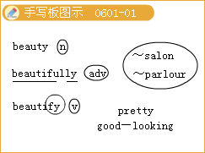
◇[例题l] 完成句子：
（1）这么多年过去了，她渐渐失去了美貌。______had faded over the years.
（2）在我们这个城市里有很多景色美丽的地方。 There are many areas of______ .
（3）她年轻时是个公认的美人。She______in her youth.
（4）在这里生活的好处之一是安宁。One of the______0f living here is that it’s so peaceful.
[答疑编号911060101]
【答案】 （1）Her beauty （2）outstanding natural beauty（3）was considered a great beauty （4）beauties
*2.astonish.使惊讶，使惊恐 astonishing。令人惊讶的，惊人的；astonishingly.
She ran 100 metres in an astonishing 10.9 seconds.她以l0.9秒的惊人速度跑完了100米。
常用搭配：be astonished at（by…to do sth.，that）被（因）……惊吓
辨析：astonished与astonishing
两者都是形容词，astonished指“（人）感到惊讶”，说明被修饰名词自身的反应；astonishing指“令人惊讶的”，说明被修饰名词对外物的影响。
◇[例题2]
You look_____at the news.
A.scored B.astonished
C.distinguished D.distributed
[答疑编号911060102]
【答案】 B
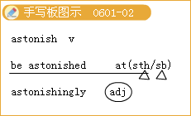
*3.attractive.goods attractive in price and quality
有吸引力的，有迷惑力的，动人的，妩媚的
I must admit that I've never found him particularly attractive.
我必须承认我从未发觉他有什么特别迷人的地方
She is an attractive girl.她是个妩媚的女孩。
记忆技巧：派生词联想记忆：
attract.吸引，引起……注意，诱惑，招引；.吸引，有吸引力，引人注意；
attraction.吸引人的事物，吸引力；attractively.有吸引力地
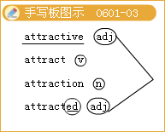
◇[例题3]
The traffic accident_____a 1arge crowd.
A.charmed B.signal
C.called D.attracted
[答疑编号911060103]
【答案】 D
*4.1eave sb. breathless使某人目瞪口呆
（1）leave使……处于（某种状态）
经典例句：Leave the door open.让门开着。
Many children were left without parents in the earthquake.在这次地震中很多孩子失去了父母。
He left the office，leaving the lights on.他没关灯就离开了办公室。
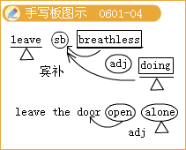
归纳拓展：
leave sb.／sth.+宾补表示“使……处于某种状态”。
leave作动词，还有“离开，动身；忘了带，丢下；不立刻做／处理；剩余，余下；遗留；把……留交，交托”等意思。
leave sb.behind把……抛在后边；超过；比……取得更多的进展
leave sth.aside不予考虑；搁置一边
leave sb.alone不去打扰某人；让某人独自待着
leave sth.alone别碰某物
（2）breathless 令人屏息的；气喘吁吁的，令人目瞪口呆的；上气不接下气的
He arrived breathless at the top of the stairs.他爬上楼顶时气喘吁吁的。
词汇链接：breathe.呼吸；breath-taking .激动人心的
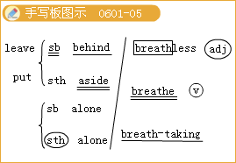
常用搭配：
out of breath上气不接下气
waste one’s breath白费口舌
breathe one’s last断气
take a deep breath深呼吸
hold one’s breath屏住呼吸
breathe again松一口气；平静下来
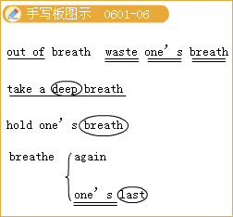
◇[例题4]
（1） Are you going to have a holiday this year?
I’d love to.I can’t wait to leave this place_____.
A.off B.out
C.behind D.over
[答疑编号911060104]
【答案】C
（2）Don’t leave the water_____while you brush your teeth.
A.run B.running
C.being run D.to run
[答疑编号911060105]
【答案】B
（3）①我想我把信用卡落在餐馆里了。 I think_____my credit card_____at the restaurant.
②深呼吸，你会感觉好点的。 _____and you’ll feel better.
[答疑编号911060106]
【答案】①left；behind ②Take a deep breath
*5.elegant.文雅的；优美的；漂亮的；雅致的；陈设讲究的；精美的；简练的；简洁的
She was tall and elegant.她身材修长，优雅大方。
He found an elegant solution to the problem.他找到了一个解决这个问题的简要方法。
People always think it is elegant.人们总是认为那很高雅。
词汇拓展：elegance.雅致；
elegantly .讲究地，典雅地
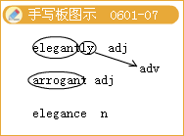
◇[例题5]
This is a clean and_____restaurant.
Every guest here feels_____.
A.elegant；at home B.elegant；oneself
C.elegantly；at home D.elegantly；oneself
[答疑编号911060107]
【答案】A
6.a thing of great beauty极美的东西
value valuable
（1）be of great（much） Importance important
use =be very useful
Help helpful
be of+抽象名词=be+该词的同根形容词
（2）be of a（n）／the／the same“属于；归于”（这类抽象名词没有相应的形容词形式），如：be of the size／weight／height／age／colour／kind／type等。
They are of different sizes，but they are the same in weight.它们大小不一，但重量一样。
注意：“0f+n.”结构相当于形容词，在句中可作表语或补语。
I don’t find anything of interest in today’s newspaper.我发现今天的报纸上没有什么有意思的事情。
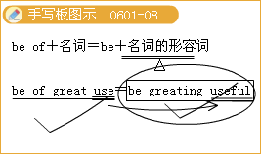

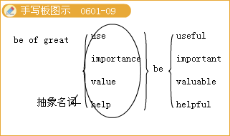
◇[例题6]
（1）I think your suggestion is_____ much value.
A.of B.in
C.with D.too
[答疑编号911060108]
【答案】A
（2）完成句子：
①你正在做的事情对我们很重要。What you are doing now is_____.
②曾经被认为很有用的花瓶被证明一点用都没有。 The vase once thought useful proved to_____.
③他是一个有能力的人。He is a man_____.
④我有很多年龄相当的好朋友。I have a lot of good friends_____.
[答疑编号911060109]
【答案】①of great importance to us ②be of no value③of ability ④of the same age
7.Superior adj.更高的，上级的，更强的；优质的；有优越感的；n.上级，长官
be superior to 比……优越，不屈服于……
be superior in 在……方面优质的／上乘的
I’11 report what you did to your superior office.
我要把你做的事向你的上级部门报告。
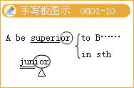
Her knowledge of Chinese literature is superior to mine.
她在中国文学知识方面比我强。
Yao Ming’s fitness and superior technique brought him victory.
姚明的体能和出色的技术使他取得了胜利
◇[例题7]
This western restaurant is superior_____the one we went to last week.
A.in B.to
C.with D.over
[答疑编号911060110]
【答案】B
8.adore vt.热爱，爱慕（某人）；喜爱，热爱（某事物）（用于进行时）；敬爱
I simply adore Zhou Jielun’s music! 我太喜爱周杰伦的音乐了!
She adores working for children. 她热爱为儿童工作。
People adore him for his noble character. 人们因他人格高贵而敬重他。
I adore chocolate.我非常喜欢巧克力。
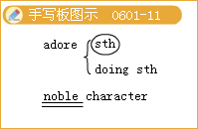
◇[例题8]
Don’t you just adore_____these cookies?
A.to eat B.eat
C.eating D.being eaten
[答疑编号911060111]
【答案】C
9.In l9th-century Europe，women used to wear corsets to achieve a body shape that is no longer considered healthy.十九世纪的欧洲，妇女们身着紧身胸衣以达到一种今天已经不再被认为是健康的体形。
结构分析：that is no longer…是定语从句，修饰其前的body shape
（1）used／adj.（of goods）which has already had an owner；
second hand用过的；半旧的used cars二手汽车used stamps用过的邮票
（2）used／习惯的
常用搭配:
be used to sth.／doing sth.习惯于…，get／become used to习惯……
used to过去常常（否定式为used not或didn’t use，疑问句可用used开头，也可用did开头）；习惯于……
a man used to country life 过惯乡村生活的人
词汇拓展：
useful adj.有用的，有益的，有帮助的useless adj.无用的，无价值的user n.用户，使用者
辨析：
used to do过去常做（某事），
be used to doing习惯于做（某事），此时to是介词；
be used to do被用来做（某事）。
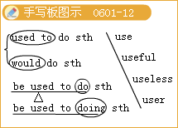
◇[例题9]
（1） _____he to come by bus?
A.Does B.Do
C.Used D.Did
[答疑编号911060112]
【答案】 C
（2）The country life he was used to _____greatly since 2002.
A.change B.has changed
C.changing D.have changed
[答疑编号911060113]
【答案】B
10. she was stating that there was no consistent view on beauty.她写道人们对美没有一致的观点。
consistent／adj坚持的，一贯的；一致的，符合的
记忆技巧：构词联想记忆：
形容词后缀ent表示“具有……性质的；关于……的”
如:dependent依赖的，依靠的；insistent坚持不懈的；emergent紧急的
常用搭配：
consist in存在于 consist of由……组成 consist with与……一致
经典例句：
The United Kingdom consists of Great Britain and Northern Ireland.联合王国包括大不列颠与北爱尔兰。
词汇链接：consistence n.坚固性，浓度；
consistency n.连结，结合；坚固性；浓度，密度；一致性，
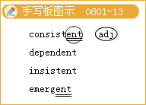

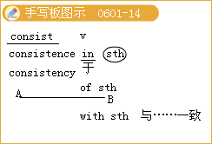
◇[例题l0]
A university _____ of teachers，administrators and students.
A.consists B.composes
C.includes D.contains
[答疑编号911060114]
【答案】A
11.Lifelong commitment and，indeed，the survival of society itself rely on people seeing beauty in difference and depth.人们毕生的责任，甚至社会自身的存亡都取决于人们对美的不同层面和深度的认识。
commitment n.承诺；许诺；献身；投入；已承诺的事
commitment to sth.／to do sth.保证做某事
She doesn’t want to make a big emotional commitment to Steve at the moment.
她不想此刻在感情上对史蒂夫作出重大的承诺。
Her commitment to work is beyond question.她的敬业精神不容置疑。
commit vt.做出；犯；承诺，保证
Women commit fewer crimes than men.女性比男性的犯罪率低。
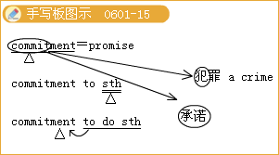
◇[例题11]
完成句子：
（1）我们在寻求对此工作真正能尽职尽责的人。 We’re looking for someone with a real sense of______.
（2）总统承诺要改革卫生保健制度。 The President ______to reforming health care.
[答疑编号911060115]
【答案】（1）commitment to the job （2）is committed
12.In other cultures，looking thin for a husband—to—be is not what a woman desires at all—rather，looking a little overweight is considered more attractive.
在其他文化中，女人根本不想在未来丈夫眼中显得苗条，而身材略微丰满才更加迷人。
结构分析：本句为复合句。what引导的从句在句中作表语，两个“looking”短语在句中都是作主语。
consider vt.考虑；把……看做，认为；vi.考虑，思考；认为，以为
常用搭配：
consider（doing）sth.考虑（做）某事
consider how／what to do考虑怎样做／做什么
consider that…考虑……
consider…as（to be）…把……看做……
consider sb.to have done认为某人做了……父
consider sb.as mud蔑视某人
经典例句：I am considering going abroad.我正在考虑出国。
The Arctic Ocean is considered by some to be a northern part of the Atlantic Ocean.
有人认为北冰洋是大西洋北边的一部分。
We considered their demands reasonable.我们认为他们的要求合理0
Have you considered what to do next? 你考虑了下一步该做什么吗?
We consider Beijing as the heart of our country.
我们把北京看做是我们国家的心脏。
词汇链接：
considerable 相当大（或多）的，值得考虑的，相当可观的；
considerably adv.相当地；
considerate adj.考虑周到的；
consideration n.体谅，考虑，需要考虑的事项，报酬
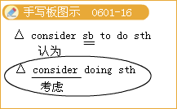

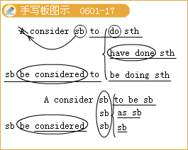
◇[例题l2]
（1）He______the right man for the job.
A.considers to be B.is considered to be
C.considers D.considers being
[答疑编号911060116]
【答案】B
（2）It’s getting warmer and warmer，the students ______climbing the hill next week.
A.is considering B.are considering
C.considered D.is considered
[答疑编号911060117]
【答案】B
（3）Her parents ______her need reasonable.
A.consider B.considered
C.is considering D.to consider
[答疑编号911060118]
【答案】A
（4）We consider ______our duty to help you.
A.this B.that
C.it D.／
[答疑编号911060119]
【答案】C
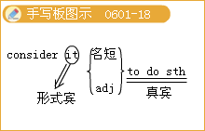
13.With the influence of history，society and culture，there are no precise criteria which can be used to judge what is beautiful.受历史、社会和文化的影响，没有精确的衡量标准用来判断什么
（1）influence n.[U]影响，作用；[C]有影-向的人或事物；影响，对……起作用
The influence of the climate on agricultural production is great.
气候对农业生产的影响是巨大的。
Don’t let me influence you.别受我的影向。
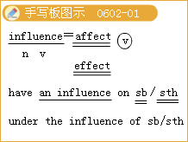
常用搭配：
have an influence on sb.／sth.对……有影响
under the influence of在……的影响下
influence sb.to do sth.影向某人做某事
（2）judge n.[c]法官；裁判员，鉴定人；∥.判决，裁判；判断
I can't judge whether he is right or wrong.我不能判断他是否正确。
I judge him to be a singer.我断定他是个歌手。
The judge was satisfied with what the Arab said.法官对阿拉伯人说的话感到满意。
judge…by…按照……识别
Don’t judge a person by what he says.不要按照一个人的话语来判断他。
考点聚焦：judge作状语时只用ing形式。
常用搭配：judge by（from）…从……判断，按照……判断
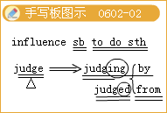

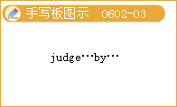
◇[例题l3]
（1）完成句子：
①她的作品已经影响了数百万人的生活。Her writings have ______the lives of millions.
②他们受到一个奇特教派的影响。They had come______a strange religious sect.
[答疑编号911060201]
【答案】 ①had a great influence on ②under the influence of
（2）Those friends have______her.
A.a bad influence to B.a bad influence on
C.bad influence with D.bad influence on
[答疑编号911060202]
【答案】B
（3）My friend，you shouldn’t judge a stranger______the clothes he wears.
A.before B.after
C.by D.through
[答疑编号911060203]
【答案】 C
14.The human race would soon die out if we could only see beauty within a set of limited criteria.如果我们只能够用一套有限的标准来衡量美，人类不久将灭绝。
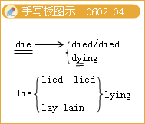
die out灭绝；死光；消失
This kind of bird is dying out.这种鸟快灭绝了。
The custom，passed down from generation to generation，has been dying out.
这个一代代流传下来的习惯已渐渐消失。
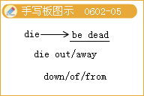
词汇拓展：
die away（声音，风或光线）慢慢变弱，逐渐消失die down逐渐变弱（平息，暗淡）
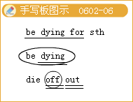
die off相继死去；先后死去be dying for渴望，极想…… die of／from死于……
The sound of their laughter died away.他们的笑声渐渐消失了。
The flames finally died down.火焰越来越小，最后熄灭了。
Her grandparents died off last year.去年她的祖父母相继去世。
辨析：die from与die of
die from死于（常表示因外部、偶然原因或疾病而死），如车祸；
die of死于（表示由于内部原因、疾病而死），如忧伤。
◇[例题l4]
（1）When the applause had______，she began her speech.
A.died down B.died out
C.died away D.died off
[答疑编号911060204]
【答案】 B
（2）Although the wind has______，the rain remains steady，so you still need a raincoat.
A.turned up B.gone back
C.died down D.blown out
[答疑编号911060205]
【答案】 C
（3） What did he die______?
He died______old age.
A.of；from B.from；of
C.from；from D.of；of
[答疑编号911060206]
【答案】 D
15.Physical beauty must also be accompanied by an attraction to something deeper within a person. 外在美一定要靠一个人的内在魅力来强化。
结构分析：该句为一个简单句，谓语动词must be accompanied，为带情态动词的被动语态。
（1）accompany vt.伴随，陪伴；为……伴奏；附有，带有，配有
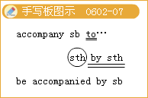
归纳拓展：
accompany sb.to…陪同某人到……
accompany sth.by sth.……伴随某事发生
be accompanied by sb.在某人的陪同下
accompany sb.at／on sth.用……给某人伴奏
I must ask you to accompany me to the police station.我得要求你陪我去一趟警察局。
Strong winds were accompanied by heavy rain.狂风夹着暴雨。
We need a piano to accompany our singing in the concert.
音乐会上我们需要一架钢琴给我们演唱伴奏。
Please see the accompanying booklet for instructions.请参阅所附的说明小册子。
（2）attraction n.吸引；吸引力，诱惑力；吸引物，喜闻乐见的事物
The display of fireworks offers many attractions.烟火表演很吸引人。
词根：attract vt.吸引，引起
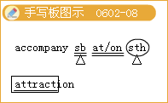
◇[例题l5]
（1）完成句子：
①军舰将护送船队。Warships ______the convoy.
②那位演唱者的姐姐用钢琴给她伴奏。The singer ______the piano by her sister.
③那夜天气很糟，狂风夹着暴雨。
That night the weather was terrible strong winds______heavy rain.
[答疑编号911060207]
【答案】 ①will accompany② was accompanied by/on③ were accompanied by
（2）The company is starting a new advertising campaign
To ______ new customers to its stores.
A.join B.attract
C. stick D.transfer
[答疑编号911060208]
【答案】 B
16.This particular kind of attraction is found in a wide range of personal qualities...
这种特殊的魅力存在于不同的人格个性特征中……
range.（价格、水平、温度等）处于某范围内，在某范围内变化；n.排列；范围，幅度；等级，类别；射程
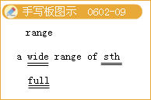
归纳拓展：
a wide range of一系列……
a full range of各种……
in the range of在……范围内
houtside the range of超出……的范围
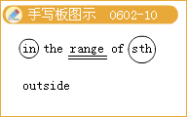
range from…to…在……范围内变动，包括（由……到……）之间的各类事物
range between…and…在……和……范围内变动
range over涉及，包括
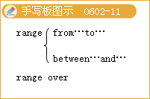
We have students from a wide range of backgrounds.我们的学生来自各种不同的背景。
The price of the house is well beyond our range.
这所房子的价格远远超出我们能承受的范围。
There were l20 students whose ages ranged from 10 to 18.
有120名学生，年龄在10至18岁之间。
◇[例题16]
His interests ______from chess to canoeing.
A.ranked B.1ined
C.rowed D.ranged
[答疑编号911060209]
【答案】 D
17…but it is inner beauty that requires US to truly see.Beauty is certainly in the eye of the beholder.……但其实内在的美才真正需要我们注意。真是情人眼里出西施。
结构分析it is inner beauty that…是强调句型。
（1）强调句型的构成：
It is／was+强调部分+that／who／whom（强调部分是人）十句子的剩余部分。
（2）it强调句式的判断方法：
it强调句式中被强调的成分是句中的某个成分。对句中某个成分进行强调，就是把该成分提到强调句式的It is／was之后.that／who之前。看出，强调位置上的成分正好是that／who后面句子中所缺少的成分。因此，把一个句子中的It is／was…that／who…这个框架去掉以后，剩余的仍是一个完整的句子。
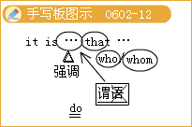
◇[例题l7]
（1）It was______back home after the experiment.
A.not until midnight did he go
B.until midnight that he didn’t go
C.not until midnight that he went
D.until midnight when he didn’t go
[答疑编号911060210]
【答案】 C
（2）It wasn’t until nearly a month later______I received the manager's reply.
A.since B.when
C.as D.that
[答疑编号911060211]
【答案】 D
Lesson2 What's Your Favourite Music?
1.accessible adj.容易理解的；易接近的，随和的，平易近人的；易得到的；易到达的，易进入的
He succeeded in making a difficult subject accessible to the readers.
他成功地把一个棘手的题目变得易于被读者理解。
I think that you’11 find she’s very accessible.
我想你会发现她是很平易近人的。
The cove is only accessible by boat.
小海湾只有小船才能进入。
归纳拓展：
accessiblyadv.易理解地；易接近地
accessibility获得，得到
access入口，进入（to）；进入权
have access to有权进入
gain／get access（to）到达（某地）；见到（某人或物）
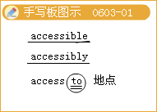

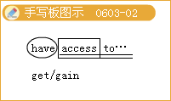
◇[例题l]完成句子：
（1）警察设法通过楼上的一扇窗子进入了屋子。
The police managed to______to the house through an upstairs window.
（2）公众无权进入此地。
The public don’t______the site.
（3）把详细资料储存在电脑里可方便查找。
Storing details on computers makes them______.
（4）我的新老师很平易近人，我们相处得很融洽.
My new teacher is very______and we are getting along well.
[答疑编号911060301]
【答案】（1）gain access （2）have access to （3）easily accessible （4）accessible
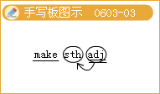
2.Comforting 令人安慰的，令人鼓舞的
经典例句：It’s comforting to know that you’ll be there.
知道你要去那里令人感到欣慰。
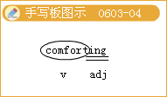
相关词汇：comfort n. 安慰；慰问； give comfort to sb.慰问某人
词汇链接：comfortable a4舒适的；comfortably adv.安乐地，舒适地，充裕地：
comfortless缺乏安慰的，不舒服的，不自由的
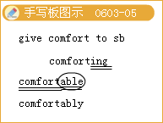
常用搭配：
Comfort letter安慰信
comfort stop（公路上设有长途客车的站）休息停车
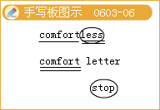
◇[例题2]
（1）The news that he got the great prize is very______.
A.comfortless B.comfortable
C.comforting D.comfortably
[答疑编号911060302]
【答案】C
（2）Hearing her______words，I felt______.
A.comfortable；comforting
B.comfortable；comfort
C.comforting；comfortable
D.comfort；comforted
[答疑编号911060303]
【答案】C
3.a delicate tune优美的旋律
delicate adj.
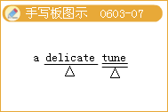
（1）易损的；脆弱的；纤弱的：
The eye is one of the most delicate organs of the body.
眼睛是人体最脆弱的器官之一。
（2）精巧的；精致的：
She was astonished by the delicate stxueture of this machine.
她惊讶于这台机器精巧的结构。
（3）微妙的；精细的；需谨慎处理的：
The delicate surgical operation took five hours.
这精细的外科手术花了五个小时。
（4）柔和的；清淡的；清香的：
a delicate flavour鲜美的味道
◇[例题3]
The international situation is very______at present.
A.perfect B.delicate
C.slim D.slight
[答疑编号911060304]
【答案】B
4.Deliver vt&vi.送交，递送；释放，解救；作（演讲），表达；接生，给……接生；分娩1
He delivered himself of his opinion at the meeting.他在会议上发表了自己的观点。
He delivered a speech on philosophy to the society.他给协会作了一次有关哲学的演讲。
归纳拓展：
deliver sb.from danger救某人脱险
deliver sth.（over）to sb.把某物交付给某人
deliver a message带信，传话
deliver oneself of sth.发表……
deliver sb.of a baby给某人接生孩子
sb.be delivered of a baby某人生了一个婴儿
She was delivered of a healthy boy.
她生了一个健康的男孩儿。
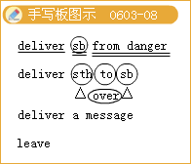

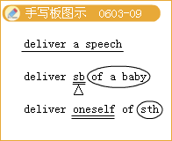
◇[例题4]（1）完成句子：
①你能把这封信送到我办公室吗?
Could you______tllis letter______my office?
②8月18日，她产下一个女婴。
On Auguest l8th，she______a daughter.
③昨天，史密斯教授用英语给我们作了一个报告。
Professor Smith______a speech in English for us yesterday.
[答疑编号911060305]
【答案】①deliver；to ②delivered ③was delivered of
（2）We can______goods to your door.
A.pass B.relay
C.deliver D.release
[答疑编号911060306]
【答案】C
5.heartbreaking adj.令人心碎的
I couldn’t help crying at the heartbreaking pictures of starving children.
看到这些令人心碎的饥饿儿童的图片，我禁不住哭出声来。
相关词汇：heartbreak极度伤心，心碎；heartbroken 颤极度伤心的
Heart n.，心脏，心；中心，要点；内心，心肠
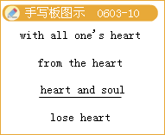
常用词组：
with all one's heart／from the heart衷心地，全心全意地
heart and soul全心全意地；干劲十足
lose heart灰，心
take heart鼓起勇气
learn sth.by heart记熟
warm—hearted热心的
He is a warm—hearted man.
他是个热心肠的人。
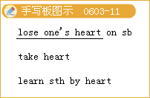

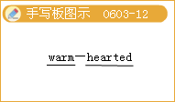
◇[例题5]
（1）It’s______to see him wasting his life like this.
A.heartbreaking B.heartbroken
C.heartbreak D.sad
[答疑编号911060307]
【答案】A
（2）How many words had you______by the end of last month?
A.lost heart
B.1earned by heart
C.heart and soul
D.taken heart
[答疑编号911060308]
【答案】B
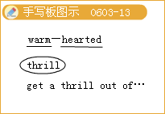
6.thrill n.兴奋，恐惧；激动；引起激动的事物；v友使激动，使胆战心惊
The film thrilled the audience.
那部电影使观众胆战心惊。
We were very thrilled to hear your wonderful news.
我们听到你的好消息非常兴奋。
He was thrilled at the sight of her.
见到她，他非常兴奋。
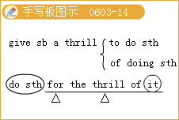
归纳拓展：
get a thrill out of因……而激动
give sb.a thrill to do sth.／of doing sth.做某事让某人感到激动
do sth.for the thrill of it为了寻求刺激而做某事
a thrill of joy / horror一阵欢乐／恐怖
be thrilled at／about／with sth.对某事感到兴奋
a thrilling experience／victory激动人心的经历／胜利
thrilled adj.激动的，兴奋的 thrilling adj.令人激动的，令人兴奋的
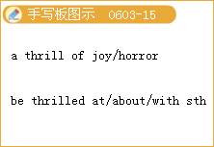

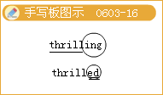
◇[例题6]
（1）It was______that we could find a river when we were very thirsty. Which of the following is wrong?
A.a thrill B.thrilling
C.a delight D.thrilled
[答疑编号911060309]
【答案】C
（2）完成句子：
①她的花容月貌令我一见倾心。
I______her beauty.
②我意识到自己获得了胜利，心里一阵激动。
______,I realized that I won.
[答疑编号911060310]
【答案】①was thrilled by ②With a thrill
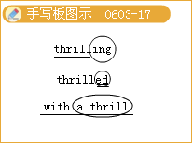
7.Tendency 倾向，趋势（to／towards）
Some people may inherit a tendency to alcoholic.
有些人天生有酗酒的倾向。
Jean’s nice but she has a tendency to talk too much.
简的人品倒不错，就是她总爱唠叨。
We’ve noticed a growing tendency for people to work at home instead of in offices.
我们注意到一种趋势，越来越多的人在家里而不是在办公室里工作。
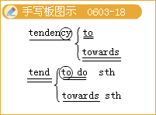
归纳拓展：
have a tendency to／towards do sth.往往会做某事，倾向于做某事
tend to do sth.往往会做某事，倾向于……
tend towards sth.有……的倾向，倾向于……
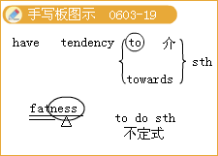
◇[例题7] 完成句子：
（1）她有发胖的趋势。
She has a______fatness.=She has a______ get fat.
（2）物价呈现持续上升的趋势。
Prices continue to show an upward______.
（3）他在冬天经常睡得比较早。
He______to bed earlier during the winter.
（4）她的观点趋向于偏激。
She______extreme views.
[答疑编号911060311]
【答案】（1）tendency towards／to；tendency towards／to
（2）tendency （3）tends towards（4）tends towards
8.refresh vt.消除……的疲劳；使振作精神
He refreshed himself with a glass of water.
他喝了杯水提神。
refresh one’s memory使某人想起，唤起某人的记忆
I looked at the map to refresh my memory of the route.
我看着地图以唤起自己对这条路线的记忆。
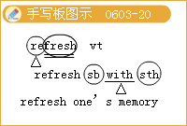

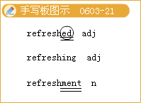
归纳拓展：
refreshed adj.恢复了精神的
refreshing 消除疲劳的；提神的，令人耳目一新的
refreshment （精力的）恢复；（身心的）爽快；食物和饮料
◇[例题8]完成句子：
（1）我睡了一觉就精神了。
I felt______after a sleep.
（2）请再告诉我一次：你是在北京出生的吗?
Just______，were you born in Beijing?
（3）这阵微风令人心旷神怡。
This breeze is very______.
[答疑编号911060312]
【答案】（1）refreshed （2）refresh my memory （3）refreshing
9.polished删.擦亮的，磨光的；精练的，无瑕的
polished rice白米
相关词汇：polish
（1）vt.擦光，擦亮，修改，润饰，润色
Polish shoes regularly to protect the leather.
要经常擦鞋，以保护皮革。
The hotel has polished up its act since last year.
这家酒店自去年以来已经改善了服务水平。
（2）n.①[C，U]擦亮剂；上光剂
We need to buy some black polish for our shoes.
我们需要给我们的鞋子买些黑鞋油。
②[u]优美；高雅；精致；完美
She played the cello with the polish of a much older musician.
她所演奏的大提琴颇有资深音乐家的风格。
polisher n.打蜡机，磨光机
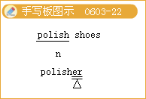
◇[例题9]
The servants______the silver tableware before the guests arrived.
A.polished up
B.polished off
C.pointed out
D.polished with
[答疑编号911060313]
【答案】A
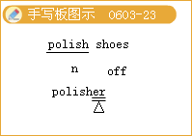
10.vain
（1）full of self-admiration自负的
She is vain about her beautiful blue eyes.
她对自己那双漂亮的蓝眼睛颇为自负。
（2）unsuccessful 徒劳的，无效的，无结果的
a vain attempt to make him change his mind
想使他改变主意的徒劳尝试
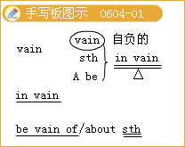
短语链接：
in vain白费；徒劳无益
be vain about／of自以为了不起
vain attempt／hope／effort徒劳的尝试／希望／努力
be vain of sth.对……感到自负
◇[例题10]完成句子：
（1）我不喜欢虚荣心强的女性。
I don’t like______women.
（2）所有的努力都白费了。
All efforts are______
（3）她对自己的美貌很自负。
She is______her beauty
（4）在无鱼的地方撒网是徒劳的。
It is______cast your net where there is no fish.
[答疑编号911060401]
【答案】（1）vain （2）in vain （3）vain of （4）in vain tｏ
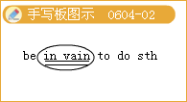
11. serious adj.
（1）（of a person’s manner or character）认真的；严肃的；严谨的；稳重的
（2）not easily or lightly dealt with；not slight严重的；重大的；危急的
经典例句：After a few jokes his speech became serious.
开了几个玩笑之后，他才一本正经地演说起来。
His mother is suffering from a serious illness.
他母亲患了重病。
记忆技巧：
（1）派生词：seriously adv.严肃地，认真地，严重地；seriousness n.严肃，认真，严重
（2）合成词：serious.minded a4心情严肃的，认真的
常用词组：
a serious young man一个严肃的年轻人
a serious warning严重警告
serious illness重病
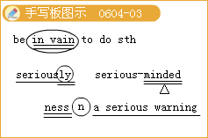
◇[例题11]
（1）Mike，be______Don’t make fun of me.
A.seriously
B.quiet
C.serious
D.angry
[答疑编号911060402]
【答案】C
（2）No one knows how______the danger is.
A.seriotls
B.seriously
C.sad
D.well
[答疑编号911060403]
【答案】A
12.terrify，terrifying与terrified
Speaking in public terrifies me.
在公众面前讲话让我害怕。
It was terrifying to a novice，but quite easy to deal with.
对初学者来说这挺可怕，但其实很容易做。
It was almost terrifying and yet wildly exciting.
这太恐怖了，然而却令人异常激动。
The idea of going down into the caves terrified her.
深入洞穴的想法使她恐惧。
I let out a terrified scream and scuttled down the stairs.
我惊恐地叫了一声，快步跑下楼梯。
He was terrified at the thought of being caught by the police.
一想到会被警察捉住，他就害怕。
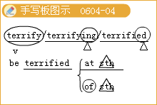
固定搭配：
be terrified at被……吓一跳
He was terrified at the sight.看到这个他吓坏了。
be terrified of…害怕
The old lady was terrified of crossing such a busy road.
老太太不敢过川流不息的马路。
◇[例题12]
She______by his appearance， for she did not finish the task he gave.
A.is terrified
B.was terrified
C. terrify
D.terrified
[答疑编号911060404]
【答案】B
13.Personally，I’m not that keen on that sort of music.
就我个人而言，我不是很喜欢那种音乐
（1）personally adv.
①亲自地；就自己而言
Personally，I'd rather go to the Science Museum.
就我个人而言，我倒愿意去科学博物馆。
All letters will be answered personally.
一切信函都将由本人亲自答复。
②无礼地；冒犯地
I'm sure she didn’t mean it personally.
我相信她绝无冒犯之意。
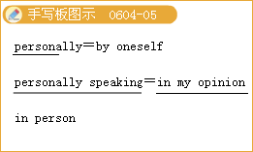
归纳拓展：
person n.令，令人
in person亲自
accept the person of偏爱，偏袒
in the person of以一…的资格，代表
personal 个人的，私人的
personality性格，个性，人格
personalize针对个人
（2）keen热切的，热情的，热心的；（指感觉）灵敏的，敏锐的；（指头脑）敏捷的，精明的；（指感情）热烈的
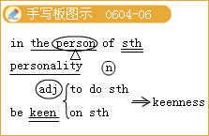
be keen to do sth.渴望做某事
be keen on（especially British English）wanting to do something or wanting
something to happen very much热心；渴望（做某事）；热衷
A number of people in the company were not keen on this new plan.
公司一些人对这个新计划不太热心。
I wasn’t keen on going there on my own.
我不渴望独自去那儿
He has been particularly keen on educational pursuits.
他尤其热衷于教育事业。
keenly adv.激烈地
keenness n.[U]渴望
◇[例题13]
（1）About the recent affairr the minister gave a highly______ remark.
A.personal
B.person
C.personnel
D.personality
[答疑编号911060405]
【答案】A
（2） Is it worth the effort?
______yes
A.Personally sDoken
B.Personally speaking
C.Personal spoken
D.Personal speaking
[答疑编号911060406]
【答案】B
（3）完成句子：
①我的朋友最会发现便宜货。
My friend______for a bargain.
②她已经出院，并急于重返工作岗位。
She’S out of hospital and______to work.
③他肯定迷上她了______他俩整夜都在跳舞。
He must______her—they’ve been dancing all night.
[答疑编号911060407]
【答案】①has a keen eye ②keen ③be keen on
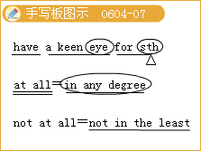
14.Some of the old rock bands are not bad at all.有些老摇滚乐队很好。
at all=in any degree作“完全，根本，丝毫”解，可用在否定句、疑问句、肯定句中，其用法如下：
（1）at all用于否定句中，在否定结构中有两个含义，要根据上下文确定。
①not at all=not in the least表示“一点儿也不”。在句中not可以紧跟动词，at all放在句末。at all用在否定旬中以加强语气。
We don’t know the result of the examination at all.
我们完全不知道考试的结果。
一Are you tired? 你累吗?
一Not at all. 一点也不累。
⑦Not at all.=You are welcome.=That’S all right.
表示“不用谢，不客气
（2）at all用于肯定句和疑问句中起强调作用，带有较强的感情色彩，意为“到底，真的，竟然”。
I'm surprised at his passing the examination at all.
他居然通过了考试，我真感到奇怪。
What did you do at all?
你到底干了些什么?
（3）at all用于条件句中，意为“既然，果真”。
Do it well if you do it at all.
既然做这件事，那么就把它做好。
◇[例题l4]There were twenty______in the group.
A.after all
B.all over
C.at all
D.in all
[答疑编号911060408]
【答案】D
15.to be honest说实在的，说实话
To be honest.it was one of the worst books I've ever read.
说实在的，那是我读过的最糟的书之一
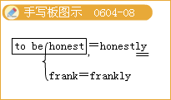

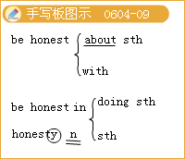
归纳拓展：
Honest 诚实的 honesty n.诚实honestly adv.诚实地
be honest about… 对……说老实话
be honest with…对……说老实话
be honest in sth.／doing sth.在（做）……方面诚实（诚恳）
友情提示：honestly置于句首加逗号，相当于to be honest；也可以置于句末，用逗号与句子隔开。
◇[例题l5] （1）句型转换：
What I really think is that she is interested in Mike only because of his money. ______，she is interested in Mike only because of his money
[答疑编号911060409]
【答案】To be honest
（2）完成句子：
说实话，这本书没有我期望的那么好。
______，the book isn’t as good as I expected.
[答疑编号911060410]
【答案】To be honest
Lesson 3
1.cheerful adj.高兴的，快乐的，令人高兴的
相关词语：cheer 执（使）振奋，（使）高兴；欢呼，喝彩；振奋，欢呼，喝彩
词汇链接：cheerfully adv.高高兴兴地；
cheerfulness高兴
cheerily adv.快活地，兴高采烈
cheering玩喝彩，欢呼；令人高兴的；
Cheers干杯。（英式口语）谢谢／再见。
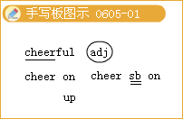
常用搭配：
cheer on鼓励cheer sb.on激励某人
cheer oneself hoarse欢呼时喊哑嗓子
cheer sb to the echo对某人大声喝彩
cheer up使振奋，感到振奋
The good news of our football team winning the game cheered up everybody who heard it.
我们足球队获胜的喜讯使每一个听到的人都感到高兴。
◇[例题1]
完成句子：
①尽管她身体不舒服，但她仍极力保持精神愉快。
Despite feeling ill，she managed______.
②他欢快的微笑说明他很开心。
His______suggests that he is happy.
[答疑编号911060501]
【答案】①to keep cheerful ②cheerful smile
2.Elegant adj.优美的，文雅的，讲究的；简练的，简洁的
Godfrey is an elegant and successful gentleman with many lady admirers.
戈弗雷是一位高雅的成功绅士，深受许多女士的青昧。
This is an elegant solution to the problem.
这才是解决这个问题的简要方法。
an elegant woman优雅的女人
an elegant style of writing
优美的写作风格
He always dresses elegantly.
他总是穿得很讲究。
3.Endless adj.无穷无尽的，极大的，无限的
The journey seemed endless.
这段路程似无尽头。
I'm fed up with your endless complaining.
我对你没完没了的牢骚讨厌极了。
The endless meetings and interviews made me bored.
没完没了的会议和采访真是把我烦透了。
归纳拓展：
endless是end加一less后缀构成的形容词，此类形容词还有很多，如：
homeless无家可归的hopeless没有希望的
useless无用的penniless不名一文的，一贫如洗的
priceless无价的harmless无害的
tireless不知疲倦的
countless无数的
◇[例题3]
（1）She is a woman with______patience.
A.ending B.endless
C.enoilnous D.large
[答疑编号911060501]
【答案】B
（2）完成句子：
①他身元分文，因此他不可能买得起这么贵的车。
He is______，so he can't afford such an expensive car.
②在很多场合中，他表现得很差。
______occasions，he behaved badly.
[答疑编号911060503]
【答案】 ①penniless ②On countless
4.Freeze v.（froze，frozen）（使）结冰，（使）凝固；（口语）站住不动
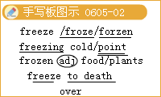
It's freezing here—can't we shut a few windows?
这里太冷了，我们就不能关上几扇窗子吗?
Come inside，you must be freezing to death.
进来，你一定冷得要死。
归纳拓展：
freeze to death冷得要死
freeze over冰封，封冻
freeze one's blood使充满害怕、恐怖的感觉
freezing也可作名词
常用搭配：freezing cold寒冷，冰冷
freezing point冰点
拓展:frozen n出冰冻的，冻僵的
frozen food冷冻食品
frozen plants冻硬的植物
◇[例题4]
（1）The driver was half______to death when he got to a faraway station.
A.freezing B.freeze
C.frozen D.frozen cold
[答疑编号911060504]
【答案】C
（2）完成句子：
①里边很冷，因此你最好穿上外套。
It's______inside so you'd better put on your coat.
②一看到那个持枪的蒙面人，我就吓得浑身冰凉。
The sight of that masked gunman______.
③有个人在山上冻死了。
A man______on the mountain.
④水在0℃时结冰。
Water______at 0℃.
[答疑编号911060505]
【答案】①freezing ② froze my blood/made my blood freeze
③ was frozen to death ④ freezes
5.Before my bed a frost of light.床前明月光
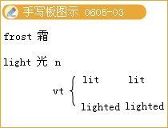
（1）frost／frost／m霜，降霜；霜冻，严寒
经典例句：The grass was covered with frost in the early morning.
清晨草上满是霜。
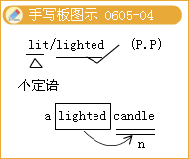
（2）light （1it／lighted，lit／lighted）们.点燃；点火；谯.照亮；光（亮）；[C]灯（光）；明亮的；浅色的；轻的，轻松的
经典例句：The sun gives US light during the day.
白天太阳给我们光亮。
The basket is very light；I can easily pick it up.
篮子很轻，我可以很容易地拿起来。
考点聚焦：lighted可以作定语，lit不可以。
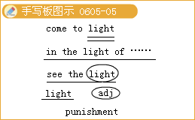
常用搭配： come to light暴露 in the light of根据，按照
see the light领会 light punishment轻微的处罚
◇[例题5]
（1）The field was covered with______ in the early morning.
A.forest B.fost
C.frown D.flame
[答疑编号911060506]
【答案】B
（2）Don't throw the______match onto the floor.
A.1ight B.1ighted
C.1it D.1ighting
[答疑编号911060507]
【答案】 B
（3）Her face______when hearing the good news.
A.1ighted B.1it up
C.1it D.1ighted on
[答疑编号911060508]
【答案】B
6.Head bent，in homesickness I am drowned.低头思故乡
head bent为独立主格结构作状语。
（1）bend （尤指身体或头部）（使）倾斜，偏向；（使四肢等）变弯，把……弄弯；（使）拐弯，弯曲；缎（把目光、精力等）集中于；口文集中精力；屈服，顺从
He bent towards me and whispered in my ear.
他俯下身来对我耳语。
Bend your knees，keeping your back straight.
膝盖弯曲，背部挺直。
I'll bend the branches back so that you can get through.
我把树枝向后弯一下，让你过去。
The river bends to the east.
这条河折向东流。
All eyes were bent on me.
大家都瞧着我。
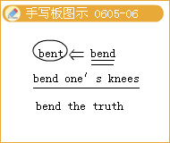

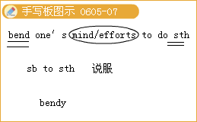
归纳拓展：
bend the truth扭曲事理，歪曲事实
bend one's mind／efforts to sth.致力于某事，专心致志于某事
bend sb.to sth.说服：迫使
注意：bendy 易弯曲的；易折的
（2）homesickness想家，思乡
Because of homesickness，he took out the picture of his whole family.
因为想家，他拿出了他的全家福照片。
注意：homesick 思乡的，想家的.
（3）drown vt.淹没，浸泡，（把声音）盖过，淹死，溺死；vi.淹死，溺死
经典例句：Don't play by the river in case you fall in and drown!
不要在河边玩耍，以免你掉到河里淹死!
The floods drowned the whole village and villagers had to move away.
洪水把整个村庄给淹没了，村民不得不迁徙。
His voice was drowned out by the traffic.
他的声音被来往的车辆淹没了。
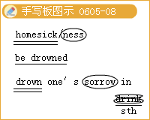

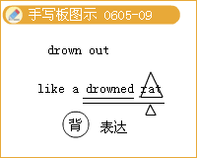

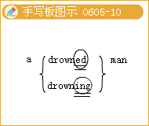
常用搭配：
drown one's sorrow in drink借酒浇愁
drown one's sorrows（troubles）（借酒）浇愁，使忘掉烦恼
drown out（以更大的声音）压过；盖没；淹没
（1ook）like a drowned rat湿得像个落汤鸡
a drowning man一个快要淹死的人
a drowned man一个溺死的人
◇[例题6]
（1）When I entered her room，she______ her desk______a letter.
A.was bent on；writing
B.was bending over；writing
C.bent；to write
D.was bent over；to write
[答疑编号911060509]
【答案】A
（2）完成句子：
①他把铁丝折成圆形。
He______the shape of a circle.
②在管子上把要弄弯的地方做个标记。
Mark on the pipe where you want to______it.
③你撒谎，你完全是在歪曲事实。
You are telling a lie.You are completely______.
[答疑编号911060510]
【答案】 ①bent the iron wire into ②bend ③bending the truth
（3）Being away from home so long a time，I felt______very much.
A.homesickness B.homesick
C.homesickly D.missing
[答疑编号911060511]
【答案】B
（4）The noises in the street______the teacher's voice.
A.filled B.enormous
C.drowned out D.entertained
[答疑编号911060512]
【答案】C
（5）完成句子：
①我的女朋友什么也没说就离我而去，我只有借酒消愁。
My girlfriend left without saying a word so I had to______
②她开大收音机的音量以压过来往车辆的嘈杂声。She turned up the radio______the noise of the traffic.
③当我回到家时，我已湿得像个落汤鸡了。
When I mxived home，I looked______.
[答疑编号911060513]
【答案】 ①drown my sorrow in drink ②to drown out ③like a drowned rat
7.The stockings had been hung长袜已经挂起来了
With attention and care小心翼翼地
In the hope that Santa带着这样的希望
Soon would be there.圣诞老人很快来到
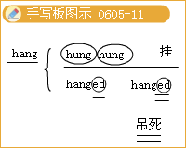

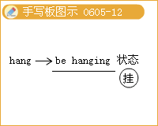

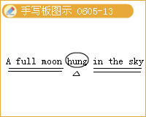

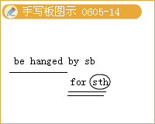

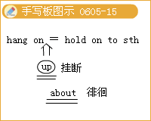
（1）hang v.（hung，hung）悬挂；吊着；挂着；
vt.（hanged，hanged）绞死；吊死；上吊
A full moon hung in the sky.
圆圆的月亮挂在天上。
He was hanged for murder.
他因杀人而被绞死。
The old tree in Jingshan Park，from which Ming Emperor Chongzhen hanged himself，was cut down in the 1960s.
景山公园里的那棵古树在20世纪60年代被砍掉了，明朝的崇祯皇帝就是在这棵古树上吊死的。
常用搭配：
hang up挂断电话
hang about闲荡，徘徊，逗留
hang on抓紧不放
hang on to紧握住；坚持下去不放弃
考点聚焦：hang不同意义时过去分词不同。
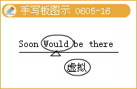
（2）would 以（will过去式）（假设）将会
用法：①当would用于陈述语气电表示过去将来时，可表示有意识的行动或将要发生的事或动作。
I said l would do my best.
我说过要尽我最大的努力。
②当would用于虚拟语气的主句中，且主语是第二、三人称时，表示行动与事实相反。主语是第一人称时，表示事与愿违或只表示设想的意志。
If you were a bird，you would fly.
如果你是一只鸟，你就会飞了。
If I had had a chance.1 would have tried.
如果我有机会，我早就尝试了。
③当would用于虚拟语气的从句中，提出条件时，不管主语是什么人称，would一概表示意愿或有意志的行动。
If you would only work harder，you would be sure to succeed.
你只要工作再加一把劲，你一定会成功的。（指现在）
If you would have done so，you might have been successful.
假使你当时愿意这样做的话，说不定你已经成功了。（指过去）
④当would用于虚拟语气的句子中但不提条件时，表示委婉语气。
Would you please show me the way?
请你给我指一下路，好吗?
⑤当would用于某些状语从句中，表示虚拟。
They left for fear that they would meet him.
生怕会见到他，他们就离去了。
would better（do sth.）最好，应该
would rather（do sth.／that—clause）宁愿，宁可
would like to do sth.想做某事
would like sb.to do sth.想要某人做某事
◇[例题7]
（1）The judge declared that the criminal would be______the very day.
A.hang B.hanged
C.hung D.hunged
[答疑编号911060514]
【答案】B
（2）He hesitated for a moment before kicking the ball，otherwise he______a goal.
A.had scored B.scored
C.would score D.would have scored
[答疑编号911060515]
【答案】D
（3）---How's your tour around the North Lake?Is it beautiful?
---It______be，but it is now heavily polluted.
A.will B.would
C.should D.must
[答疑编号911060516]
【答案】C
8.My wife，wearing a scarf，我的妻子围着围巾，
And I，wearing a cap，我戴着帽子，
Had just settled ourselves刚刚安顿好自己
For a long winter nap.享受一个冬日长长的睡眠。
（1）just adv.正好，恰好；刚刚，刚才；仅仅是，只不过；公正的，公平的；合理的，有充分根据的
经典例句：
It is just what l wanted.
这正好是我要的东西。
I was just a child then.
那时我只是一个孩子。
They made a just decision.
他们作出了公正的判决。
This is a just demand.
这是一个合理的要求。
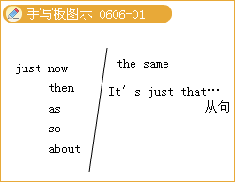
短语链接：
just now刚才；此刻，现在
just then就在那时
just as正像，就……的样子；正当……时
just so正是如此
just about差不多，几乎；正是……附近
just the same照样，尽管……还；完全一样
It's just that…只是因为……
（2）settle 安定，安顿；停息；定居；解决，调停；结算，支付
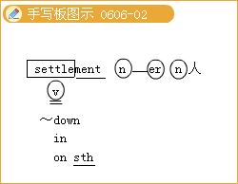
经典例句：
This medicine can settle your nerves.
这药能镇静你的神经。
The old man hoped his son would marry and settle down.
那位老人希望儿子能结婚并安定下来。
单词积累：
settler n.移民者，殖民者
settlement n.解决，处理；移民，殖民
短语链接：
settle down舒适地坐下或躺下，使……平静；安顿
settle in习惯于，适应；安顿下来
settle on sth.选择某事物，决定（做）某事
（3）long长的，远的；长期的；秽.渴望，极想
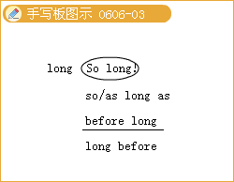

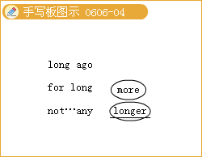

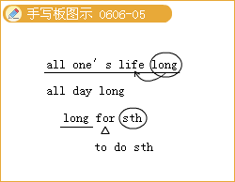
经典例句：
I'm longing to see you.
我渴望见到你。
I long for him to stay.
我希望他留下来。
短语链接：
as／so long as只要；既然，由于
before long不久以后
long before在……很久以前
long ago很久以前
for long长久地
not…any longer=no longer不再
all one's life long一辈子
all day／night long整列梗
so long只要；长久地；不再；再见
long for sth.渴望得到……
long to do sth.渴望做某事
the long and the short实质是如此，总而言之
◇[例题8]
（1）Judge Nathan has a good reputation for being______.
A.just B.fair
C.impartial D.justice
[答疑编号911060601]
【答案】 A
（2） ______things，he began to think over the next subject.
A.Settling down B.Having settled down C.Settled down D.To settle down
[答疑编号911060602]
【答案】B
（3）The children______the festival because then they can get many gifts.
A.1ong for B.for long
C.ask for D.1odge
[答疑编号911060603]
【答案】A
（4）完成句子：
①不久她就要高中毕业了。
It won't be______she graduates from high schoo1.
②征服者将其人民迁移到这块土地上。
The conquerors______their own people in the land.
③你得到了应得的报酬。
You have reeeived______.
[答疑编号911060604]
【答案】①before long ②settled ③ a just reward
9.And then，in an instant，突然，一瞬间，
I heard on the roof我听到屋顶上
The stepping and scratching每一只小蹄儿的
Of each little hoof.踏步和摩擦声
（1）roof n.structure covering or forming the top of a building or vehicle，屋顶，房顶；车篷，车顶
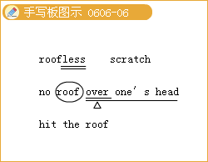

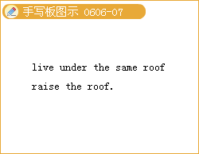
词汇链接：roofless无屋顶的；无家可归的
常用搭配：
no roof over one's head无家可归
hit the roof（美式口语）勃然大怒
live under the same roof住在一起
raise the roof喧闹不休，（在屋内）吵翻天，大声抱怨
（2）scratch 搔，抓，扒；涂写；n.搔，抓，抓痕
Peter scratched his head，saying slowly.
彼特挠着头，慢吞吞地说。
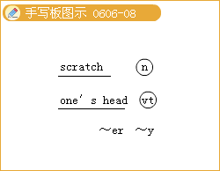
记忆技巧：派生词：scratcher凡.抓扒者；抓扒用具；
scratchy （书写等）潦草的，乱涂的
◇[例题9]
（1）Kate finds herself without a______over her head.
A.roof B.home
C.house D.room
[答疑编号911060605]
【答案】A
（2）The cat______the door because it wanted to go in
A.scratched B.watched
C.rubbed D.grasped
[答疑编号911060606]
【答案】 A
10.As I pulled in my head，当我伸直脑袋
And was turning around，四围转动时
Down came stout Santa胖胖的圣诞老人下来了
In a single bound.只是一跳
（1）single 仅一个的；唯一的
separate；considered by itself分别的；各自的（蔓）.
unmarried独身的；未婚的
or the use of only one person单人的
经典例句：
The teacher personally know every single student in the class.
那位老师对班上每一个学生都很了解。
（2）stout adj.（常作定语）粗壮的，结实的；指人相当胖的，强壮的
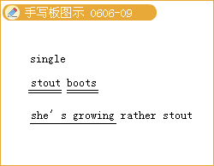
stout boots for climbing登山用的结实的靴子
She's growing rather stout.
她渐渐富态了。
◇[例题10] （1）The new furniture cost us every______penny we had.
A.sole B.single
C.only D.unique
[答疑编号911060607]
【答案】B
（2）完成句子：
His girlfriend is growing______ （胖了）.
[答疑编号911060608]
【答案】stout
11.His oval eyes shined他椭圆形的眼睛在闪烁
And his face looked so merry!他的面上看上去这样快乐!
His cheeks were like roses一他的双颊像玫瑰——
His nose like a cherry!他的鼻子像樱桃!
（1） oval 椭圆形的；n.椭回形（物），卵形
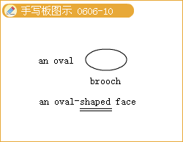
an oval brooch椭圆形胸针
an oval.shaped face鹅蛋脸
The mirror is oval.
镜子是椭圆形的。
The playing field is a large oval.
运动场很大，呈椭圆形。
（2）like喜欢；希望，愿意,想要（常与should／would连用）；
prep.像，跟一…一样；
conj.如同，像；一样；相似的，相同的（more like，most like）
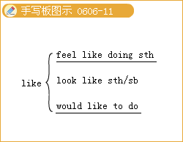
经典例句：
There are several people interested，like Mr. Jones andMr. Simpson.
许多人都有兴趣，诸如琼斯先生和辛普森先生。
常用搭配：
feel like想要
look like似乎，好像
feel like doing想做
would like to do愿意做
◇[例题11]
（1）完成句子：
大厅的中间有一个椭圆形的桌子。
There is______in the middle of the hall.
[答疑编号911060609]
【答案】 an oval table
（2）I______to give all my life to the cause of education
A.will like B.should like
C.feel like D.shall like
[答疑编号911060610]
【答案】 B
（3）---My family usually goes skating for vacation.I like skating，but l want to try something different this year.
--- ______
A.Let's go B.Cheer up
C.Like what? D.Take care.
[答疑编号911060611]
【答案】 C
12.After looking around环顾四周后
And scratching his nose，揉揉鼻子，
He gave a nod他点了点头
And up the chimney he rose.顺着烟囱升上去
（1）nod点头，点头招呼弘打盹，打瞌睡
经典例句：
The student nodded to me as she passed.
那个学生从我身边经过时向我点头致意。
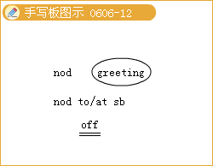
常用搭配：
nod to／at sb.向某人点头
nod off睡着
（2）up／Ap／prep.向上；adv.起床，起来；（从静止到活动）……起来；（从活动到结束）
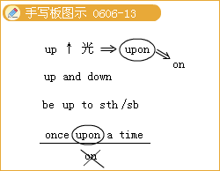
up and down上下波动，来回，时好时坏
up to sth.直到；忙于；适于
be up to sb.由某人决定（承担，负责）
upon prep.在……上（upon与on同义，可互换,upon较少用于口语中；0nce upon a time中不用on替换）
◇[例题12]
（1）When being asked about his opinion，he said nothing but______approval.
A.signed B.body
C.waved D.nodded
[答疑编号911060612]
【答案】 D
（2）--Smoking is bad for your health.
--Yes，I know.But I simply can't______.
A.give it up B.give it in
C.give it out D.give it away
[答疑编号911060613]
【答案】A
13.It conveys the poet's sadness at being far from his home and family.
它表达了诗人远离家乡和亲人的悲痛之情
convey
（1） 传达；传递；传播：
A good slogan should convey a message oridea.
一个好的口号应该传达一种信息或理念。
（2）转让：
My aunt has conveyed her house to me.
我阿姨已经把她的房子转让给我了。
（3）搬运；运送：
Your "luggage will be conveyed to the hotel by taxi.
你的行李将由出租车送到酒店。
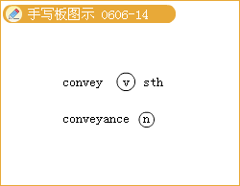
归纳拓展：
conveyance n.传达，运送；转让；[法律]产权转让书
◇[例题13] 完成句子：
（1）管子把热水从锅炉输送到散热器里。
Pipes——hot water——the boiler______the radiators.
（2）言辞无法表达我内心的喜悦。
Words cannot convey______I was.
（3）请向您父母转达我的祝愿。
Please______my wishes______your parents.
（4）他的律师给他拟了一份产权转让书。
His lawyer______a ______for him.
[答疑编号911060614]
【答案】 （1）convey；from；to （2）how delighted
（3）convey；to （4）drew up；conveyance
14.in an instant立即，马上
I will be back in an instant.
我马上就回来。
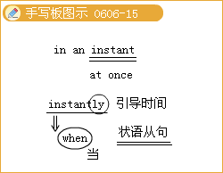
归纳拓展：
instant n.瞬间，片刻；立即的，立刻的；速溶的，方便的
instantly adv.立刻，马上
the instant／the moment／the minute.
I recognized her the instant（that）I saw her.
我一看见她，就认出她了。
◇[例题14]
______I saw him，I knew he was the very man that the police were looking for.
A.The instant B.The moment
C.Immediately D.Instantly
[答疑编号911060615]
【答案】 D
Lesson 4 Communication Workshop
1.A Film Review电影评论（影评）
Review 评论；复习，回顾
The play got splendid and excellent review.该剧受到了高度的、极好的评价。
a review copy供评论用的赠阅本
a scientific review科学期刊
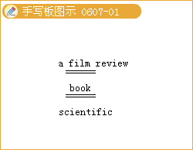
◇ [例题1] This magazine consists mainly of ______of new books and plays.
A.advice B.comments
C.collections D.reviews
[答疑编号911060701]
【答案】D
2.summary n.总结；概括；概述；adj.总结性的；概括的，从速从简的；草草的；速决的，立即的；当场
I made a summary report for the records.
我对记录内容作了简要报告。
On his desk，there is a two-page summary of a government report.
在他的桌上，有一份两页的政府报告摘要。
Any employee caught stealing faces summary dismissal.
任何被发现偷盗的雇员都会被当场解雇。
归纳拓展：
in summary总的来说
summarily adv.草草地；从速从简地
summarize v.总结；概括；概述
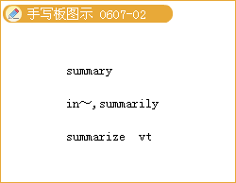
◇[例题2] ______，this was a ______performance.
A.In all；disappointing
B.In all：disappointed
C.In summary；disappointing
D.In summary：disappointed
[答疑编号911060702]
【答案】C
3.base 基础，基地，根据地；基于；以……为根据
The company has its base in New York，and branch offices all over the world.
公司总部设在纽约，分部遍及全世界。
They based their estimate on the figures for the last five years.
他们以过去五年的数字为根据进行估算。
归纳拓展：
base sb.／sth.／oneself in... 以……为据点，把（总部等）设在……
base sth.on／upon…以……为基础
be based on… 以……为根据
on the basis of在……的基础上；根据…
词汇链接：
based （以某事）为基础，为根据；在……居住（或工作）；基地（或总部）在…
basic 基本的；基础的
basically adv.大体上，基本上；总的说来；从根本上说
basics n.基本因素；基本设施；基本需要
basis n.原因；缘由；基准，准则；基础，要求；基点
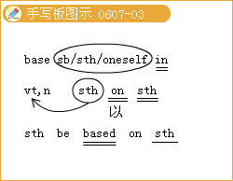

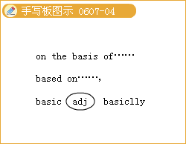
◇[例题3] （1）完成句子：
①意见应该总是以事实为依据。 One should always ______on facts.
②这部电影以现实生活中的一件事为基础。The movie ______a real—life incident.
③总的说来，我们能为此做很多事。 ______，there's a lot we can do about it.
④雇主不允许有性别歧视。 Employers are not allowed to discriminate ______sex.
[答疑编号911060703]
【答案】① base one's opinion ②is based on ③Basically ④ on the basis of
（2）Scientific theories must ______facts.
A.base on B.be base on
C.be based on D.be based in
[答疑编号911060704]
【答案】C
4.Her sisters，Felicie and Adelaide，are nasty and treat Beauty as a servant.
她的姐妹费利西娅和阿德菜德非常恶毒，并且把她当仆人对待。
Treat v.对待，处理；医疗，治疗；款待，请客
经典例句：Don't treat me as a child.别把我当小孩看。
She treats everything I say as some kind of joke.
她把我说的每一件事都当成是某种玩笑。
We treated him to an ice cream. 我们请他吃冰淇淋。
归纳拓展：
treat…as／like…以……态度对待；以……方式对待
treat sb.with respect尊敬某人
treat sb.to sth.请某人吃饭；款待
treat sb.for an illness治疗某人的病
相关词汇：treatment n.疗法，处理方法；治疗；对待的方法或态度
经典例句：He's gone to hospital in London for special treatment.
他到伦敦的医院接受特别治疗。
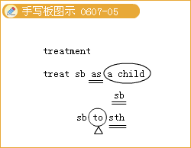

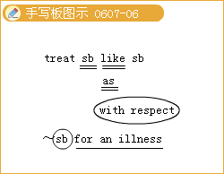
◇[例题4]
（1）He's gone to hospital in Beijing for special ______，and there they have good medical care.
A.training B.cure
C.disease D.treatment
[答疑编号911060705]
【答案】D
（2）完成句子：
①我请每一个孩子吃个苹果。 I ______each of the children ______an apple.
②该书探讨有关经济发展的问题。
The book ______the problems of economic development.
③我把她当作家人来看待。 I ______her______one of the family members.
④马戈特尽管是长辈，但从未受到多少尊重。
Despite her seniority，Margot ______ never ______ much respect.
[答疑编号911060706]
【答案】 ①treated；to ②is treated ③treated；as ④was；treated with
5.The owner of the castle is all abnormal creature，half-man，half-beast，who tells the merchant-either one of his daughters replaces him as a prisoner in the castle，or he will die.
那个城堡的主人是个畸形的动物，半人半兽，他告诉那位商人，他的任一个女儿可以替他作为囚犯待在城堡里，否则商人就要死。
（1）abnormal adj.反常的，不正常的；不规则的
记忆技巧：
①反义词：normal，一为前缀，表示“偏离”,“离开”的意思。
②派生词abnormality n.反常，变态，畸形；abnormally adv.反常地，例外地 abnormal weather反常的天气
（2）creature n.生物（人或动物）
What a lovely creature! 多么可爱的家伙!
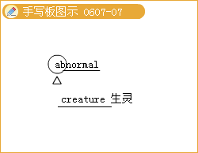
◇[例题5]
（1）An ______amount of rain fell in October.
A.irregular B.abnormal
C.unusual D.innolmal
[答疑编号911060707]
【答案】B
（2）She is a pretty ______.
A.animal B.beast
C.creative D.creature
[答疑编号911060708]
【答案】D
6.Beauty offers to replace her father and be trapped in the castle.
贝蒂主动提出替代父亲，于是她身陷城堡
trap陷阱，圈套；诱捕，使中圈套；困住；使陷于危险中
a mouse—trap老鼠夹 be caught in a trap落入陷阱
trap sb.into（doing）sth.诱骗某人做某事
be trapped in…被困在……中
Thirty miners were trapped underground. 30名矿工被困地下。
We was trapped into signing a confession.我们被诱骗在供词上签字了。
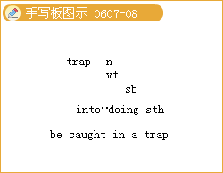
◇[例题6]
（1）完成句子：
①电梯出故障了，我们困在里面出不来。
The lift broke down and we ______inside it.
②窃贼被警方用计擒获。The thief was caught ______a police ______.
[答疑编号911060709]
【答案】①were trapped ②in；trap
（2） ______between the two tracks，the little car couldn't move a bit.
A.Trapped B.Being trapped C.Trapping D.To be trapped
[答疑编号911060710]
【答案】A
7.The film deals with the theme of appearances in a very interesting and clever manner.电影用一种很有趣而且聪明的方法来处理人物的外貌这一主题。
deal
（1）处理，对付
How did you deal with the box? 你是如何处理这个箱子的?
He is easy to deal with.他很好对付。
（2）涉及，论及；讨论
The book deals with the troubles in Ireland. 这本书涉及了爱尔兰的各种纠纷。
（3）跟…做生意，与……交易
I've dealt with this company for 20 years.我跟这家公司做生意已经20年了。
指点：do with与deal with的意思相同，但用法不同；do with与what连用，而deal with与how连用。
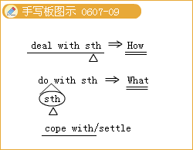
◇[例题7]We all know that，______，the situation will get worse.
A.not if dealt carefully with
B.if not carefully dealt with
C.if dealt not carefully with
D.not if carefully dealt with
[答疑编号911060711]
【答案】B
8.In one vivid scene.Beauty looks in the mirror and her face is transformed into the Beast's.有一个精彩的场面，贝蒂照镜子发现她的漂亮脸蛋变成了野兽的。
transform转变，变形；变革
经典例句：
She used to be terribly shy，but a year abroad has completely transformed her.
她过去十分腼腆，但在国外待了一年以后完全变了。
词汇链接：transformable碱可改变外观或性质的；
transformation n.（外观或性质的）改变，改观，转变；
transformer n.变压器
搭配：transform sth.／sb.from sth.把……从……改变为
transform sth.／sb.into sth. 把…改变成
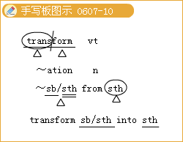
◇[例题8]In only 20 years，the country has ______into an advance industrial power.
A.translated B.degraded
C.declined D.transformed
[答疑编号911060712]
【答案】D
9.The film also uses some other clever special effects.
这部电影也使用了一些其他巧妙的特技效果。
effect 产生；结果，效果，影响，作用
经典例句：
A word from the teacher will have a great effect on my son.
老师的一句话会对我的儿子起很大的作用。
词汇链接：effective有效的；effectively 有效地，实际上，事实上
常用搭配：
come into effect实行，开始实施 for effect为了外表好看；为了给人某种印象
have an effect（on／upon）（对…）有影响 in effect有效；实际上，事实上
take effect生效，奏效 color effects色彩效果
evil effect恶果 a fatal effect不幸的后果
sound effects音响效果 speak with（without）effect说话有（没有）效力
辨析：effect与result
effect严格强调因果关系；指和cause直接相对应的结果；result是普通用语，指直接或间接，近因或远因所引起的结果。
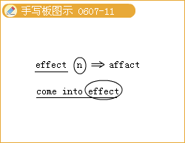

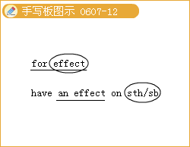

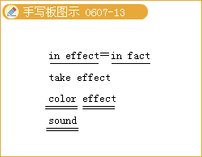

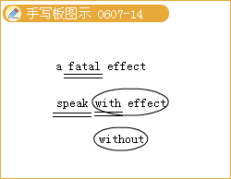

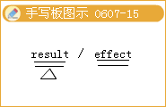
◇[例题9]
（1）The farmer felt the ______of the drought for years
A.effort B.efficient
C.effect D.effective
[答疑编号911060713]
【答案】 C
（2）完成句子：
①新税率从4月起生效。 The new tax rates ______onon April
②实际上，我们的工资将下降2%。 ______，our wages will fall by 2%。
③我试图说服他，但却无济于事。I tried to persuade him，but with little or ______.
[答疑编号911060714]
【答案】①come into effect ②In effect ③no effect
10.For example，when Beauty is walking back and forth while waiting for the Beast to visit her room，you can see a statue's head following her movements!
比方说，当贝蒂来回走动等待野兽拜访她的房间时，你可以看到一个塑像的头随着她而动!
（1）statue 塑像，雕像 一
记忆技巧：按派生词和形近词记忆
statuette小雕像，小塑像；stature身高
（2）follow跟随，接着；沿着，顺着…走；听懂，理解；听从，遵循
经典例句：You must follow the teaching of your teachers.
你们必须听从老师们的教导。
常用搭配：
as follows如下 follow after追求；力求达到（或取得）
follow out贯彻，执行 follow up把…探究到底
follow the advice遵照嘱咐 follow the example of…以…为榜样
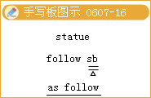

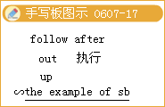
◇[例题10]
（1）She stayed with us until the ______afternoon.
A.tomorrow B.fling
C.following D.forthcoming
[答疑编号911060715]
【答案】C
（2）Millions of tourists come into New York to visit the ______of Liberty.
A.Statue B.Sculpture
C.Stature D.Portrait
[答疑编号911060716]
【答案】A
11.In addition，the whispering furniture is as frightening as anything in modern films.另外，小声讲话的家具像现代电影里任何东西一样令人害怕。
whisper 低语；耳语
You must whisper or he'll hear.你得小点声儿说，否则他会听到的。
She leaned over and whispered something in his ear.
她探过身去附耳跟他说了些什么。
（1）vi.（树木等）沙沙；（风）飒飒
The pines are whispering.松树沙沙作响。
（2）vt.私下说；悄声暗示
It's whispered that his father was once in a prison.
私下里传闻说他父亲曾经坐过牢。
（3）n.私语；耳语；低语；传闻；谣言；沙沙声；飒飒声
They were talking in whispers.他们在说悄悄话。
I have heard a whisper that he's going to resign.
我听到一个传闻，说他准备辞职。
The whisper of those trees makes me afraid.那些树的沙沙声让我感到害怕。
用法归纳：
whisper（about）sth.／sb.
They are whispering about her.他们正在私下说她。
whisper sth.to sb.：He whispered the news to me.他私下告诉我这个消息。
whisper to sb.sth.：
She whispered to her mother the thing which she happened to see on her way home.
她对她妈妈耳语，说了这件在回家路上巧看到的事。
whisper that：
Some clerks were whispering that the manager was no longer in control.
一些职员在窃窃私语，说经理不再掌权了。
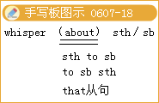
◇[例题11] I spoke in a ______，so she couldn't hear what I said.
A.cheer B.voice
C.silence D.whisper
[答疑编号911060717]
【答案】D
12.Although it is in black and white，the striking use of light makes it seem at times like a moving painting.尽管电影是黑白的，但是引人注目的灯光效果使电影不时地看起来像感人的素描
（1）strike （struck，struck） 敲，击；（钟）打点，鸣；打动，给……以深刻印象；（灾害等）突然袭击；（蛇、兽）咬，抓；忍.[C]罢工
经典例句：
The footballer took a strike at the goal. 那个足球运动员飞脚射门。
The stone struck me on the side of the head.石子打中了我头部的侧面。
Strike while the iron is hot.趁热打铁。
词汇：striker玩罢工的人；（足球）前锋；（板球）击球手；
striking引人注目的，显著的；
strikingly adv.非常地
搭配：go on strike罢工 strike down击倒，杀死
be on strike在罢工 strike at sb.／sth.向……打去；
strike sb.on the head打某人的头 strike a match划火柴
（2）painting n绘画，油画；涂漆（painting指着色的画；drawing指黑白色的线条画，素描；portrait指肖像，生动写照）
Hanging on the wall was a splendid painting.挂在墙上的是一幅华丽的油画。
相关词语：paint涂，涂漆；画；描绘，描述；n.油漆，颜料
记忆技巧：
按合成词记忆：paint box颜料盒；paint brush画笔； Painter n.画家；油漆工
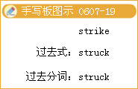

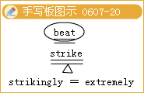

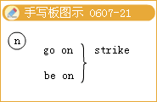

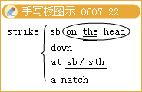

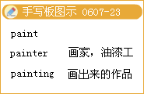
◇[例题12]
（1）The younger of the two noblemen was ______by the young lady's beauty.
A.struck B.stuck
C.beat D.hit
[答疑编号911060718]
【答案】A
（2）Her parents painted the door ______a bright color.
A / B.being
C.to be D.as
[答疑编号911060719]
【答案】A
（3）His letters ______a wonderful picture of his visit to that country.
A.write B.paint
C.describes D.painting
[答疑编号911060720]
【答案】B

