Unit 15 Learning

Warm-up
Make connections between words, e.g.scarf, hat （clothes）.
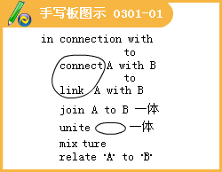
Lesson 1
1.Nowadays, more and more people of various ages and backgrounds are continuing to study to improve themselves.
2.Here's what they have to say about their life-long learning experience.
3.Sun Wen --28 years old "It's never too late to learn."That was the advice I got after I failed my College entrance exam.
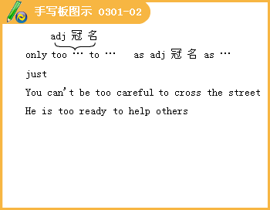
4.Now I'm about to graduate from the School of Continuing Education at Qinghua University with a Bachelor's Degree in Computer Engineering by distance learning.
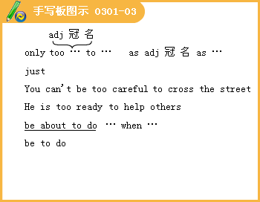
5.In the past, if someone like me had failed to get into university through the college exam, he would have had no chance of getting a degree.
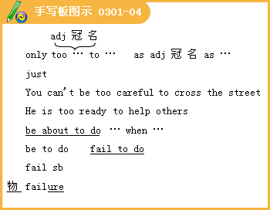
6.But it's different now.I decided to give myself a second chance by studying for a degree in the evenings and on weekends while keeping a secure full-time job.
7.Frankly speaking, the last four years have been hard work, but it's been worth it!
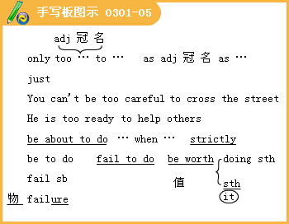
8.Ms Tang -45 years old
Three months ago, when my manager told me that I would be laid off, my mind went blank and my heart swelled with anger.
9.In the past, if someone had worked for a company for over 20 years, they would have stayed there until retirement!

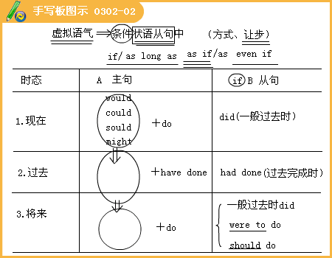
10.I suspect that they laid me off because the company was not doing that well but it still brought a lump to my throat and made me want to cry.
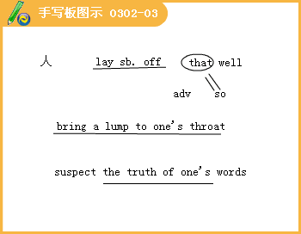
11.I felt as if I had done something wrong!
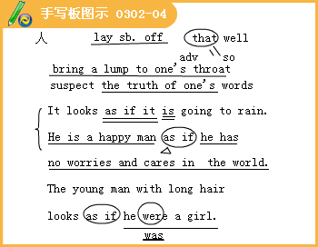
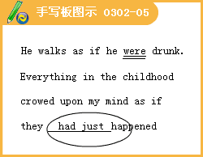
12.I know this isn't true though.
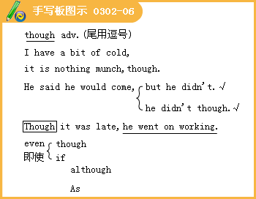
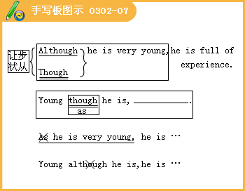
13.At first, I enjoyed being a full-time housewife and called myself "CHO"or "chief home officer".
14.But soon I got bored and decided to do a business course.
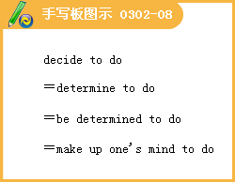
15.I think that getting laid off will prove to be the best thing that ever happened to me.
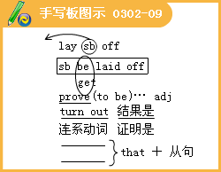
16.Grandpa Chen --75 years old I'm sure you all know the saying, "You can't teach an 01d dog new tricks."
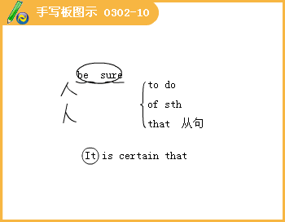
17.It all started a few months ago when postage went up.
18.I'd been sending letters by airmail to my daughter in the US once a week, but, suddenly, it was too expensive.
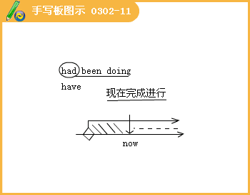
19.I decided that it was time I became an Internet tiger.
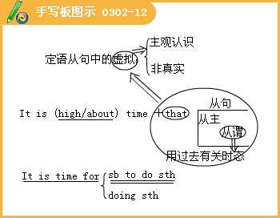
20.And aside from emailing, it's fun to see and talk to my grandchildren in the US on the i-Cam.
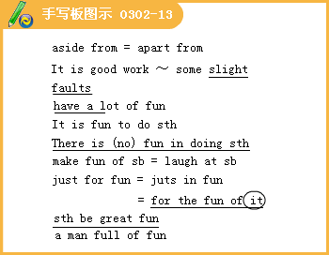
Different Schools
1.what topics you think will be mentioned.

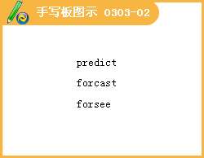
2.Think of things you would like to know and write questions, e, g.What does "alternative education "mean? How different was Nicholas' school from Jack's school?
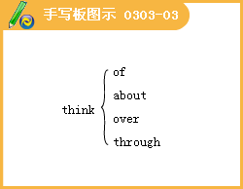
3.Founded in 1896, "Tredona School" is proud of its long list of outstanding past students.

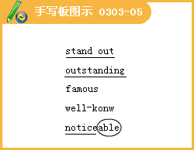
4.The results we have seen from our approach to teaching challenge conservative and traditional schools.
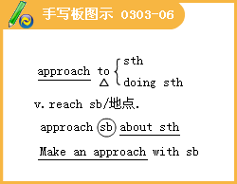
5.Our goal is to contribute to the students' whole being by giving each of them real-life skills.
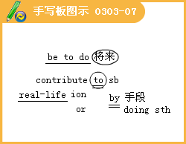
6.Our school motto reflects the importance we place on good manners, hard work and success.

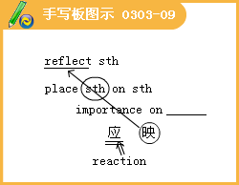
7.Our teachers are employed to teach and get students to participate in the learning process --- they are not there to hand out punishment.
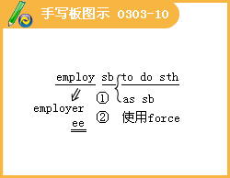
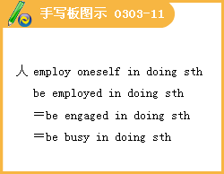
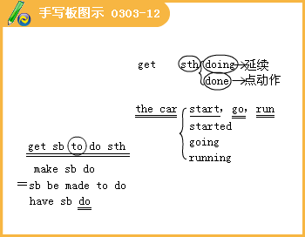
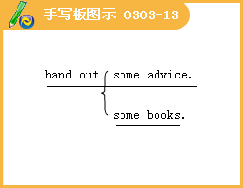
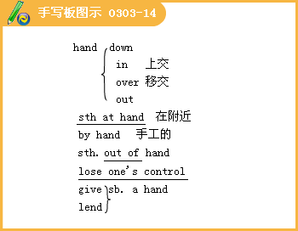
8.Due to the limited number of places and our excellent reputation, students should apply early.
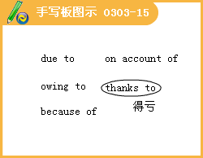
9.Read the words on the blackboard and copy them into your notebooks.

10.Talk among yourselves in small groups and explain why you made those decisions.
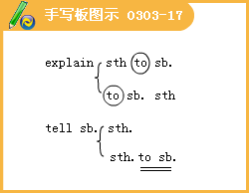
11.Decide on an environmental topic that you'd like to research.
12.One of the problems I've heard about the sort of alternative school that Nicholas goes to is that students don't prepare well for tests.
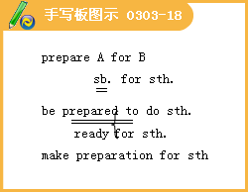
13.I don't think it's as popular as it used to be in the 1970s.

14.What are the advantages and disadvantages of traditional schooling?
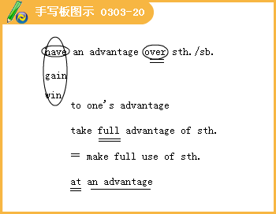
15.Well, select another one then.

16.I’m angry that you've made me come shopping with you but I'm so tired.

17.I want to _______ do further research.

Lesson 3 Teachers
1.Graham Lawrence, 29, science author who gives presentations on TV, went to Overton School
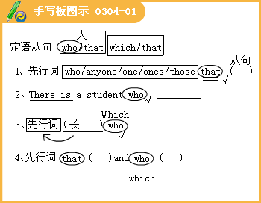

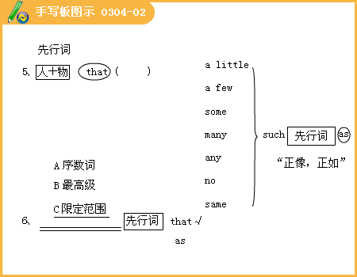
2.I haven't seen Mr.Jenkins since I left school but I often think about him.
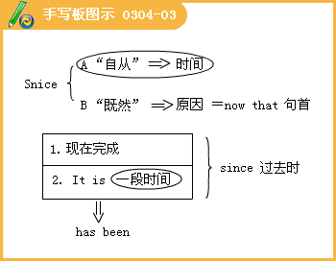
3.I wasn't very good at most school subjects.
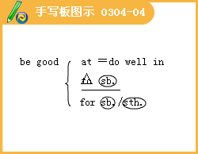
4.I suppose I was a bit lazy and now I wish I'd done more work, especially in maths.
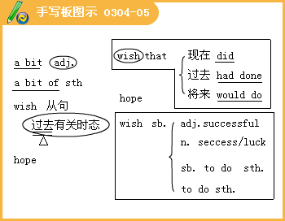


5.The only thing I can remember from school maths is that the angles of a triangle add up to 180 degrees!
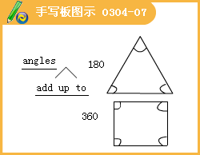


6.But when I was 15 and went into Mr.Jenkins' class, Ireally became interested in subject for the first time.
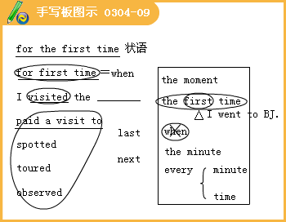
7.Before Mr.Jenkins, science had simply been a subject full of strange words to me.

8.I had no idea what an atom was and I didn't really want to know either!


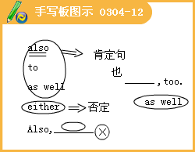
9.I found it all so boring and difficult.
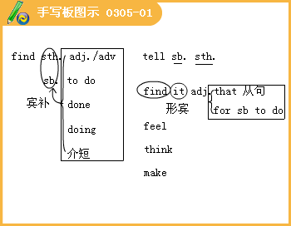
10.He used to explain things with lots of practical examples and simplified things that seemed difficult.
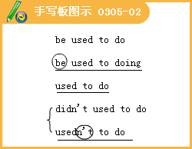
11.I remember that he let me pour some powder into the rocket and then another student lit a flame to set it off.
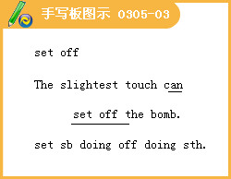
12.I know that I wasn't a willing student and I shouldn't have been so difficult at school, but it was probably because I lacked confidence in myself.
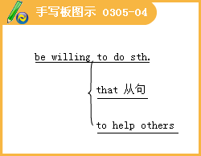

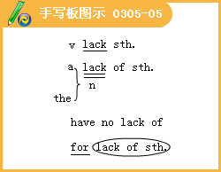
13.Sometimes I wish I could phone him and ask for his opinion!
14.Before Graham came into my class, he was very difficult.
15. Once I ought him and a friend seeing who could spit the furthest off the school stage!
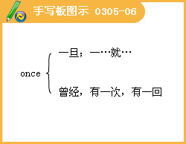
16.I've read a couple of his books and seen him on TV.
17.I wish I was as successful with all my students as I was with Graham.
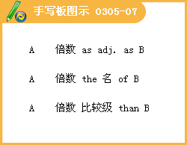
18. It's difficult teaching nowadays.
19.And I wish they would decrease the size of classes --it's not easy doing lessons in laboratories with big groups and it must be even worse in the poorer schools!
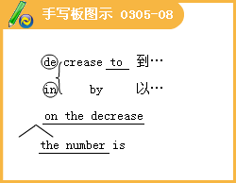
20.At least with schools like ours we have laboratories!
21.My wife often wishes that I had chosen a job with less stress but I love what I do.
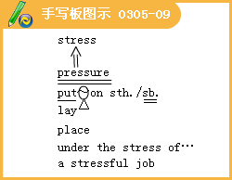
22.The thing about being a teacher is that you have access to children's minds when they are open and eager to learn.
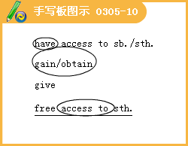
23.And if what I do as a teacher can help turn a child like Graham into such a successful adult, then I know what I'm doing is worthwhile.
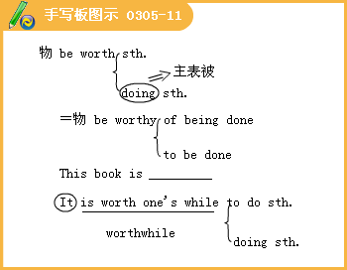
Lesson 4 Understanding
1.It seems obvious now how we acquire knowledge and understanding.
2.To start with, you need questions.
3.Then, to find answers, you observe the world around you and study the facts.
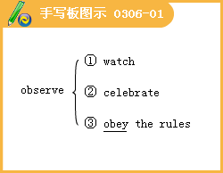
4.After that you consider possible answers and test each to find the right ones.
5.Although today we are more accustomed to typing a few key words into a search engine and waiting for the Internet to spit the answer out for us, modern scientists and thinkers are still solving the world's problems with this type of analysis--luckily for us.
6.However, in the 17th century when Francis Bacon suggested that this type of thinking was the way to gain knowledge, he was going against the views of the day.
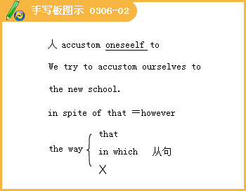
7.Bacon held an important rank under King James （1566 - 1625） of England but his true interest was not the day to day bureaucratic details of the government, but the worthy search for knowledge.
8.This was certainly not the interest of most people in his day.At that time ,people believed more in religion than in facts and people like Galileo Galilei（1564~ 1642）, who proved scientific ideas such as "the Earth is not the centre of the universe", were often punished by the church with no one coming to their defense.
9.The church and many people tended to ignore the facts and were unwilling to challenge what they had always comfortably believed.
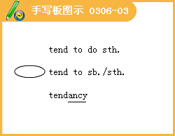
10.They preferred to make assumptions about the world based on the experiences of others.
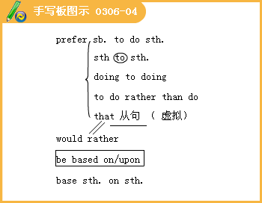
11.In fact, when Galilei proved that the Earth was not the centre of the universe, instead of believing him, people chose to believe views that were almost 2000 years old!
12.It is not surprising that people wanted to believe these ancient views as they had been put forward by the great philosopher Aristotle（384-322 BC）.
13.He said that the Earth must be the centre of the universe because it felt like the Earth was standing still.Galilei disagreed.
14.At first, people approved of his studies and urged him to continue, but later when he proved Aristotle wrong, they grew angry and put him in prison.
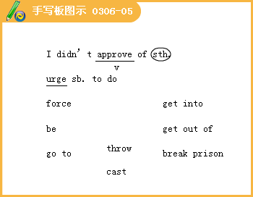
15.They didn't want to challenge what, they'd always thought was true.
16. "Ibis also shows how people didn't want to search for their own understanding or educate themselves.
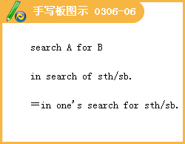
17.People feel that if someone important and respected says that something is right, then it must be so.
18.But even though Aristotle was a great man who inspired many great scientists and philosophers after him, he was wrong at times.
19.In other words, we learn more every day and none of us can ever sit back and say, "We know it all".
20.These men knew that knowledge and understanding are things to fight for; more vital to a man, and more beneficial to mankind, some might say, than all the money in the world.
Communication Workshop
1.As well as the subjects on the timetable, there would be many after-school interest groups such as chess, choir, photography and sports.There would be regular trips to places like museums and art galleries too.
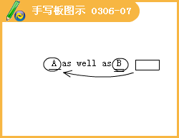
2.In conclusion, l think my school would have a good variety of activities --something for everyone.It's certainly a place I would like to go to!
Culture Corner & Bulletin Board
Good teachers leave lasting impressions on their students.
虚拟语气
简单句中 Would you please……
May you succeed
复合句中
名词性从句 主语从句
宾语从句
表语从句
同位语从句
形容词性从句 定语从句
状语从句

前提1：主语从句
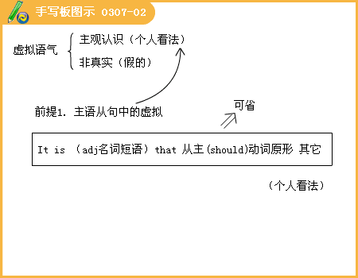

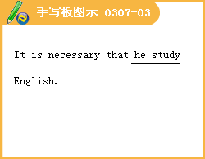
前提2：宾语从句
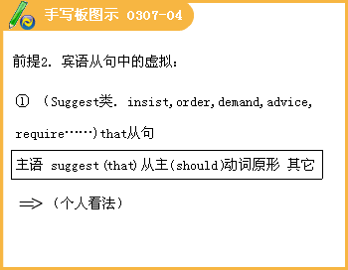

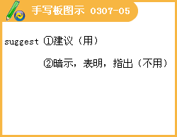



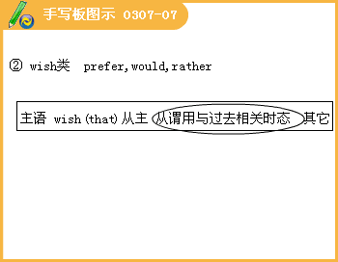
前提3：表语从句
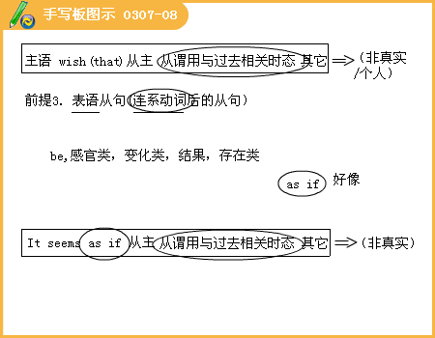
前提4：同位语从句
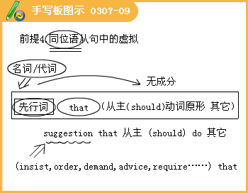
前提5：定语从句

前提6：状语从句


