Unit 16 Stories

◇[例题l] 完成句子：
（1）他在书店里买了本博斯韦尔写的《约翰逊传》。
He bought a copy of Boswell’______ of Johnson in the bookstore. （2）我想退休后写自传，这得到了妻子的支持。
I want to write ______ when I retires，which is supported by my wife.
[答疑编号911040101]
【答案】（1）Biography （2）autobiography
◇[例题2]Some of the old ______ about the space age are coming true.
A.fantasies
B.delusions
C.nightmares
D.impressions
[答疑编号911040102]
【答案】A
◇[例题3]
（1）The girl had to______her journey because of her mother's illness.
A. abandon
B. leave
C. desert
D. quit
[答疑编号911040103]
【答案】A
（2） He abandoned himself to computer games,__ made his mother worried.
A. play; which
B. playing; which
C. play; that
D. playing; that
[答疑编号911040104]
【答案】B
◇[例题4]
（1） The house has a（n） ______over the sea.
A. image
B. view
C. sight
D. outlook
[答疑编号911040105]
【答案】B
（2）完成句子：
①从我们坐的位置看，整个舞台尽收眼底。
We had __________ of the whole stage from where we were sitting.②There was a tall guy sitting in front of me,____________（把我的视线挡住了）
③那湖很快映人眼帘。（view）
The lake soon ____________________.
[答疑编号911040106]
【答案】①a good view ②blocking my view ③came into view
◇[例题5]
（1）The high building will be ______to make way for the new road.
A.put down
B.knocked down
C.knocked up against
D.knocked over
[答疑编号911040107]
【答案】B
（2） The young man was in such a hurry that he almost ______ before he saw me.
A. knock down me
B. knocked me down
C. turned me over
D. turned over me
[答疑编号911040108]
【答案】B
◇[例题6]
（1）He fell a ______to his own avarice.
A. victim
B. victimize
C. victimization
D. victims
[答疑编号911040109]
【答案】A
（2）完成句子：
①她盲目赶时髦。
She's a fashion_____.
②他很快就被她的魅力给迷住了。
He soon ______her charms.
[答疑编号911040110]
【答案】（1）victim （2）fell victim to
◇[例题7]
（1）完成句子：
①你要是能偶尔给我来封信就好了。
It’d be nice if you’d write to me_______.
②Let’s solve the problem _______（一劳永逸）!
③突然传来一阵重重的敲门声。______________________ there was loud banging on the door.
[答疑编号911040111]
【答案】①once in a while ②once and for all ③All at once
（2）______ you began you couldn’t stop.
A.When
B.While
C.0nce
D.Whether
[答疑编号911040112]
【答案】C
◇[例题8]
（1）After the explosion，the policemen did a lot of work to find out some clues from the _______
A.on-lookers
B.viewers
C.people
D.witnesses
[答疑编号911040201]
【答案】D
（2）完成句子：
①警方正呼吁曾目睹这场事故的司机协助。
The police are appealing to any driver who may have _____ the accident.
②His good health is ______（证明了）the success of the treatment.（witness）
③她出庭为被告作证。
She appeared as _______the defense.
[答疑编号911040202]
【答案】①witnessed ②a witness to ③a witness for
◇[例题9]
（1）It suddenly_______to me that we could ask our neighbor's to help us.
A.thought
B.considered
C.came
D.occurred
[答疑编号911040203]
【答案】D
（2） It______ to me that he made a mistake.
A. happened
B. took place
C. occurred
D. felt
[答疑编号911040204]
【答案】C
（3） Pliny wrote about a terrible volcanic eruption that he______as a young man.
A. witnessed
B. has witnessed
C. had witnessed
D. was witnessed
[答疑编号911040205]
【答案】C
（4）--Why are you so late?
--I was in half the way when it ______to me that I had left my notebook home, so I had to fetch it.
A. occurred
B. hit
C. happened
D. reminded
[答疑编号911040206]
【答案】A
◇[例题l0]
（1）Sooner or later the whole basin of water may be turned into _____________ice in cold winter.
A.a piece of
B.a block of
C.a basin of
D.a sheet of
[答疑编号911040207]
【答案】B
（2） Seeing the road ______ with snow, we had to spend the holiday at home, watching TV.
A. blocking
B. to block
C. blocked
D. to be blocked
[答疑编号911040208]
【答案】C
（3）完成句子：
①因患重感冒，我的鼻子堵了。
My nose ____________________________ because of a heavy cold.
②The police _________________ （封锁了）the main roads of the city after the explosion.（block）
[答疑编号911040209]
【答案】①is blocked up ②blocked off
◇[例题ll]
（1）It’s always difficult being in a foreign country，_______ if you can’t speak the language.
A.extremely
B.naturally
C.basically
D.especially
[答疑编号911040210]
【答案】D
（2）用especially，particularly或specially填空：
1.He likes the country，_______ in spring.
2.We came here _______to see you，our friend.
3.It has been _______ hot this week. *
4.It is _______ fine today.
[答疑编号911040211]
【答案】①especially／particularly ②specially （3）especially／particularly ④especially／particularly
（3）It was probably nervousness in the interview that _______ him the job.
A.lose
B.missed
C.went
D.lost
[答疑编号911040212]
【答案】D
（4）Hurry up，or you may______ the train.
A.missing
B.miss
C.lost
D.losing
[答疑编号911040213]
【答案】B
（5）As he looked down，he found his bag _______ .
A.lose
B.missing
C.losing
D.being lost
[答疑编号911040214]
【答案】B
◇[例题l2]
（1）To tell the truth，I don’t like _______ you speak to her.
A.the way B.the way in that C.the way which D.the way of which
[答疑编号911040301]
【答案】A
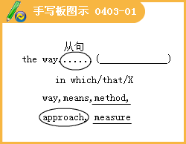
（2）There are usually at least two _______ of looking at every question.
A.means B.directions C.views D.ways
[答疑编号911040302]
【答案】D
（3）What surprised me was not what he said but ______he said it.
A.the way B.in the way what C.in the way D.the way which
[答疑编号911040303]
【答案】A
（4）The classroom is big enough _______ ，but we’11 have to move if we have more students.
A.for the moment B.on the moment. C.in a moment D.for a moment
[答疑编号911040304]
【答案】A
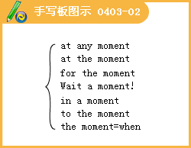
（5） I’ll come to see you _______ .
A.at any moment B.in a moment C.for the moment D.a moment a90
[答疑编号911040305]
【答案】B
（6）I started _______ you called me
A.the moment B.at any moment C.for the moment D.in a moment
[答疑编号911040306]
【答案】A
（7）The copper mirror has been well _______ though it has a history of more than 500 years.
A. preserved B.treated C.prevented D.stayed
[答疑编号911040307]
【答案】A

（8）It’s the duty of the police to _______ the public order.
A.prevent B.present C.preserve D.prepare
[答疑编号911040308]
【答案】C
◇[例题l3]
（1）It is the ability to do the job _______ matters not where you come from or what you are
A.one B.that C.what D.it
[答疑编号911040309]
【答案】B
（2）It is I _______ your teacher standing here.
A.who is B.who am C.that is D.that are
[答疑编号911040310]
【答案】B
（3） _______ a wonderful film it was _______ we saw yesterday!
A.What；what B.What：that C.That；that D.That；what
[答疑编号911040311]
【答案】B
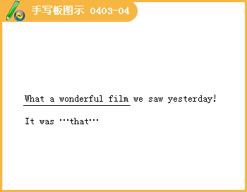
（4） _______is a fact that English is being accepted as an international language.
A.There B.This C.That D.It
[答疑编号911040312]
【答案】D
（5）-- Wasn’t it Dr Wang who spoke to you just now?
—_______.
A.I didn’t know he was B.Yes，it was C.No，he wasn’t D.Yes，he did
[答疑编号911040313]
【答案】B
（6） --_______ that he managed to get the information?
--Oh.a friend of his helped him.
A.Where was it B.What was it C.How was it D.Why was it
[答疑编号911040314]
【答案】C
◇[例题l4]
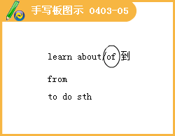
_______ the uprising，he returned to Italy.
A.Learning from B.Learning of C.Learning by heart D.Learning
[答疑编号911040315]
【答案】B
◇[例题l5]
（1）Windy days are______of March.
A.character B.chart C.chill D.characteristic
[答疑编号911040316]
【答案】D
（2）In this novel，the author______his heroine in a few paragraphs.
A.characterized B.wrote about
C.talked about D.wrote especially about
[答疑编号911040317]
【答案】A
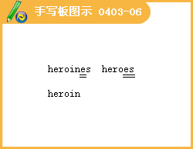
◇[例题l6]
Even before quite a few people，she can’t_______the courage to speak aloud.
A.gather B.collect C.assemble D.raise
[答疑编号911040318]
【答案】A
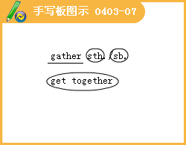
◇[例题l7]
（1）A square has_______，as we know.
A.three sides B.four sides C.five sides D.six sides
[答疑编号911040319]
【答案】B
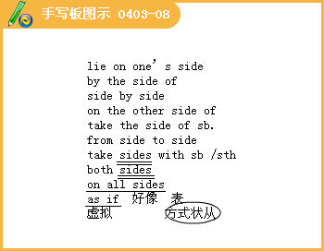
（2）There are trees Oil_______0f the road in our school.
A.all the sides B.every side C.both sides D.either sides
[答疑编号911040320]
【答案】C
（3）The plastic flowers look as if they_______.
A.are real B.had been real C.was real D.were real
[答疑编号911040321]
【答案】D
（4）I’ll try my best to get a ticket for tomorrow’s show_______it means I'll wait the whole night.
A.as if B.even if C.even so D.as long as
[答疑编号911040322]
【答案】B
◇[例题l8]
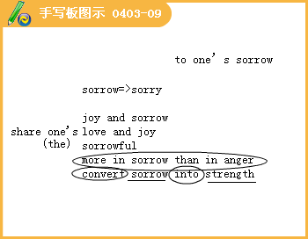
The whole nation was in deep_______at this news that the great mail was killed.
A.sorry B.sorrow C.pity D.happy
[答疑编号911040323]
【答案】B
◇[例题l9]
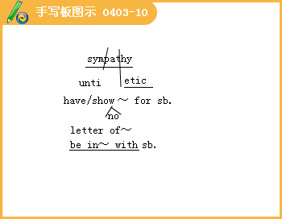
（1）My husband_______with my proposal to move to a new apartment.
A.responded B.agreed C.sympathized D.reacted
[答疑编号911040324]
【答案】C
（2）She was so kind—hearted that when the little boy told her what had happened she felt_______towards him.
A.sympathetic B.sympathy C.sympathized D.synthetic
[答疑编号911040325]
【答案】A
◇[例题20]
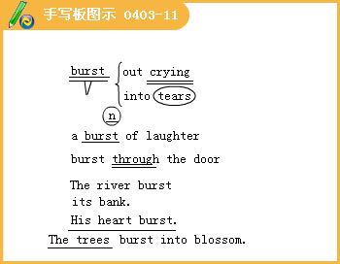
（1）I don’t know why she burst into ______
A.tear B.tore C.torn D.tears
[答疑编号911040326]
【答案】D
（2）The sun_______，hot and brilliant.
A.burst into B.burst out C.burst forth D.burst up
[答疑编号911040327]
【答案】C
（3）完成句子：
1.The river has_______ （决堤了）.
2.The hall was_______ （挤满）people.
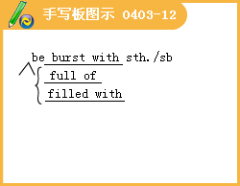
3.He_______ （闯入）the bedroom.
4.The oil_______ （冒出）the ground.
[答疑编号911040328]
【答案】1.burst 2.burst with 3.burst into 4.burst from
◇[例题21]
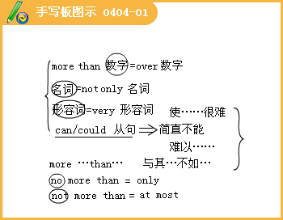
（1）一Did you take enough money with you?
一No，I needed______I thought l would.
A.not so much as B.as much as C.much more than D.much less than
[答疑编号911040401]
【答案】C
（2）一Don’t you think Sam is the best person for the position? He is______wise.
--1’m afraid not.He is wise.
A.more kind than B.as kind as C.not so kind as D.kinder than
[答疑编号911040402]
【答案】A
◇[例题22]
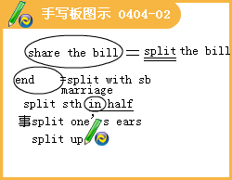
（1）My trousers were so tight，and they______when I sat down.
A.spun B.spit C.split D.splashed
[答疑编号911040403]
【答案】C
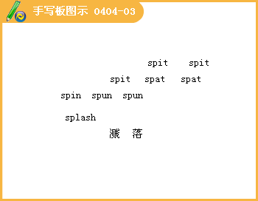
（2）Some types of wood______easily.
A.splits B.splitting C.split D.to split
[答疑编号911040404]
【答案】C
◇[例题23]
（1）What surprised all the other students was not what he said but______he said it.
A.the way B.in the way that C.in the way D.the way which
[答疑编号911040405]
【答案】A
（2）I want to know the______you learn English.
A.path B.road C.street D.way
[答疑编号911040406]
【答案】D
（3）If you meet with difficulties，you should find a way______them.
A.to get rid B.overcoming C.getting rid of D.to overcome
[答疑编号911040407]
【答案】D
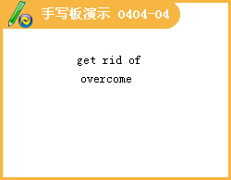
Lesson 2 Name Stories
◇[例题l]
The address you said is on this block；can you be a bit more————?
A.special B.specific C.additional D.spare
[答疑编号911040501]
【答案】B
◇[例题2]
The new discovery of oil is of great————to the country’s economy.
A.signature B.significant C.significance D.sign
[答疑编号911040502]
【答案】C
◇[例题3]
His description about the girl is still ______in my memory.
A.vividly B.vividness C.vivid D.expression
[答疑编号911040503]
【答案】C
◇[例题4]
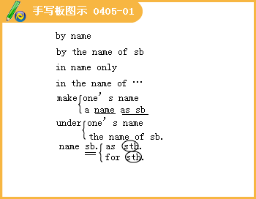
（1）He has not a dollar______ ，but he is working hard to earn money.
A.in his name B.to his name C.under his name D.from his name
[答疑编号911040504]
【答案】B
（2）Tasmania was————after its discoverer，A.J.Tasman.
A.called B.named C.made D.said
[答疑编号911040505]
【答案】B
（3）完成句子： 。
①他已被提名任董事。
He has been ————————————
②他说有人说谎，但他不愿指名道姓。
He said someone had lied but wouldn't————————————
[答疑编号911040506]
【答案】 named for the director（as the director） name names
◇[例题5]
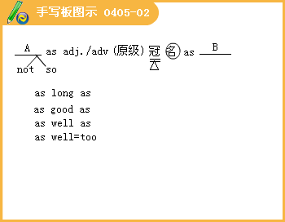
（1）A typhoon swept across this area with heavy rains and winds————strong as ll3 miles per hour.
A.too B.very C.so D.as
[答疑编号911040507]
【答案】D
（2）It is reported that the United States used————energy as the whole of Europe.
A.as twice B.twice much C.twice much as D.twice as much
[答疑编号911040508]
【答案】D
（3）I like this jacket better than that one，but it costs almost three times————
A.as much B.many C.so much D.SO many
[答疑编号911040509]
【答案】A
◇[例题6]
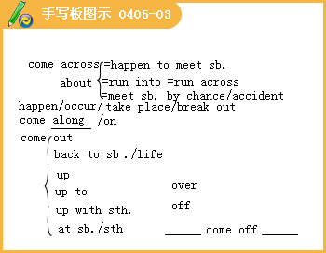
（1）They thought about it for a long time，hut still couldn’t————a solution.
A.come over B.get along with C.come out D.come up with
[答疑编号911040510]
【答案】D
（2）As you————new words in a context，it is a very good method for you to guess their meanings.
A.come about B.come across C.come out D.come up
[答疑编号911040511]
【答案】B
（3）_____made the whole family very happy.
A.My brother came back B.My brother's coming back
C.My brother to come back D.My brother's come back
[答疑编号911040512]
【答案】B
◇[例题7]
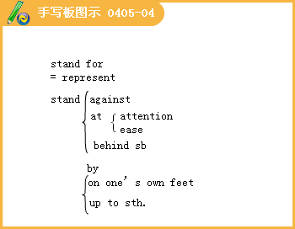

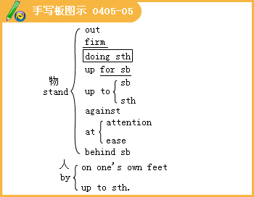
（1）The letters______well against the dark background.
A.stood by B.stood for C.stood on our own feet D.stood out
[答疑编号911040513]
【答案】D
（2）完成句子：
①你必须维护自己的权利。
You must______your rights.
②我们喜欢我们学校以及它所提倡的一切。
We like our school and all it________________
③老师不容许这样的行为。
The teacher wouldn’t______such behavior.
[答疑编号911040514]
【答案】 stand up for ;stands for ;stand for
◇[例题8]
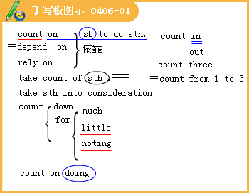
（1）The manager says he needs an assistant that he can _____to deal with the problems that may occur in his absence.
A.depend B.turn up C.count up D.count on
[答疑编号911040601]
【答案】D
（2）完成句子：
①你不能总是指望别人的帮助。
You can't always________the help from others.
[答疑编号911040602]
②第一印象确实很重要。
First impressions really do_______________________.
[答疑编号911040603]
③我们没有想到会有那么多人度假。
We didn’t________so many people________.
[答疑编号911040604]
（3）At the party the beautiful girl gave us a／an________performance.
A.admire B.admiration C.admirable D.admirations
[答疑编号911040605]
【答案】C
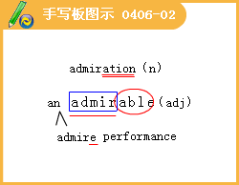
（4）Mrs. Johns smiled with______
A.admire B.admiration C.admirations D.her admiration
[答疑编号911040606]
【答案】B
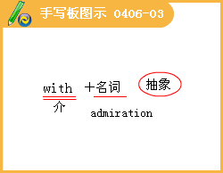
◇[例题9]
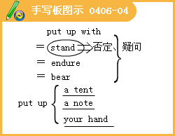
用put短语的正确形式填空：
1.He________his work________and made some coffee.
2.He never________dishes after meals.
3.The plan she________at the meeting was agreed to by most people present.
4.She tried to________her thoughts——but it was too noisy.
5.Never________till tomorrow what you can do today.
6.I can’t______ these results any more.
7.Mike ______a tent and made a fire.
8.He is ______ a model plane.
9.He______some money ______ in the case.
[答疑编号911040607]
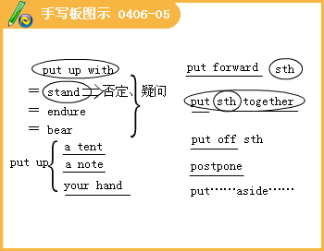
完成句子：
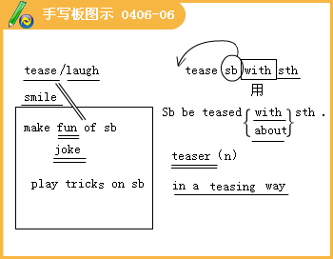
①我小的时候别人老取笑我长得胖。
1________my weight as a child.
[答疑编号911040608]
②别逗猫!
Stop________the cat!
[答疑编号911040609]
③这可真是个难题。
It is a real________.
[答疑编号911040610]
④他以嘲笑的口吻对我说了这个消息。
He told me the news________.
[答疑编号911040611]
◇[例题l0]
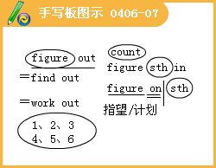
（1）His salary went into five________ a year
A.figures B.numerals C.numbers D.fatigue
[答疑编号911040612]
【答案】A
（2）We________your coming early.
A.figure out B.figure on C.figure in D.figure up
[答疑编号911040613]
【答案】B
（3）They couldn’t________where l was last night.
A.figure out B.figure on C.figure up D.figure in
[答疑编号911040614]
【答案】A
（4）完成句子：
①I________ （计划）being in New York in January.
②I，m dieting to________ （保持体形）.
[答疑编号911040615]
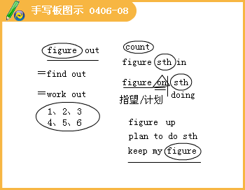
◇[例题ll]
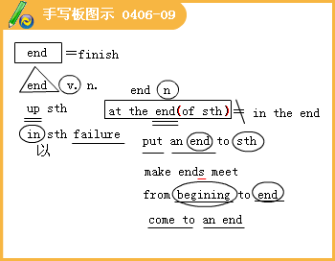
（1）To start with the aim of doing harms to others is only to________by ruining oneself.
A.at the end B.in the end C.make ends meet D.end up
[答疑编号911040616]
【答案】D
（2）完成句子：
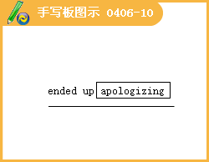
①他们长期的斗争以失败告终。
Their long struggle________________.
[答疑编号911040617]
②最初他拒不承认有任何责任，到最后还是道了歉。
At first，he refused to accept any responsibility， but he________.
[答疑编号911040618]
③政府决心遏制恐怖主义活动.
The government is determined to ________ terrorism.
[答疑编号911040619]
④他们失业了，还要养活两个小孩子，无法维持起码的生活。
Being out of work and having two young children they found it impossible to ______.
[答疑编号911040620]
◇[例题l2]
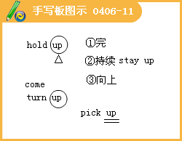

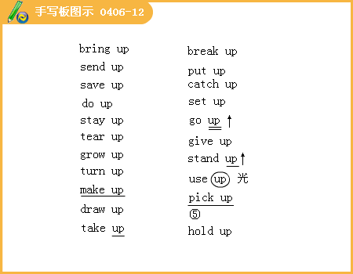
（1）The story was so touching that I could hardly________my tears.
A.hold on B.hold back C.hold up D.hold on to
[答疑编号911040621]
【答案】B
（2）Although there were so many people in the square，I could________my friend.
A.pick up B.pick out C.make up D.set out
[答疑编号911040622]
【答案】B
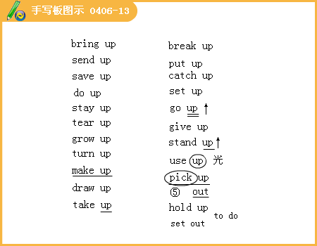
（3）Kathy________a lot of Spanish by playing with the native boys and girls.
A.picked up B.took up C.made up D.turned up
[答疑编号911040623]
【答案】A
◇[例题l 3]
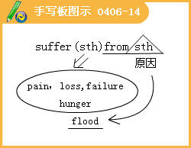
（1）The new plant can't________ the cold weather，so the researchers are trying to deal with it.
A.suffer for B.suffer C.longfor D.suffer from
[答疑编号911040624]
【答案】B
（2）The farmers________a lot________the flood.Because it rained heavily.
A.suffered；from B.suffered；of C.will suffer；for D.suffer；to
[答疑编号911040625]
【答案】A
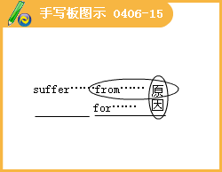
◇[例题l4]
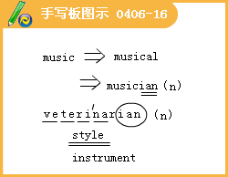
（1）The beautiful girl has no formal________qualifications.
A.music B.musician C.musical D.musics
[答疑编号911040626]
【答案】C
（2）I've left my________at home.
A.music B.musician C.musical D.musicians
[答疑编号911040627]
【答案】A
◇[例题l5]
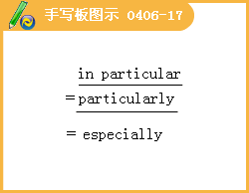
（1）The summer here is very hot，________at noon.
A.specially B.particularly C.particular D.peculiar
[答疑编号911040628]
【答案】B
（2）There is nothing of________importance in today’s newspaper.
A.particular B.partial C.peculiar D.specific
[答疑编号911040629]
【答案】A
Lesson 3
◇[例题l]
The reason why the company is successful is due to the fact that they produce___________materials.
A.superior B.expensive C.quantity D.a lot of
[答疑编号911040701]
【答案】A
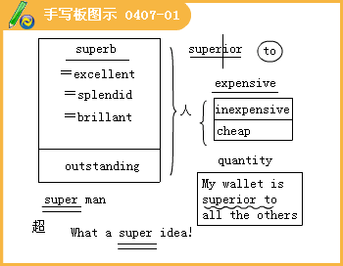
◇[例题2]
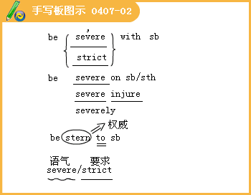

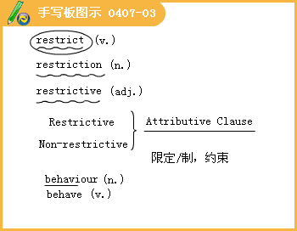
（1）strict severe stern
（2）I try to___________my smoking to five cigarettes a day.
A.stop B.quit C.restrict D.pause
[答疑编号911040702]
【答案】C
（3）Your___________at the meeting yesterday hurt me very much.
A.behaviour B.action C.conduct D.benefit
[答疑编号911040703]
【答案】A
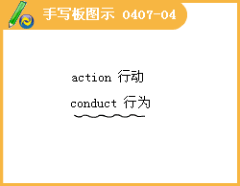
◇[例题3] 完成句子：
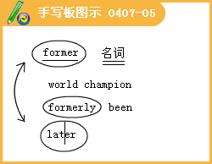
（1）前世界冠军也参加了本次比赛。
The___________also competed in the match.
[答疑编号911040704]
（2）前一种选择要明智得多。
___________option would be much more sensible.
[答疑编号911040705]
（3）我得知这座房子以前是一家客栈。
I learnt that the house had___________an inn.
[答疑编号911040706]
（4）在这两种可能性中，前者似乎比后者更有可能。
Of the two possibilities，___________seems more likely than___________.
[答疑编号911040707]
◇[例题4]
（1）The Town Hall___________in the 1880’s was the most distinguished building at the time.
A.to be completed B.having been completed
C.completed D.being completed
[答疑编号911040708]
【答案】C
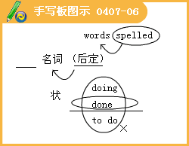
（2）There have been several new events___________to the program for the 2008 Beijing
A.add B.to add C.adding D.added
[答疑编号911040709]
【答案】D
◇[例题5]
（1）My time is very___________ can only spare you ten minutes for an interview.
A.previous B.scarce C.dear D.precious
[答疑编号911040710]
【答案】D
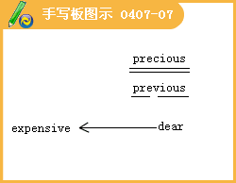
（2）He has fallen asleep with the books laid ___________ on the desk.
A.opened B.open C.opening D.to open
[答疑编号911040711]
【答案】B
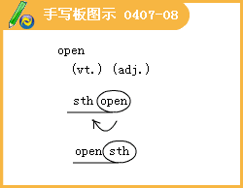

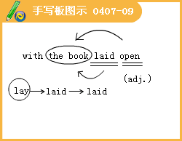
（3）Who left the door ___________
A.open B.opened C.opening D.to open
[答疑编号911040712]
【答案】A
◇[例题6]
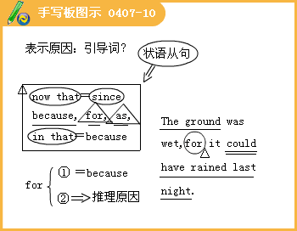
（1）We have finished the work at hand so___________ let us have some coffee.
A.just B.just now C.1ate D.now
[答疑编号911040713]
【答案】D
（2） ___________you won’t help us，I have to turn to others.
A.Although B.Because C.For D.Now
[答疑编号911040714]
【答案】D
（3）They are___________to meet their new colleague.
A.eagle B.keen C.ambitious D.eager
[答疑编号911040715]
【答案】D
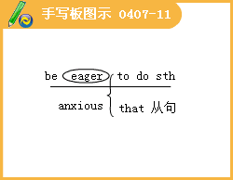

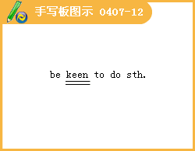
◇[例题7]
（1）We___________managed to have people accept our theory after a lon9，hard struggle.
A.momentarily B.suddenly C.graciously D.gradually
[答疑编号911040716]
【答案】D
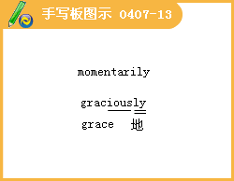
（2）完成句子：
①由于水的作用，岩石逐渐磨损。
The rock___________wears away due to the action of the water.
[答疑编号911040717]
②孩子们渐渐开始明白。
___________，the children began to understand.
[答疑编号911040718]
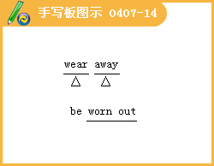

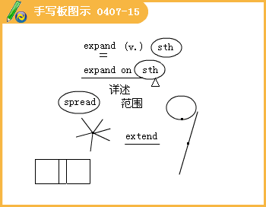
[例题8]
Iron___________when it's heated.
A.extends B.spreads C.widens D.expands
[答疑编号911040719]
【答案】D
◇[例题9]
What he said was too＿＿＿＿ for me to understand.
A.complex B.completive C.compliant D.complementary
[答疑编号911040801]
【答案】A
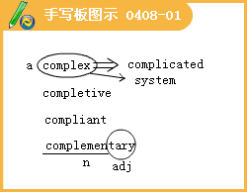
◇[例题l0]
It was＿＿＿＿ that she was i11.
A.actual B.apparent C.evidently D.appearance
[答疑编号911040802]
【答案】B
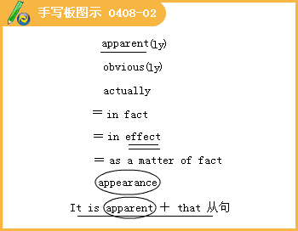
◇[例题11]
（1）I was still sleeping when the fire＿＿＿＿，and then it spread quickly.
A.broke out B.put out C.came out D.got out
[答疑编号911040803]
【答案】A
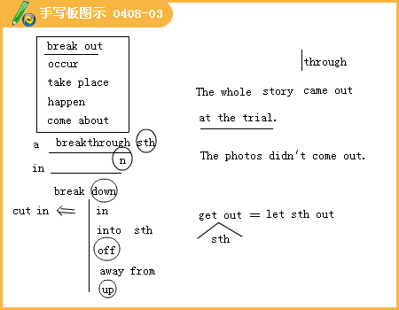
（2）To understand the grammar of the sentence，you must break it＿＿＿＿into parts.
A.down B.up C.off D.out
[答疑编号911040804]
【答案】A
◇[例题l2]
The＿＿＿＿of lightening frightened us.
A.gleams B.sparkles C.twinkles D.flashes
[答疑编号911040805]
【答案】D
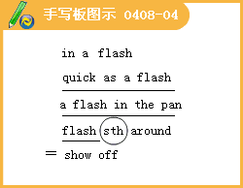
◇[例题l3]
（1）＿＿＿＿ ，I lost heart in English learning，but my teacher often said to me，“Keep on working hard，you’11 succeed＿＿＿＿.
A.At a time：in time B.At a time：on time
C.At one time；in time D.At one time；on time
[答疑编号911040806]
【答案】C
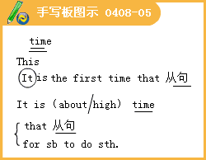
（2）It is high time that we＿＿＿＿hard.
A.work B.worked C.have worked D.had worked
[答疑编号911040807]
【答案】B
（3）He didn’t make＿＿＿＿clear when and where the meeting would be held.
A.this B.that C.it D.these
[答疑编号911040808]
【答案】C
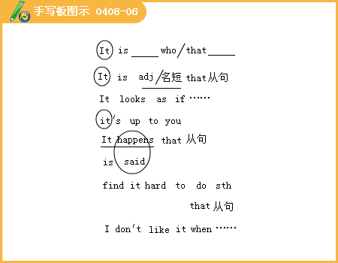
（4）I have nothing to confess.＿＿＿＿you want me to say?
A.What is it that B.What it is that
C.How is it that D.How it is that
[答疑编号911040809]
【答案】A
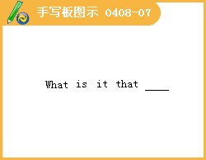
◇[例题l 4]
（1）The dictionary is being printed and it will soon＿＿＿＿.
A.turn out B.come out C.start out D.go out
[答疑编号911040810]
【答案】B
（2）It’s already 10 o'clock.I wonder how it ＿＿＿＿that she was 2 hours late on such a short trip.
A.came over B.came out C.came about D.came up
[答疑编号911040811]
【答案】C
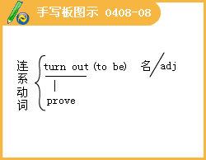
◇[例题l]
（1）She didn’t think that her husband was＿＿＿＿to her.
A.attentive B.attention C.active D.available
[答疑编号911040901]
【答案】A
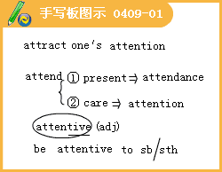
（2）He is very＿＿＿＿his studies.
A.attentive B.attentively
C.paying attention to D.attentive to
[答疑编号911040902]
【答案】D
◇[例题2]
（1）Let Harry play with your toys as well，Clare—you must learn to＿＿＿＿.
A.support B.care C.spare D.share
[答疑编号911040903]
【答案】D
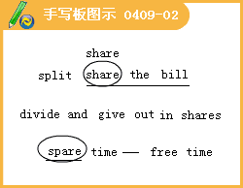
（2）Mr. Smith and his wife＿＿＿＿ the housework and live happily.
A.share in B.share with
C.share out D.do their share for
[答疑编号911040904]
【答案】A
◇[例题3]
（1）一Did you remember to give Mary the money you owed her?
一Yes, gave it to her＿＿＿＿I saw her.
A.while B.the moment C.suddenly D.once
[答疑编号911040905]
【答案】B
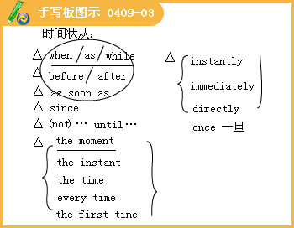
（2）Although we hadn’t met for 25 years，I recognized him＿＿＿＿I saw him.
A.while B.since C.before D.the minute
[答疑编号911040906]
【答案】D
◇[例题4]
（1）This man’s appearance＿＿＿＿her of her father.
A.remembers B.recalls C.suggests D.reminds
[答疑编号911040907]
【答案】D
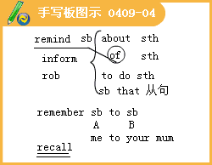
（2）In our childhood，we were often＿＿＿＿by grandma to pay attention to our table manners.
A.demanded B.reminded C.allowed D.hoped
[答疑编号911040908]
【答案】B
（3）What you said just now＿＿＿＿me of the days I spent in the countryside.
A.mentioned B.informed C.reminded D.memorize
[答疑编号911040909]
【答案】C
◇[例题5]Americans are often＿＿＿＿with chopsticks.
A.awkward B.awful C.aware D.automatic
[答疑编号911040910]
【答案】A
◇[例题6]
（1）The girl becomes＿＿＿＿beautiful!
A.better B.more and the more C.more and more D.the more
[答疑编号911040911]
【答案】C
（2）The young man is＿＿＿＿Mr Zhang in chemistry.
A.more superior than B.superior to
C.the more superior to D.the better superior than
[答疑编号911040912]
【答案】B
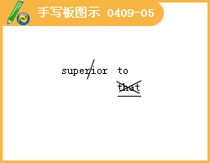
◇[例题7]
The child＿＿＿＿the salt all over the floor.
A.spilt B.spill C.splashed D.spat
[答疑编号911040913]
【答案】A
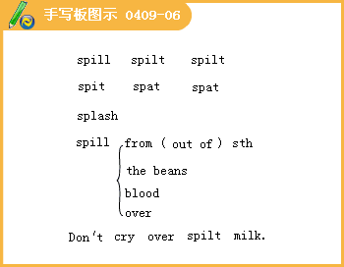
◇[例题8]
Their teacher has a（an） ＿＿＿＿look，but in fact he is very good to them all.
A.good B.nasty C.easy D.angry
[答疑编号911040914]
【答案】B
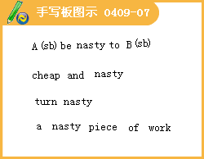
◇[例题9]
（1）I couldn’t＿＿＿＿.The line was busy.
A.go by B.go around C.get in D.get through
[答疑编号911040915]
【答案】D
（2）The company managed to ＿＿＿＿all the commodities that were out of fashion at the market.
A.get on with B.get rid of C.get back at D.get in with
[答疑编号911040916]
【答案】B
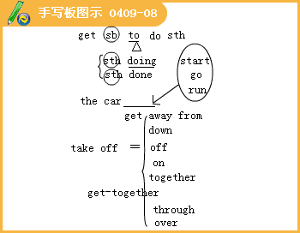
◇[例题l0]
（1）California＿＿＿＿when gold was discovered there.
A.developed B.advanced C.made progress D.boomed
[答疑编号911040917]
【答案】D
（2）完成句子：
①我们能听到远处敌人的大炮轰隆声。
We could hear the enemy’s guns＿＿＿＿in the distance.
②房产市场出现突然的繁荣。
There appears a sudden ＿＿＿＿ in housing market.
③钢铁工业迅速发展。
The steel industry is＿＿＿＿.
[答疑编号911040918]
【答案】 ①booming out ②boom ③booming

