Unit 14 Careers

Warm-up
1.Listen to dialogues and an interview:
2.Learn about reported requests, commands and statements.
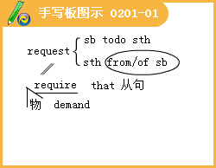

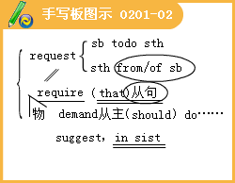

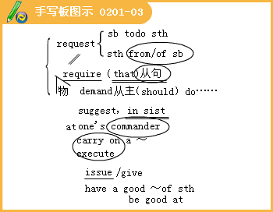
3.Which jobs can you see in the photos? Use the Key Words to help you. Add more jobs to the list.



4.Complete the sentences with the Key Words below.

Lesson 1 Your Choice
1.Decide what you would do in these situations.
2.Does the description fit your personality？

3.Would you like to do the kind of jobs that the answer key suggests for you？
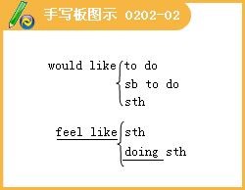

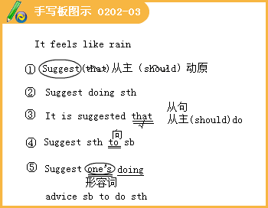
4.A friend is having problems writing a plot summary for a book report.
She asks you to help her.What would you do?
5.You are working for an institute that gives aid to the poor in a small village.Your boss tells your team to repair an old pump near a river.What would you do?
6 b）Choose a certain job that you think you could do well, such as collecting data. Then plan how you could do the job well. c） Try to improve the design of the pump. Look at the river and see if there is a better place to build the pump.
d）Ask everybody in your team to do certain jobs. Make sure they know what to do. Choose one of the hardest jobs for yourself to set an example.
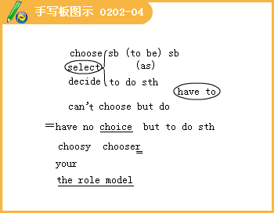

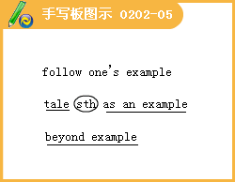
7. You are on a school trip and the coach has an accident when a deer runs across the road. No one is hurt, but you are stuck on a forest road with no traffic. It is getting dark and it has started to snow. What would you do?
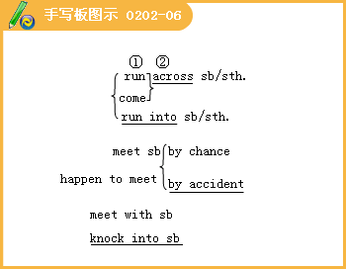





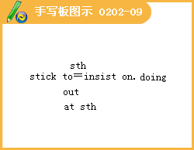
8.a）Talk to anybody who looks afraid or worried.Tell them not to worry
h）Keep calm.You know that the situation is not really dangerous and somebody is going to get help.
c）Tell your friends a story, while you are waiting for help.
d）Take charge of the situation.Ask a small group to go to the nearest village to get help.Tell everybody on the bus to put on more clothes to keep warm.
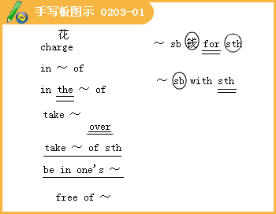
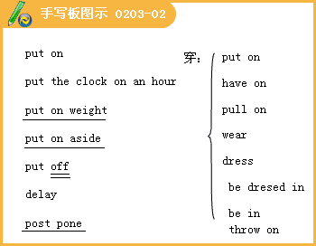
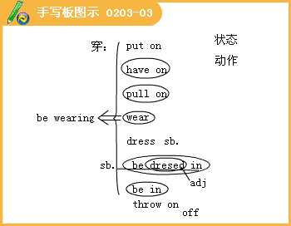
9.Last week your teacher asked your class to perform a short play for the school.So far, nothing has been done and there are only ten days until the performance.What would you do?

10.Offer to take part and ask others to do the same.Help people to learn their lines.
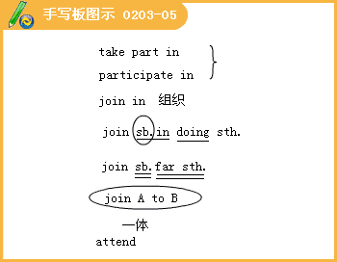
11."Don't lose the receipt.It's important."
The salesgirl instructed the shopper
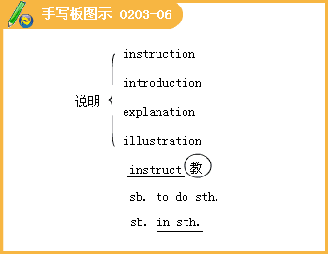
12.Mrs.Smith must cancel my trip to Paris.
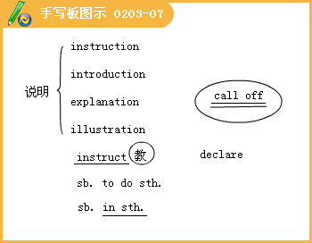
13.He shouldn't announce the results before the end of the month.
14.She should prepare the information I need for my presentation.

15.listen rather than speak -- learn as much as possible about your job and the company.
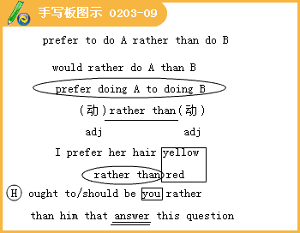
16.keep your desk tidy at all times
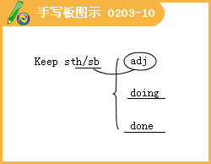
8.a）Talk to anybody who looks afraid or worried.Tell them not to worry
h）Keep calm.You know that the situation is not really dangerous and somebody is going to get help.
c）Tell your friends a story, while you are waiting for help.
d）Take charge of the situation.Ask a small group to go to the nearest village to get help.Tell everybody on the bus to put on more clothes to keep warm.
9.Last week your teacher asked your class to perform a short play for the school.So far, nothing has been done and there are only ten days until the performance.What would you do?
10.Offer to take part and ask others to do the same.Help people to learn their lines.
11."Don't lose the receipt.It's important."
The salesgirl instructed the shopper
12.Mrs.Smith must cancel my trip to Paris.
13.He shouldn't announce the results before the end of the month.
14.She should prepare the information I need for my presentation.
15.listen rather than speak -- learn as much as possible about your job and the company.
16.keep your desk tidy at all times
1.Use a dictionary tocheck the meaning of the phrasal verbs.
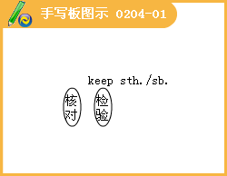
2.Turn up at the interview a couple of minutes early.
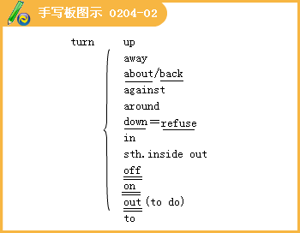
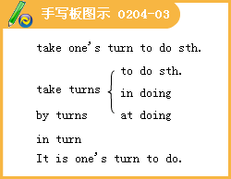
3.Make up information about yourself.

4.Make out you understand something when you don't!

5.Speak up and express yourself clearly.
6.Sit up straight and look peoplein the eye.
7.She asked about my experience with children, so I （8） _____a lot of detail about my childhood.
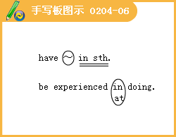
8.Listen to people asking the interviewer to repeat or explain something.
1.Think of a successful person that you admire.
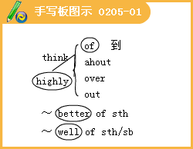
2.Sometimes I don't see my family for weeks.

3.As a child, Wang Junyan never dreamed of becoming a famous person on TV.
4."I never thought about going on TV because my family didn't even have one until I was in junior high school ! "She explained.


5.I asked her how she had achieved success and she told me that being curious, working hard, and believing in what was true made her the success she is today.

6.It was my mother who taught me to be curious.
7.She worked extremely hard to support me through school and during my time at Fudan University in Shanghai."Her attitude towards life will never stop influencing my thoughts and actions.
8.I asked her if there was any special moment that made her realize this and she replied that it was after she was asked to inspect an illegal business.
9. Her report helped the people who had been affected and it also helped the government inspect the company and catch the guilty people. "That is when I realized the importance of being a journalist ～ "said Junyan.

10. This paid off because she won an award for the report.

11. I discovered then that as long as I am committed and never give up I will be able to produce high quality reports.
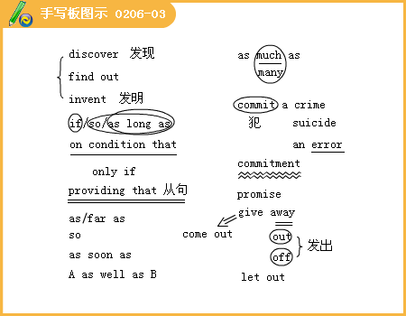
12. I asked Junyan what she liked most about her job and she said that although there wasn't much glory in a reporter's existence, she found it interesting and challenging.

13. I meet a lot of people and go to many different places. I'm never bored with this job!
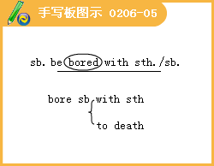
14. Today when I'm looking for stories, I still feel like I'm turning over stones to see what might be hiding beneath!
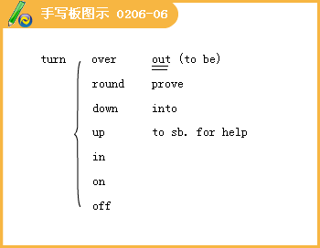
15. The following time and place expressions were used in the interview.

16. When we report a Wh-question, we include the Wh-word.
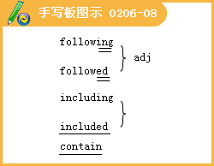


1. Read each paragraph with a sentence gap again and identify the topic of the paragraph,e.g.gap 1= dealing with change.

2. For each gap, find a sentence that matches the topic of the paragraph and links with the sentence before and after it.

3. Now people are beginning to pay attention to Toffler's ideas because the speed of change is becoming increasingly fast.
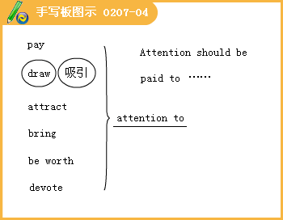
4. It is sometimes difficult to work out the patterns of change.
5. Take a deep breath and try to get a sense of the good things the future has to offer.
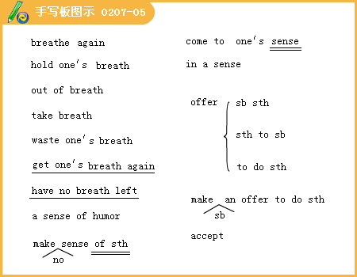
6. Without doubt, the number of jobs in information technology will multiply.

7. There are also many other important changes taking place.

8. According to Mark Hastings of the Institute of Management, in the future, people will organize their working life around a variety of jobs, instead of working just for one division or branch of a company.

9. Similarly, companies will operate in different ways.

lO. People will move around to do different jobs, rather than moving up in the company as before. Many more people will work for small, dynamic companies which can respond quickly to changes in the market. Other people will give up working for a boss and start their own businesses.
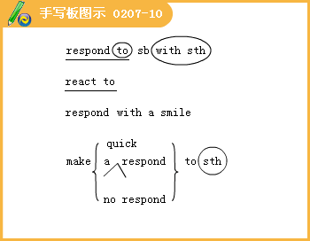
ll. All this means that companies will require people who are flexible and can work on their own.
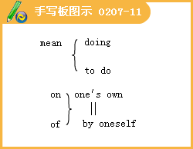
12. Good communication skills will be extremely important. According to Dr Laurence Lyons of Future Work ,women will be envied because they have an advantage in this area. James Traeger, spokesman of a government training organisation, explains that many men will have to be retrained. "It's not about making men more like women, but helping men to communicate as well."
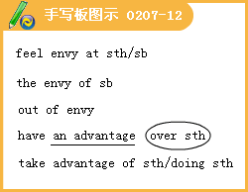
13. English will probably remain the international business language, so don't bother learning Russian or Spanish.
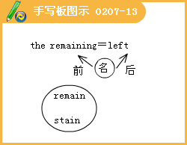
14. Above all, a manager will need to feel comfortable working with people from other countries and continents.

15. New technology is the driving force behind these rapid changes, so don't get left behind.

16. You don't need to become a computer expert, but you must consider improving your computer skills.
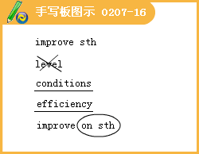
17. Work with more than one program in case you have to use them at work, and try to read about new technology.
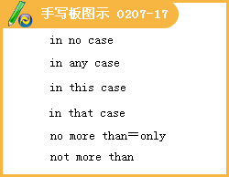
18. On the other hand, the service industry, the media and information technology are booming.
19. They will also need people who can work together and get on well in a team.
Communication Workshop
1. What reasons does Li Meiling give for applying for the job.

2. I feel that I can get on well with people from different backgrounds, since I have worked with lots of different people on many projects for local events.

3. I think I would be a good journalist due to my language skills.
4. I have always been good at writing and I have read many novels by distinguished authors.

5. In addition, l am also a good photographer, which might be useful for some of the articles.

Culture Corner
1. The job market has changed and our approach to finding work must change as well.
2. Today, five years in a job is a long time and some people even change jobs every two years.

3. This makes the job market very tough to get into and therefore good exam grades in school alone do not make an applicant stand out from the crowd. Instead, companies are always looking for people who：
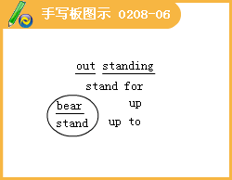
4. Companies prefer to select people with the ability to create something new, on their own and in a team, and to judge what will and will not be successful.

5. Teamwork skills include your ability to work well as part of a group.

