Unit 17 Laughter

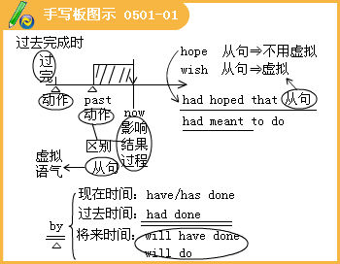

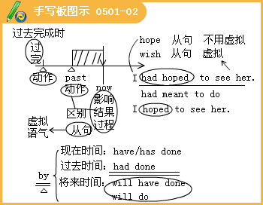
Lesson 1
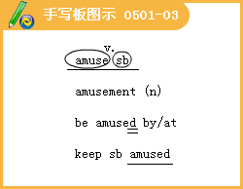
◇[例题l]
（1）She was _______at the monkey’s antics.
A.naked B.yielded C.entertained D.amused
[答疑编号911050101]
【答案】D
（2）完成句子：
①我觉得最好笑的是想到了马丁穿着连衣裙。
____________most was the thought of Matin in a dress.
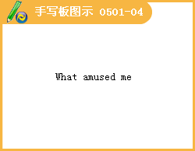
②艾米会连续好几个小时津津有味地玩拼图玩具。
Doing jigsaw puzzles would ______ for hours on end.
③令每个人都感到好笑的是，那个演员的胡须掉了下来。
_______the actor's beard fell off.
[答疑编号911050102]
【答案】①What amused me ②amuse Amy ③To everyone’s amusement
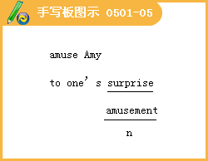
◇[例题2]
（1）In a sudden _______0f anger，the man tore up everything within reach.。
A.attack B.burst C.split D.blast
[答疑编号911050103]
【答案】B
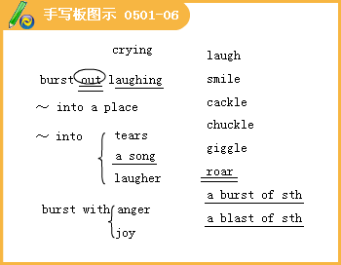
（2） The police _______into the room and caught the murderer.
A.burst B.entered C.looked D.shouted
[答疑编号911050104]
【答案】A
（3） Suddenly she ______ like a child when I came.
A.burst into laughing B.burst out laugh
C.burst out laughing D.burst out in laughing
[答疑编号911050105]
【答案】C
（4）At the funny scene ,we all ______
A.burst into laughing B.burst out laughter
C.burst into laugh D.burst into laughter
[答疑编号911050106]
【答案】D
（5）Have you ever _______ when everybody else was very happy?
A.giggling B.to giggle C.giggled D.giggle
[答疑编号911050107]
【答案】C
◇[例题3]
（1）The fat old marl looked _______ in his tight pink trousers.
A.normal B.mockery C.moderate D.ridiculous
[答疑编号911050108]
【答案】D
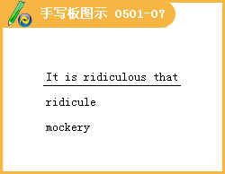
（2）完成句子：
①我的想法受到其他队员的嘲笑。
My ideas _______the rest of the team.
②他已成了大家嘲笑的对象，其他男孩不把他放在眼里。
He has become an _______，ignored by the other boys.
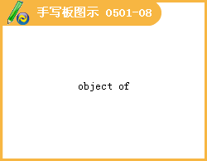
③你竟然会犯这样一个错误，太荒唐了。
_______that you should make such a mistake.
④你穿上那条紧身牛仔裤看起来真可笑。
You _______in the tight jeans.
[答疑编号911050109]
【答案】①were ridiculed by ②object of ridicule
③It is ridiculous ④look ridiculous
◇[例题4] When Zhao Benshan played his comedy Selling Walk Stick，we all _______.
A.fall about laughing B.fell into laughter
C.fell about laughing D.fell about laughter
[答疑编号911050110]
【答案】C
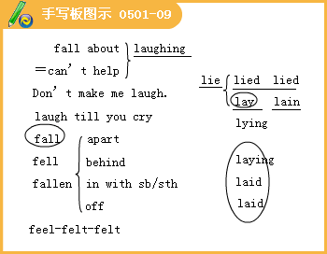
◇[例题5] 完成句子：
（1）攻击引起愤怒的回应。
The attack caused an angry _______.
（2）她对我提出的建议报以一笑。
She _______my suggestion with a laugh.
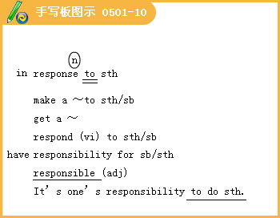
（3）政府对我们的求助给予了同情的回应。
The government made a sympathetic..._______our appeal for help.
[答疑编号911050111]
【答案】（1）response （2）responded to （3）response to
◇[例题6]
（1）What he said is _______，I think，as he is not honest.
A.believe B.unbeliever C.believable D.unbelievable
[答疑编号911050112]
【答案】D
（2）Ｉ _______what he told me yesterday.
A.believe in B.believe C.believed in D.believed
[答疑编号911050113]
【答案】D
（3）I _______suppose what he said_______true.
A.／；isn’t B.don’t；is C.am not；is D.don’t；are
[答疑编号911050114]
【答案】B
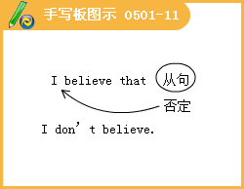
◇[例题7] 完成句子：
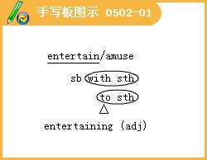
（1）那位老人讲了一连串有关本地区的趣事来使我们高兴。
The old man _______us _______a stream of anecdotes about the local.
（2）那人是一位很风趣的客人
The man is a most _______guest
（3）她掉进水里，逗得孩子们乐不可支。
She fell in the water___ the children.
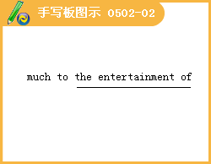
（4）报纸上登有本地的娱乐活动。
The local ______are listed in the newspaper.
[答疑编号911050201]
【答案】
（1）entertained; with （2）entertaining
（3）much to the entertainment of （4）entertainments
[例题8]
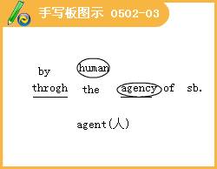
（1） This radio company is so big that it has a lot of______ in foreign countries.
A.conductors B.agents C.drivers D.introducers
[答疑编号911050202]
【答案】B
（2）The rocks in the river are worn smooth ______of water.
A.with the agency B.by the anent
C.through the agency D.with the anent
[答疑编号911050203]
【答案】C
[例题9]
In spite of the bad things he’s done, I still believe in his essential______
A.goods B.goodly C.goodness D.goody
[答疑编号911050204]
【答案】C
[例题10] The designer's aim is to produce _______shape and texture.
A.mixture B.a harmony of C.harmony of D.a harmony
[答疑编号911050205]
【答案】B
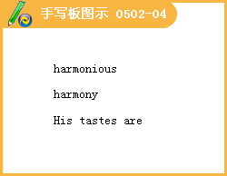
[例题11]
（1） I _______for it for weeks before I found it.
A.have been looking B.has been looking
C.had been looking D.was been looking
[答疑编号911050206]
【答案】C
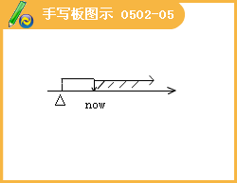
（2） I have no _______with me, may I pay by cheque?
A.cash B.currency C.cast D.current
[答疑编号911050207]
【答案】A
（3）完成句子：
①我们能到哪能把这张支票兑换成现金？
Where can we____this cheque______?
②你付现款还是有结算帐户？
Are you______or do you have a trade account?
③这张支票在任何银行都能兑成现金。
The cheque_____in any bank.
④公司目前现款有点紧张
The company’s a bit______.
[答疑编号911050208]
【答案】①get; cashed ②paying cash ③is cashable ④short of cash
[例题12] 完成句子
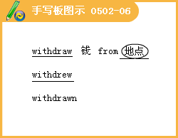
①她把她的全部存款取出后就到国外深造去了。
She _______all her savings and went abroad for further education.
②允许你每月从帐户上提取两次存款
You are allowed to _______a month from the account.
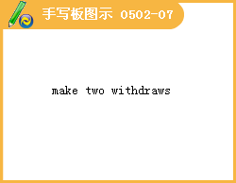
③那个将军拒绝撤回部队。
The general refused _______his troops.
[答疑编号911050209]
【答案】①withdrew ②make two withdrawals ③to withdraw
（2）The US government threatened that it would _______all its investment from that country if the country didn't reduce the custom duties.
A.take B.move
C.withdraw D.draw
[答疑编号911050210]
【答案】C
[例题13] --I'm terribly sorry I broke your glass.
--_______
A.That's right B.Bad luck C.Sorry D.You can forget it
[答疑编号911050211]
【答案】D
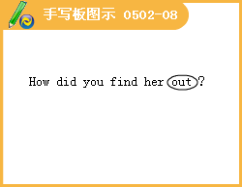

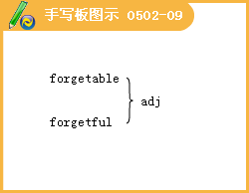

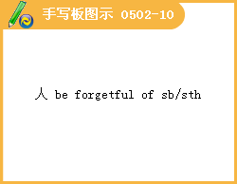
[例题14] He's not _______enough to be given too much responsibility.
A.nature B.old C.maturely D.mature
[答疑编号911050212]
【答案】D
【例题15】 完成句子
（1）他们开始选新经理时，没有考虑他。
He_______when they set about choosing a new manager.
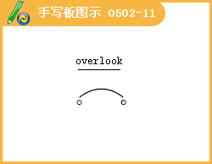
（2）她没有理会他的粗鲁举动，竭力装作若无其事的样子。
She_______his rudeness and tried to pretend nothing had happened.
（3）从邻居的窗户可看到我家的花园。
Our garden______our neighbour's windows.
（4）从我的房间可以眺望长江
My room______the Changjiang River.
[答疑编号911050213]
【答案】（1）was overlooked （2）overlooked （3） is overlooked by （4） overlooks
[例题16]
（1）John was late for the business meeting because his flight had been _______by a heavy storm
A.kept B.stopped C.slowed D.delayed
[答疑编号911050214]
【答案】D
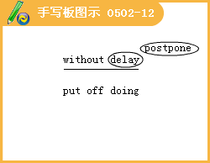
（2）完成句子
①把这事立刻向警察局报告。
Report it to the police station_______
②索赔从速，逾期利益可能受损。
Don't______, or you may lose benefit.
[答疑编号911050215]
【答案】①without delay ②delay claiming
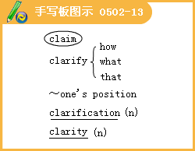
[例题17] 完成句子
（1） 他要她说清楚她是什么意思。
He asked her_____she meant.
（2） 来自世界各国的领导人都阐明了自己的立场
The leaders from countries around the world______
（3） 她在努力弄清楚这些规则
She was_______the regulations.
[答疑编号911050216]
【答案】（1）to clarify what （2）clarified their position
（3）seeking clarification of
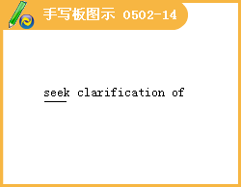
【例题18】
（1） When everybody was ______,the ship sailed.
A.above board B.across the board C.on board D.go by the board
[答疑编号911050301]
【答案】C
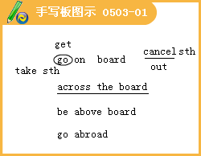
（2） The sports meeting has been _______because of the weather.
A.abolished B.missed C.returned D.cancelled
[答疑编号911050302]
【答案】D
【例题19】
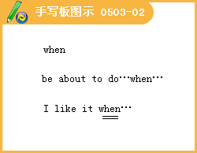
（1）He was about halfway through his meal ____a familiar voice came to his ears.
A.why B.where C.when D.while
[答疑编号911050303]
【答案】C
（2） I had just stepped out of the bathroom and was busily drying myself with a towel _______I heard the steps.
A.while B.when C.since D.after
[答疑编号911050304]
【答案】B
（3）完成句子
①天很黑，所以他不得不摸索前行。
It was very dark and he had to_______
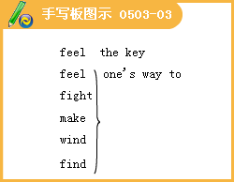
②99号公路沿着海岸线弯弯曲曲地延伸。
Highway 99______along the coast.
[答疑编号911050305]
【答案】①feel his way ②winds its way
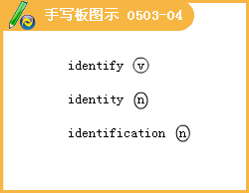
【例题20】
She can’t ______his happiness with her own.
A.identity B.identify C.identification D.identifies
[答疑编号911050306]
【答案】B
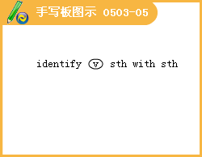
【例题21】
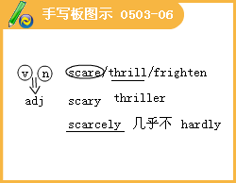
（1）Water _____on the mountains, we built many wells.
A.was scarce B.scarce C.being scarce D.being short
[答疑编号911050307]
【答案】C
（2）He scarcely knew a word of English,_______?
A.didn't he B.did he C.doesn't he D.haven't he
[答疑编号911050308]
【答案】B
【例题22】
The expert ______that there will be an earthquake in the area in the near future.
A.tells B.predicts C.foretells D.speaks
[答疑编号911050309]
【答案】B
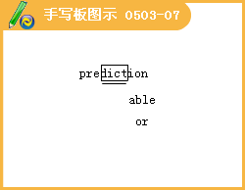
Lesson 2
◇[例题l]
（1）For about six months，he and his fellow staff have_______at the new design.
A.devoted B.engaged，C.took D.worked
[答疑编号911050401]
【答案】D
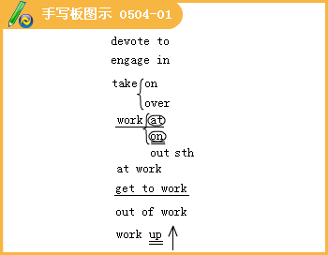
（2）We didn’t plan our art exhibition like that but it_______very well.
A.worked out B.tried out C.went on D.carried on
[答疑编号911050402]
【答案】A
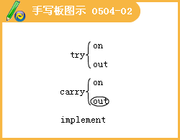
◇[例题2]
（1）I would_______against undue optimism.
A.caution B.cautious C.cautions D.caution to the winds
[答疑编号911050403]
【答案】A
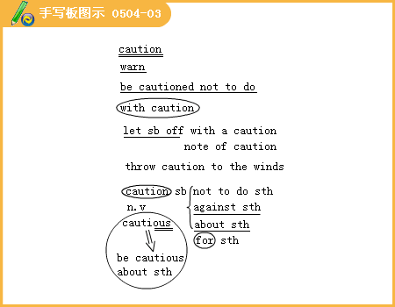
（2）完成句子：
①老师警告他不要迟到。
The teacher_______being late.
②她小心翼翼地环顾了一下四周，然后才离开了房子。
She_______around and then walked away from the house.
③政府警告说增加工资会导致失业。 。
The government_______that pay increases could lead to job losses.
[答疑编号911050404]
【答案】①cautioned him against ②looked cautiously ③cautioned
◇[例题3]
（1）The author of the guidebook is an architect_______.
A.of profess B.by professional C.of professor D.by profession
[答疑编号911050405]
【答案】D
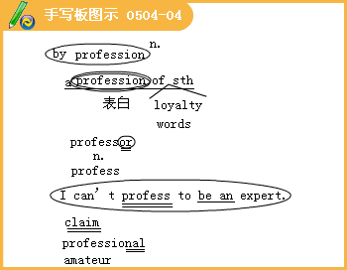
（2）She_______that she knows nothing about the plot.
A.professes B.professions C.professors D.professional
[答疑编号911050406]
【答案】A
◇[例题4] 完成句子：
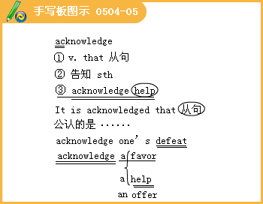
（1）他们拒绝承认失败。
They refused to_______.
They refused to acknowledge that
（2）公司送给他一块金表，以答谢他为公司所做的工作。
He were given a gold watch_______his work for the company
[答疑编号911050407]
【答案】（1）acknowledge defeat；they were defeated（2）in acknowledge of
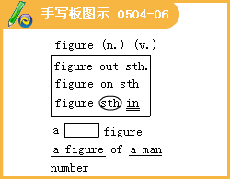
◇[例题5]
（1）His salary went into five_______a year.
A.figures B.numerals C.numbers D.fatigue
[答疑编号911050408]
【答案】A
（2）完成句子：
①I_______how much during the week I spent.
我算出了这个星期花了多少钱。
②How does she manage to_______when she eats so much?
她吃得这么多，究竟是怎样保持好身材的?
[答疑编号911050409]
【答案】①have figured out ②keep her figure
◇[例题6]
（1）The dog_______the door because it wanted to go in.A.scratched B.watched C.rubbed D.grasped
[答疑编号911050410]
【答案】A
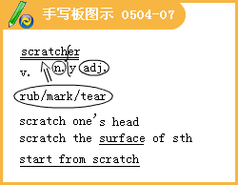
（2）The moment she meets difficult problem，she often_______.
A.scratch surface B.start from scratch
C.scratch her head D.scratches her head
[答疑编号911050411]
【答案】D
◇[例题7] 用much too或too much填空：
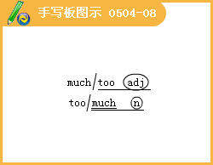
（1）You have given me_______.
（2）There is_______snow on the land.
（3）Look! My storybook is_______interestin9·
（4）I can not thank you_______for your kindness.
（5）The last group was just_______exciting.They played and sang really well.
[答疑编号911050412]
【答案】（1）too much （2）too much （3）much too （4）too much （5）much too
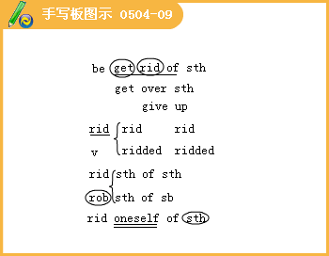
◇[例题8]
（1）The bosses knew that Joe was the soul of the strike and decided to him.
A.got rid B.get rid C.got rid of D.get rid of
[答疑编号911050413]
【答案】D
（2）完成句子：
①由于他所做的研究，联合国正力图让全世界人民摆脱饥饿。
Thanks to his research.the UN is trying to_______the world_______.
②我不得不把我的助手开除，因为他总是迟到。
I had to_______my assistant because he was habitually late.
[答疑编号911050414]
【答案】①rid；of hunger ②get rid of
◇[例题9]
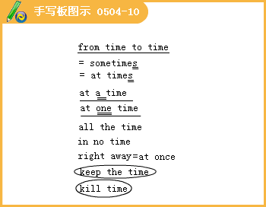
（1）Dick is suffering_______a cold which he caught_______his classmates.
A.from；in B.by；from C.from；from D.by；in
[答疑编号911050415]
【答案】C
（2）How far is it_______here_______the post office?
A.to；to B.from；to C.from；from D.／；to
[答疑编号911050416]
【答案】B
（3）完成句子
①孩子们很快就要离开家了。
The kids will be leaving home_______
②他有的时候脾气可真坏。
He can be really bad—tempered ③我刚好来得及赶上那班飞机。
1 was just_______for the flight.
④她一直哭着。
She kept crying_______.
[答疑编号911050417]
【答案】①in no time ②at times ③in time ④all the time
◇[例题10] 完成句子：
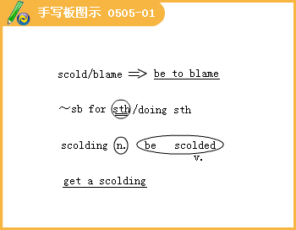
（1）我挨了我妈一阵数落。
I_______from my mother.
（2）那个警察责备那个司机超速行驶。
The policeman_______the driver_______.
（3）当他在商店里偷东西的时候，被老板抓住并训斥了一顿。
He_______by the shopkeeper when caught stealing in the shop.
[答疑编号911050501]
【答案】（1）got a scolding （2）scolded；for speeding （3）was scolded
◇[例题11]
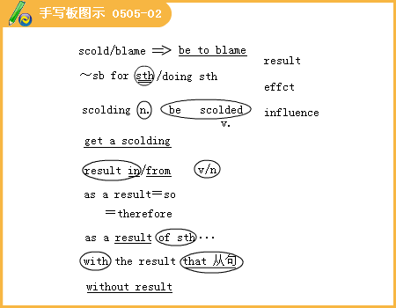
（1）The pain in his back_______from a fall several years ago.
A.terminates B.ends C.results D.is due
[答疑编号911050502]
【答案】C
（2）Over 200 people died_______the air crash.
A.with regard to B.as a result of
C.in the course of D.on the grounds of
[答疑编号911050503]
【答案】B
（3）My friend Martin was very sick with a high fever；_______，he could neither eat nor sleep.
A.as a result B.after all
C.any way D.otherwise
[答疑编号911050504]
【答案】A
◇[例题l2]
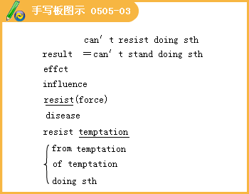
（1）完成句子：
①I_______taking a look at him.
我忍不住看了他一眼。
②She_______him what she really thought.
她克制住自己，没有把真实想法告诉他。
[答疑编号911050505]
【答案】①can’t resist ②resisted telling
（2）Will this new wall_______the force of the sea?
A.enforce B.resist C.reserve D.defend
[答疑编号911050506]
【答案】B
◇[例题l3]
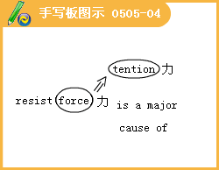
The incident has further increased the_______between the two countries.
A.admission B.permission C.division D.tension
[答疑编号911050507]
【答案】D
◇[例题l4]
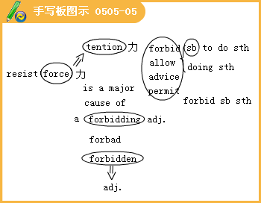
（1）Their parents_______them to drink.
A.prohibit B.forbid C.ignore D.block
[答疑编号911050508]
【答案】B
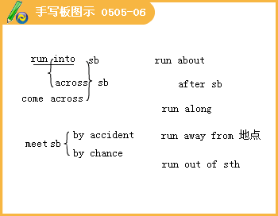
◇[例题l5]
（1）完成句子：
①公司起初很有生机，但此后便陷入困境。
After a promising start，the company_______.
②两个孩子被轧死了。
Two children were_______and killed.
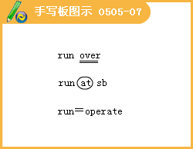
③下班回家的路上有个强盗拿着刀子朝我冲过来。
The robber_______me with a knife on my way back from work.
[答疑编号911050509]
【答案】①ran into trouble ② ran over ③ run at
（2）Let the motor_______until it warms up.
A.run B.move C.motion D.go
[答疑编号911050510]
【答案】A
（3）The army has_______grain.They are in a very difficult situation.
A.run down B.run out of C.run off D.run into
[答疑编号911050511]
【答案】B
◇[例题l6]
Computer Science is an_______subject for law students at our university，and many students in my class choose it
A.optical B.option C.opponent D.optional
[答疑编号911050512]
【答案】D
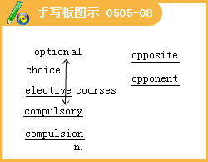
Lesson 3
◇[例题l]
I appreciate the_______of Zhao Benshan very much.
A.play B.film C.comedy D.action
[答疑编号911050513]
【答案】C
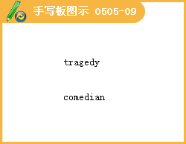
◇[例题2]
（1）单句改错：
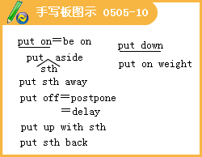
①She has her hair long.
②He had on his coat，went downstairs and soon disappeared in the darkness.
③ Joan is having on a red coat today.
④ The dress is beautiful；please try on it.
[答疑编号911050514]
【答案】①hasàwears ②had_àput ③having onàwearing ④on ità it on
（2）You can take anything from the shelf and read，but please_______the books when you’ve finished with them.
A.put on B.put down C.put back D.put off
[答疑编号911050515]
【答案】C
（3）The forest guards often find campfires that have not been
_______completely.
A.turned down B.put out C.put away D.turned over
[答疑编号911050516]
【答案】B
◇[例题3]
（1）I like the goods of that store，but the pushy salesgirls there .
A.turn me down B.turn me off C.take me off D.cut me off
[答疑编号911050601]
【答案】B
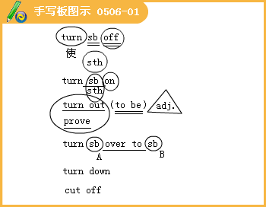
（2）完成句子：
①我们就是在这儿转往北京的。
This is where we Beijing.
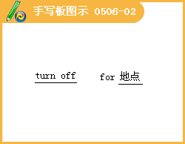
②他们修理爆裂的水管时，关上了水门。
They the water while they mended a burst pipe.
[答疑编号911050602]
【答案】①turn off for ②turned off
◇[例题4]
（1）完成句子：
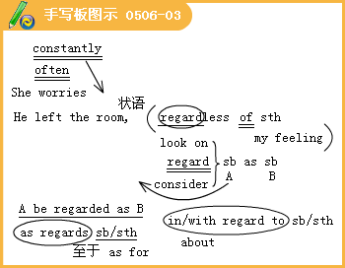
①伊迪丝穿着古怪，被大家视为怪人。
Edith wore strange clothes and widely an eccentric.
②你受到许多批评，但无论如何你必须坚持下去。
You have got a lot of criticism but you just have to______
③我们所有的建议都遭到了拒绝，不管它们的价值如何。
All our proposals were rejected their merit.
[答疑编号911050603]
【答案】①was regarded as ②carry on regardless ③regardless of
（2）She became a customer of the bookshop.
A.continuous B.constant C.content D.consent
[答疑编号911050604]
【答案】B
（3）Regardless 0ur mistakes，the teacher corrected our thesis patiently.
A.in B.of C.for D.about
[答疑编号911050605]
【答案】B
◇[例题5]
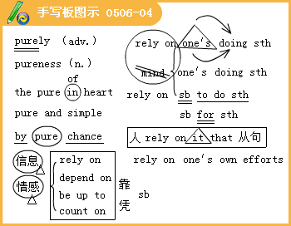
（1）By coincidence we met in Beijing for the second time.
A.pure B.purity C.through D.poor
[答疑编号911050606]
【答案】A
（2）The people on the island on the supplies that were brought from the mainland.
A.acted B.called C.put D.relied
[答疑编号911050607]
【答案】D
（3）Nowadays we increasingly computer for help US.
A.rely；with B.depend；with C.rely；upon D.trust；on
[答疑编号911050608]
【答案】C
◇[例题6]
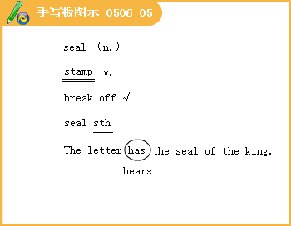
I've bought to put around the edge of the bath.
A.a water B.a rubber C.a seal D.a field
[答疑编号911050609]
【答案】C
◇[例题7]
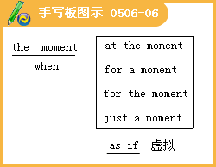
（1）The classroom is big enough ，but we’11 have to move if we have more students.
A.for the moment B.on the moment C.in a moment D.for a moment
[答疑编号911050610]
【答案】A
（2）The young woman loved the boy he were her own son.
A.as long as B.even if C.as soon as D.as if
[答疑编号911050611]
【答案】D
（3）It seems as if we to walk home.
A.have B.had C.will have D.shall have
[答疑编号911050612]
【答案】D
◇[例题8]
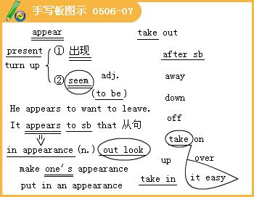
（1）My at the party was not very welcome.
A.engagement B.gathering C.meeting D.appearance
[答疑编号911050613]
【答案】D
（2）The student his dictionary and looked the word up in it.
A.took off B.took back C.took down D.took out
[答疑编号911050614]
【答案】 D
（3）The cry was and soon everyone was nodding and saying，“But he has nothing .”
A.taken out；on B.taken up；on
C.taken up；on D.taken off；in
[答疑编号911050615]
【答案】C
◇[例题9]
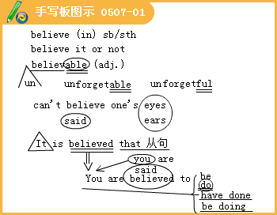
完成句子：
（1）眼见为实。
Seeing is .
（2）人们普遍认为他们正计划进行收购。
They widely be planning a takeover bid.
（3）他从衣袋里掏出一把枪的时候，我简直不敢相信自己的眼睛。
I could hardly when he took a gun out of his pocket.
（4）我相信他的话是真的，但我不信任他。
I him，but I don’t him.
[答疑编号911050701]
【答案】（1）believing （2）are；believed to （3）believe my eyes
（4）believe；believe in
◇[例题10]
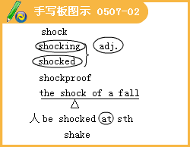
（1）I felt the as the aircraft hit the ground.
A.surprise B.result C.shock D.fall
[答疑编号911050702]
【答案】C
（2）I m not easily ，but that book really is obscene.
A.surprised B.shocking C.shocked D.surprising
[答疑编号911050703]
【答案】C
◇[例题11]
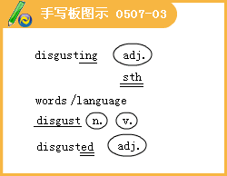
He always says some language，so we are
at him.
A.disgusted；disgusted B.disgusting；disgusted
C.disgusting；disgusting D.disgusted；disgusting
[答疑编号911050704]
【答案】Ｂ
◇[例题12]
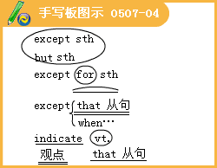
（1）I know nothing about the young lady she is from Beijing.
A.except B.except for C.except that D.besides
[答疑编号911050705]
【答案】C
（2）One can’t perfection.
A.except B.expect C.respect D.inspect
[答疑编号911050706]
【答案】Ｂ
（3）With a nod of his head he to me where I should sit.
A.told B.said C.indicated D.asked
[答疑编号911050707]
【答案】C
◇[例题l3]
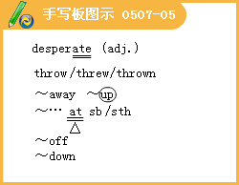
（1）The prisoners became in their attempts to escape.
A.despite B.discard C.desperate D.desolate
[答疑编号911050708]
【答案】C
（2）The girl her clothes and herself into the sea.
A.threw off；jumped B.threw away；threw
C.threw off；threw D.threw up；dropped
[答疑编号911050709]
【答案】C
（3） --What happened to you?
--I felt a little sick and I what I had eaten.
A.threw away B.threw at C.threw off D.threw up
[答疑编号911050710]
【答案】D
◇[例题l4]
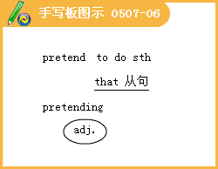
When they met in the street，they pretended each other.
A.not to know B.to not know C.knowing not D.not knowing
[答疑编号911050711]
【答案】A
◇[例题l5]
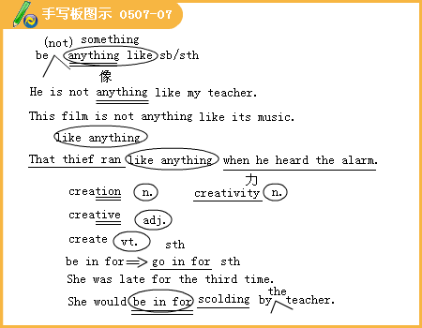
（1）He is his father.
A.something like B.anything like C.not something like D.1ike anything
[答疑编号911050712]
【答案】A
（2）Lenin stressed that it is precisely the people who history.
A.invent B.imagine C.create D.discover
[答疑编号911050713]
【答案】C
（3）完成句子：
①校长看见我在黑板上画画，这下子我可惹麻烦了。
The headmaster saw me draw the picture on the blackboard—Ｉ
it now.
②要是她发现你做的事，你就要挨骂了。
You’11 it if she finds out what you’ve done.
[答疑编号911050714]
【答案】①am in for ②be in for
◇[例题l 6]
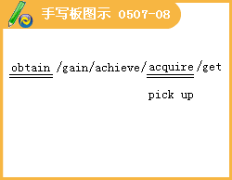
（1）完成句子：
①在哪里能买到她最新出版的书?
Where can I a copy of her latest book?
②他总是有办法得到他想要的东西。
He always manages to .
③他很好地掌握了英语这门语言。
He a good command of English language.
④在工作领域，妇女还没有取得完全平等的地位。
Women have yet to full equality in the workplace.
[答疑编号911050715]
【答案】①obtain／get ②obtain what he wants ③has acquired ④achieve
（2）Learning a foreign language is a question of learning new skills，of
new knowledge.
A.getting B.achieving C.obtaining D.acquiring
[答疑编号911050716]
【答案】C
◇[例题l7]
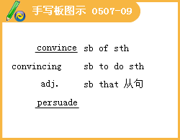
（1）完成句子：
①我怎样才能使你相信她是诚实的呢?
How can Ｉ you her honesty?
How can you her honesty?
②我一直设法说服琼跟我一起来。
I've been trying to Jean come with me.
[答疑编号911050717]
【答案】①convince；of；be convinced of ②convince；to
（2）He couldn’t his father that John was telling the truth.
A.convince B.believe C.ensure D.conceive
[答疑编号911050718]
【答案】A
◇[例题l8]
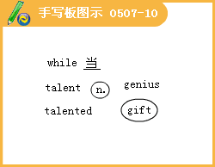
（1）We thought there were 35 students in the dining hall， ，in fact，there were 40.
A.while B.whether C. that D.which
[答疑编号911050719]
【答案】A
（2）While watching television， .
A.the doorbell rang B.the doorbell rings
C.we heard the doorbell ring D.we heard the doorbell rings
[答疑编号911050720]
【答案】C
（3）This little boy is a rare as a pianist，
A. expert B.authority C.skill D.talent .
[答疑编号911050721]
【答案】D
◇[例题l9]
（1）“You can’t have this football back you promise not to kick it at my cat again.
A.because B.since C.when D.until
[答疑编号911050722]
【答案】D
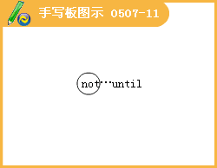
（2）It is difficult for us to learn a lesson in life we’ve actually had that lesson.
A.until B.after C.since D.when
[答疑编号911050723]
【答案】A
◇[例题20]
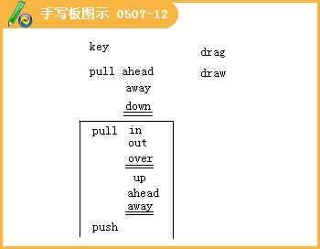
（1）The to the settlement of the question lies in the unity.
A.point B.answer C.key D.tie
[答疑编号911050724]
【答案】C
（2）The train was when we hurriedly got to the platform.
A.pull on B.pulling off C.pulling round D.pulling out
[答疑编号911050725]
【答案】D
（3）The old lady was seriously ill for a time，but she managed to with careful nursing in hospital.
A.pull through B.pull down C.pull in D.pull up
[答疑编号911050726]
【答案】A
◇[例题21]
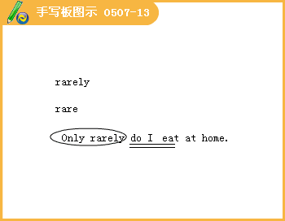
（1）It is for a person in his position to make such a mistake.
A.rare B.scarce C.usual D.rarely
[答疑编号911050727]
【答案】A
（2）The girl is a with languages.
A.genie B.genesis C.genuine D.genius
[答疑编号911050728]
【答案】D
Lesson 4 Communication Workshop
◇[例题l]
（1）He finally——to find the reference book that he had been looking for.
A.tried
B.attempted
C.run
D.managed
[答疑编号911050801]
【答案】D
1.Six of us managed to escape the sinking ship in a life boat，but it was soon upset by the waves.
我们六人设法通过救生船逃离即将下沉的船，但是很快救生船就被波浪打翻了。
（1）manage管理，经营；设法得以……，终于；操，纵，驾驭，对付
I finaHy managed to find what l was looking for.
我终于设法找到了一直要找的东西。
She knows how to manage him when he is angry.
她知道他生气时如何对付他。
He managed the company while his father was ill.
父亲生病期间他管理公司。
They managed quite well on very little money.
他们靠很少的钱把日子过得不错。
① manage to do sth.设法做成某事
辨析：manage to do与try to do
manage to do与try to do近义，但manage to do表示“设法做成某事”，有“已达成（=succeed in doing）”之意，而try to do表示“企图去做”某事。
She managed to get the work done with very little help.
她在没有多少帮助的情况下设法把工作完成了。
She tried to get the work done witll very little help.
她努力在没有多少帮助的情况下完成这一工作。
②相关词语：management n.管理、经营
③记忆技巧：后缀法联想记忆，后缀ment表示“结果，手段，状态”等，如manage+ment_management：n.管理develop+ment development n.发展；govern+ment ---+government n.统治，统治方式
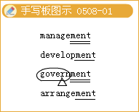
（2）upset弄翻，打翻；扰乱，打乱，使不安
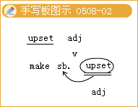
（3）sinking属现在分词作定语。
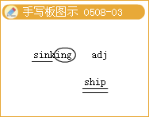
提示：
①单个的现在分词作定语时，常放在被修饰词的前面；现在分词短语作定语时，一般放在被修饰词的后面。
②现在分词修饰something，everything，anything等不定代词或指示代词those等时，要放在这些词的后面。
③现在分词作定语说明一个主动动作正在进行。 。
④现在分词的完成式having done或完成被动式having been done不能作定语，也不能作补足语。
（2）The company’S failure was mainly due to its bad
A.run
B.management
C.deal
D.handle
[答疑编号911050802]
【答案】B
（3）Because he didn’t finish the work on time and was fired by the company，he was very——about it.
A.upset
B.upseted
C.upsetting
D.upright
[答疑编号911050803]
【答案】A
（4）— Who called me this morning when l was out?
— A man calling——Robert.
A.him
B.himself
C.his
D.／
[答疑编号911050804]
【答案】B
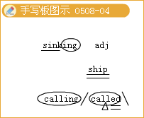
2.I swam，pushed forward by the wind and the water.我游着，被风和水向前推着。
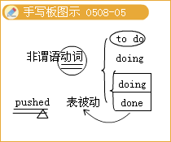
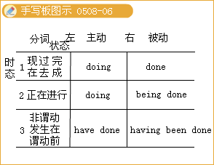
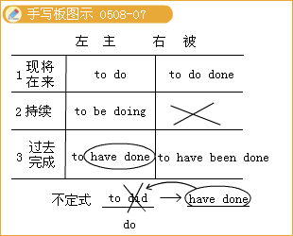
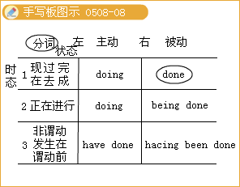
◇[例题2]
（1） with so much trouble，we failed to complete the task on time.
A.Faced
B.Face
C.Facing
D.To face
[答疑编号911050805]
【答案】A
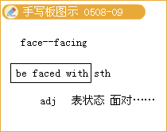
（2） for the breakdown of the school computer network，Mice was in low spirits.
A.Blaming
B.Blamed
C.To blame
D.To be blamed
[答疑编号911050806]
【答案】B
3.I tried to rise，but I found that my arms and legs were strongly tied to the ground.
我试图站起来，但我发现我的胳膊和腿被牢牢地绑在地上
Tie
n.（also necktie）strip of decorative material worn round the neck under the collar and knotted in’front领带
bind（sth.）with rope，string，etc.系；
经典例句：He always wears a shirt and tie. 他总是穿衬衣戴领带。
Tie the horse to the tree.把马拴在树上。
Shall I tie the package or tape it? 我把这个包裹捆起来还是贴胶带?
vt.＆vi.不分胜负；打成平局
Last night’s vote was tied.昨晚表决的票数相同。
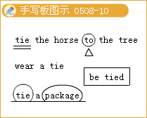
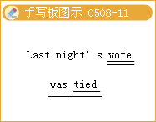
◇[例题3]Make sure the parcel is securely up before you post it.
A.tied
B.packed
C.loaded
D.installed
[答疑编号911050807]
【答案】A
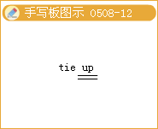
4.I looked down as much as I could and saw a human creature just six inches high，with a bow and arrow in his hands.我尽力朝下看，发现了一个手里拿着弓和箭的只有6英寸高的小人。
结构分析：with a bow and arrow in his hands是with复合结构形式之一：with+宾语+介词短语。该结构在句中作后置定语，修饰 creature。
with复合结构具体形式：
现在分词（宾语正发出该动作）
过去分词（宾语已承受该动作）
该结构在句中常用作状语，表示时间、条件、伴随、方式、原因等。
经典例句：She said goodbye with tears in her eyes. 她含着泪水说再见。
He was standing with his hands in his pockets.他双手插在口袋里站着。
He was thinking for a while with his eyes shut. 他闭着眼睛思考片刻。
With spring coming on，everything comes to life. 春天来了，万物复苏。
He used to sleep with the windows open. 他过去常常开着窗户睡觉。
With nothing to do，I went out for a walk. 由于没有什么事要做，我便到外面散步。
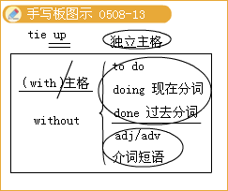
◇[例题4]
（1） production up by 60%，the company has had another excellent year.
A.As
B.For
C.With
D.Though
[答疑编号911050808]
【答案】C
（2） two exams to worry about，I have to work really hard this weekend.
A.With
B.Besides
C.As for
D.Because of
[答疑编号911050809]
【答案】A
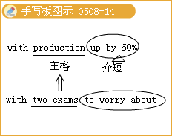
（3） and no way to reduce her pain and suffering from the terrible disease，the patient sought her doctor’s help to end her life.
A.Having given up hope of cure
B.With no hope for cure
C.There being hope for cure
D.In the hope of cure
[答疑编号911050810]
【答案】B
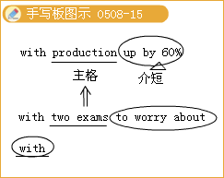
5.After being almost starved with hunger，I showed that l wanted food.
在我饿得慌后，我比划着我需要吃饭
Starve 饿死，挨饿，饿得慌；使挨饿
He starved to death in a hunger strike. 他在一次绝食斗争中饿死了。
Thousands could starve if the crops fail again.如果粮食再次欠收，可能会有数以千计的人挨饿。
词汇拓展：
be starving十分饥饿
be starve of非常需要
starve for渴望得到
I’m starving.Let’s have lunch. 我饿坏了。我们去吃午饭吧。
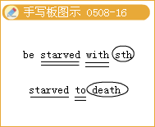
◇[例题5] The plant was——light and died.
A.starve
B.starving
C.starved of
D.starve for
[答疑编号911050811]
【答案】C
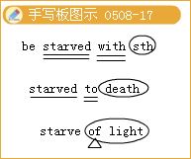
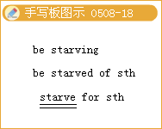
6.I started to yawn and quickly fall asleep.我开始打呵欠，很快就入睡了。
Yawn vi.打呵欠；n.呵欠
make sb.yawn使某人困倦
with a yawn打着呵欠
◇[例题6]A dull speech greeted with——.
A.yawns
B.applause
C.welcome
D.reply
[答疑编号911050812]
【答案】A
7.And it was no wonder，for their doctors，by the Emperor’s order，had put a sleeping drug in with the wine·.
这就不足为奇了，因为他们的医生按皇帝的旨意在酒里下了一种有助于睡眠的药物
（1）no wonder不足为奇，难怪
wonder／SwAnd9／n.惊奇，惊异；奇迹，奇事；仉诧异，奇怪；纳闷，想知道
（2）no wonder难怪。常见搭配如下：
It is no wonder that…
No wonder that…
He had made a thorough investigation.No wonder he knew so much about it.
他进行了彻底的调查。难怪他对此事了解这么多。
（3）by在此处有“按照，根据”之意。常见搭配如下：
by the day／week／month按日／周／月
by the dozen／yard／ton论打／码／吨（by+the+单数名词）
by weight按重量（by+不可数名词）
in calories／pounds／meters
以卡／磅／米为单位（in+复数名词）
（4）句中for是并列连词，意为“因为”，连接并列句，起补充说明的作用。
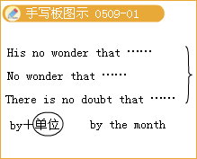
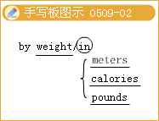
◇[例题7]
（1）There was an accident. the traffic is blocked.
A.There is no point
B.There is no need
C.It is no wonder
D.It is no way
[答疑编号911050901]
【答案】C
（2） Tom’S got a headache；he drank SO much last night.
A.No doubt
B.Above all
C.Of course
D.No wonder
[答疑编号911050902]
【答案】D
（3）We can buy the materials meters or the yard.
A.in；by
B.in；in
C.by；in
D.by；by
[答疑编号911050903]
【答案】A
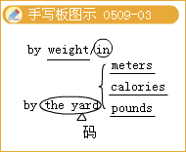
8.Think about the other people who were involved.Were they funny，tough，nervous?
想想其他相关的人，他们滑稽、粗鲁、紧张吗?
Tough （tougher，toughest）
（1）难办的；棘手的；费力的
Being the new kid at school is always tough.
孩子刚入学时总会遇到些困难。
（2）坚强的；能吃苦耐劳的
Mary is a tough lady.
玛丽是一位坚强的女士。
（3）坚定的；严格的
Mom was always very tough with us kids
妈妈对我们这些小孩总是很严格。
（4）不幸的；不公平的
Losing his job was tough on him.
失去工作对他来说是很不幸的。
It is very tough on her that she should lose her job because of someone else’s mistake.
非常不幸的是，由于别人的错误导致她失去了工作。
词汇链接：toughly adv.粗暴地，猛烈地；toughen vt.＆vi.（使）坚硬
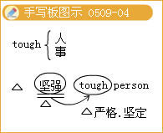
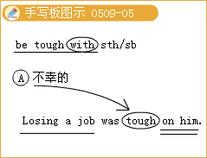
◇[例题8]Explorers have to be to endure all kinds of hardships.
A.rough
B.tough
C.brave
D.raw
[答疑编号911050904]
【答案】B
9.thanks to幸亏，多亏
thanks to是介词短语，意思是“幸亏；多亏；依赖；依靠；由于；因为”。多用于句首，可以表达正面的意义，也可以表达负面的意义，特别是用在含有讽刺意味的句子中。
Thanks to your help，I passed the test. 幸亏你的帮助，我测验及格了。
Thanks to the bad weather，the match had been canceHed. 因为坏天气，比赛取消了。
“由于；因为”的表达方式：
thanks to[n.+prep.]由于；多亏（作状语）
because of[conj.+prep.]因为，由于（作状语）
result fromh+prep.]起因，由于（作谓语）
owing to+prep.]由于（作表语或状语）
due to+prep.]由于（作表语或状语，不用于句首）
The project failed due to lack of money.那项计划因资金不足而失败。
Owing to the shower.the baseball game was interrupted. 由于阵雨，那场棒球比赛中止了。
It was thanks to his advice that I succeeded. 多亏了他的忠告我才得以成功。x
I was late because of the rain.因为下雨我迟到了。
But for your help we should not have finished it on time.多亏你的帮助，否则我们不会按时完成这项工作。
注意：due to，owing to，thanks to和because of都是介词短语，后面跟名词或代词，不能跟从句或动词不定式毛使用but for时，主句一般使用虚拟语气。
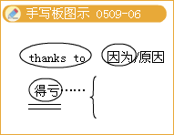
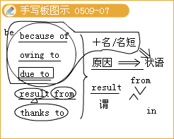
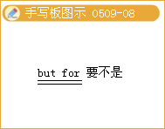
◇[例题9]
（1） the new policy，we are now having a happy life.
A.Thanks to
B.Because
C.For
D.Thank for
[答疑编号911050905]
【答案】A
（2） our English teacher，our English has been g-ready improved.
A.Thanks to
B.Thank for
C.But for
D.Except for
[答疑编号911050906]
【答案】A
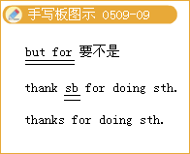
10.accomplish／a’kAmpllf／vt.成功，完成，取得（成就）；实现；达到（目标），所跟名词多是aim，journey，mission，purpose，task等抽象名词
经典例句：A lazy man would never accomplish anything. 懒惰的人永远一事无成。
Mr Thomas Was considered a inan who would never accomplish anything.
托马斯先生被认为是一个永远一事无成的人。
It was a real accomplishment to finish the work in two days. 两天就完成了这项工作真不一般。
Being an accomplished cook，he enjoys very good salary. 他是一个技艺精湛的厨师，工资收入很可观。
accomplish one’s object／aim达到目标
accomplish one’s mission完成使命
accomplishment n.成就，专长
accomplished adj.熟练的
be accomplished in擅长…
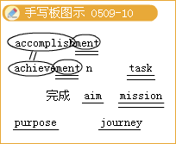
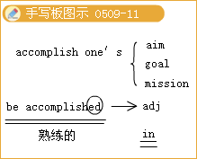
◇[例题l0]
（1）The best method to this goal is to unite as many sympathetic people as possible with the labor movement itself.
A.accompany
B.finish
C.accomplish
D.complete
[答疑编号911050907]
【答案】C
（2）Man’s first walk on the moon was a stunning technological .
A.Success
B.achievement
C.succession
D.accomplishment
[答疑编号911050908]
【答案】B
语法专练
1.一般现在时与现在进行时
（1）一般现在时
①表示经常或习惯性的动作或者叙述现在的事实。常用的时间状语有：always，usually，often，sometimes，seldom，never，every day（week，month，year），once a week，now and then，from time to time，at times等
We go to work every day except Sunday.
除了星期天我们天天上班。
He is always ready to help others.
他总是乐于助人。
②表示客观事实或客观真理。
The teacher told the students that the earth moves around the sun.
老师告诉学生地球绕着太阳转。
③一些表示运动的不及物动词常用一般现在时表示安排或计划好了的将来动作。此类动词有：come，go，leave，arrive，fly，return，be，start，begin，open，close，end，stop等。
The CCTV news begins at 7：00 P.m..
中央电视台新闻联播晚上7点开始。
The movie starts in l o minutes，hurry up!
电影10分钟后开演，快点!
④在以here或there开头的倒装句中用一般现在时表示正在进行的动作。
Look!Here comes the train.
看!火车来了。
Listen!There goes the bell.
听!铃响了。
⑤在时间状语或条件状语从句中通常用一般现在时代替一般将来时。引导此类从句的词有：when，as，while，before，after，whenever，till，until，as soon as，the moment，if，unless，once， as long as，on condition that等。
I’11 give the book to him as soon as I see him.
我一见到他就把书给他。
Ⅱyou go，so shall l.
如果你去我也去。
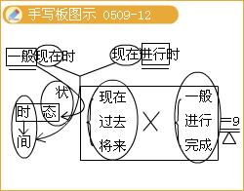
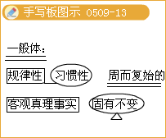
（2）现在进行时
现在进行时表示现在正在进行的动作。
---What are you doing?你在干什么?
---1’m doing some sewin9.我正在缝衣服。
They are discussing how to sell the books elsewhere.
他们正在讨论如何在别的地方销售这些书
有些动词（如：go，come，stay，leave，start等）的现在进行时形式也可以表示将来即将发生的动作。
Your father is coming to see you tomorrow.
你父亲明天要来看你。
The plane is leaving for Paris.
这架飞机要飞往巴黎。
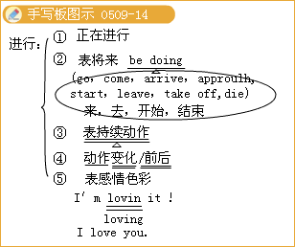
2.一般过去时与过去进行时
（1）一般过去时
一般过去时通常由动词的过去式表示。规则动词的过去式是在动词末尾加一ed或一d，个别动词需要双写词尾的辅音字母后再加一ed或变y为i再加一ed。不规则动词的过去式有其特殊形式。
①一般过去时主要用于表示过去某一时刻或某段时间发生的事、存在的状态（包括习惯性动作），常与表示过去的时间状语last night，yesterday等连用。
The plane arrived ten minutes ago.
After graduation he first worked as a driver，and then started a company
②表示过去经常发生的或习惯性的动作，used to表示“过去常常做……，现在不再做了”；而would只表示过去的一个习惯性动作，可以表示为“used to／would+动词原形”。
Mike used to get up late.
During the vacation we would go skating in winter.
（2）过去进行时
过去进行时主要用于表示过去某个时刻或某段时间内正在进行或继续进行的动作。过去进行时经常与过去时搭配使用。
In 2006，he was studying in a university in the south.
I don’t think he heard me.He was arguing with you.We were walking along the street when the accident happened.
注意：与现在进行时一样，过去进行时也可与always，frequently等副词连用，表示过去频繁发生的动作，强调说话者的个人情感。
The old man was always mislaying his keys.
（3）一般过去时与过去进行时的用法比较
①一般过去时表示在过去某个时间发生的动作或存在的状态，往往表示动作已完成；而过去进行时则表示过去某个时间正在进行的动作，表示动作的未完成性。
比较：
Kate wrote a letter to her friend last night.
Kate was writing a letter to her friend last night.
I read a novel last night.
I was reading a novel last night.
②过去进行时和一般过去时都可表示过去某段时间内发生的动作或情况，但过去进行时通常用来说明短暂的动作和状态.侧重于动作持续时间的长短；而一般过去时则只说明过去发生了某事的事实。
I often went to swim while l was living in Qingdao.
I was running downstairs when I saw her.
3.现在完成时与现在完成进行时
对于一般动词来说，现在完成时强调动作已经结束；现在完成进行时强调动作的延续过程，动作可能结束，也可能还在进行。
I have written a book.（动作结束）
I have been writing a book.（可能未写完，侧重最近一直忙于写书）
对于某些动词如work，live，stay，wait等，两种时态几乎相同。
I have worked here for lo years.
I have been working here for l o years.
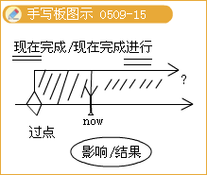
4.过去完成进行时
（1）过去完成进行时的形式
（2）过去完成进行时的基本用法
过去完成进行时表示动作在过去某一时间之前开始，一直延续到这一过去时间。动作是否继续下去，由上下文而定。和过去完成时一样，过去完成进行时也必须以一过去时间为前提。
I had been looking for it for days before I found it.
这个东西，我找了很多天才找着。
We’d only been waiting for the bus a few moments when it came.
我们只等了一会儿，公车就来了。
The telephone had been ringing for three minutes before it was answered.
电话响了三分钟才有人接。
如果上下文清楚，过去时间也可省去
He was tired.He’d been working all day.
他累了。他工作了一整天。
过去完成进行时还常用在间接引语中。
The doctor asked what he had been eating.
医生问他吃什么来着。
和过去完成时一样，过去完成进行时后亦可接具有“突然”意义的when从句（此从句用一般过去时）。
I had only been reading for a few minutes when he came in.
我刚看了几分钟书他就进来了。
She’d only been studying her lesson for ten minutes when her little brother interrupted her.
她温习功课不过十分钟，她的小弟弟就把她打断了。
（3）过去完成进行时应注意的几点
过去完成进行时：表示在过去某个具体时间之前正在进行的动作，强调动作的持续性，而不是最终结果。如：
I finally saw Bob at 4：00 P.m..I had been waiting for hours.
我最后见到鲍勃是在下午4点，我已经等了好几个小时了。
It was 3：00 P.m..The runners had been running since 10：48 a.m.
现在是下午3点，赛跑者从上午l0点48分就开始跑了。
注意：非行为动词通常不用于进行时。
It was 6：00 P.m..He had had a headache all day.
现在是下午6点.他已经头疼了一整天了。
不能说：He had been having a headache all day.
过去完成进行时总是表示与另一过去动作之间的关系。使用过去完成进行时表示先发生的事件，使用一般过去时表示后发生的事件。
She had been practicing for two years when she entered the race.
她参加比赛时已练习了两年。
（她先练习，后参加比赛。）
过去完成进行时：表示基于过去事件得出结论。
She was out of breath.It was clear that she had been running.
她上气不接下气。很明显她一直在跑。
The streets were wet.It had been raining.
街道湿了。天一直在下雨。
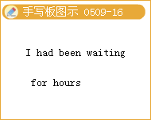
语法专题
1.Since you weren’t at the meeting，we .the decision without you。
A.made
B.had made
C.were making
D.would make
[答疑编号911050909]
【答案】A
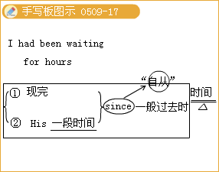
2.The plane at 7：00 p.m.，so I have to be at the airport by 6：40 at the latest.
A.has left
B.would leave
C.will have left
D.leaves
[答疑编号911050910]
【答案】 D
3.I can no longer put up with her；she always me as a child.
A.does.treat，
B./, treats
C.has；treated
D.has；been treating
[答疑编号911050911]
【答案】C
4.I can guess you were in a hurry.You your sweater inside out.
A.had worn
B.wore
C.were wearing
D.are wearing
[答疑编号911050912]
【答案】D
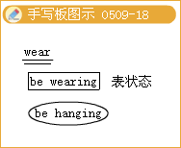
5.一Has Tom returned from Japan yet? I'd like to meet him.
一I’m terribly sorry，but he back here only for last weekend.
A.has been
B.would be
C.had been
D.was
[答疑编号911050913]
【答案】D
6.-- Why didn’t Tow have his lunch? It's already one o'clock.
-- His pet bird this morning.He still for quire a long time in his room crying.
A.died；had sat
B.has died；has sat
C.has died；is sitting
D.died；has been sitting
[答疑编号911050914]
【答案】D
7.--Everyone was at the party except you.What happened?
--I after Mike，my pet dog，at home.It was ill.
A.have looked
B.was looking
C. would look
D. had looked
[答疑编号911050915]
【答案】B
8.An increasing number of students，year by year，across China hard to realize their dream of studying abroad.
A.try
B.have tried
C.will try
D.are trying
[答疑编号911050916]
【答案】D
9.阅读下面文章，用括号内动词的适当形式填空。
Marathon Running
On October 23，I ran the Boston Marathon with a partner， Marcia Davis.We （1） （train）together since last year，and we （2） （plan）to enter the race ever since we saw Oprah in the Washington Marathon.The start of the race was dramatic.Up to that point，we （3） （joke and laugh），but we were very serious when we lined up.1 was so nervous I couldn’t breathe.Marcia and I （4） （practice）on those same streets for a couple of weeks，so at the beginning we did well.By the time we got to Heartbreak Hill，we （5） （run）for almost four hours，and I really believed we could finish.Then，halfway up the hill, Marcia stopped.She just couldn’t run anymore.We （6）（look forward）to this race for so long that I didn’t want to go on alone，but Marcia wanted me to finish.When I got to the finish line，I saw Marcia.She （7） （wait）for me for three hours.First we cried.Then we started talking about next year’s marathon.
[答疑编号911050917]
【答案】 （1）had been training（2）had been planning（3）had been joking and laughing（4）had been practicing
（5）had been running（6）had been looking forward（7）had been waiting
Lesson 5 Language Awareness & Culture Corner
1.This story is about a middle-aged man who was feeling very down.
这个故事是关于一个失意的中年人的。
结构分析：该句是一个复合句。who引导定语从句，修饰先行词man。另外，middle—aged属合成形容词，作定语，修饰man。
归纳拓展：
合成形容词很多是由过去分词或带一ed词尾的词构成的：
Absent minded心不在焉的 cold blooded冷血的
good—tempered脾气好的 kind—hearted心肠好的
Harrow—minded心胸狭隘的 short—handed人手短缺的
middle—sized中等身高的 middle—aged中年的
◇[例题l]
（1）Her pet is a______dog.
A.middle—size B.middle—sizing
C.middle—sizes D.middle—sized
[答疑编号911051001]
【答案】D
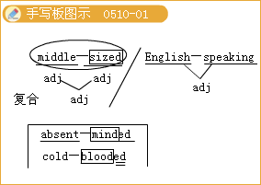

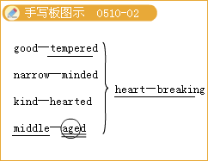
（2）At class she was in an______state，so she missed half of the key points.
A.absent—minding B.absence—minded
C.absent—mind D.absent—minded
[答疑编号911051002]
【答案】D
2.He had had problems at work and his wife had left him to go off with a lion tamer。
他在工作中出了问题，他妻子离开他和一个驯兽员私奔了
go off with（没经许可）拿走，携（款）跑掉，和……私奔
She’S gone off with my book.她没经许可就把我的书拿走了。
The girl went off with the gamekeeper.那女孩同猎场看守人私奔了。
相关短语：
go on继续
go over仔细检查（或审查、查阅）某事；反复研究，仔细琢磨
go after追逐，追求
go ahead前进，开始
go by经过，过去，遵守
go in for从事，沉迷于
go into加入，投入；研究，调查，审查
go out熄灭
go through完成，做完（with），审查，检查
go with陪伴；与……一致，适合
go off爆炸
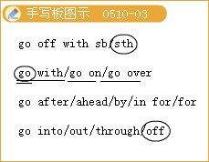
◇[例题2]
（1）After twenty、years of honest service the cashier suddenly______￡1 00，000 0f company’s money.
A.go off with B.go with
C.went with D.went off with
[答疑编号911051003]
【答案】D
（2）In the recent years，many new laws and rules have been drawn up for people to______in their economic activities.
A.go without B.go after
C.go against D.go by
[答疑编号911051004]
【答案】D
3.So，after he had been feeling depressed for over a month，he decided to go to the doctor.
一个多月以来，他一直感到很压抑，于是他决定去看医生。
结构分析：had been feeling depressed为过去完成进行时，表示过去一段时间以来一直进行的动作。
depress vt.
（1）使低沉、压抑；使人忧愁，消沉，沮丧
Wet weather always depresses me.阴雨天总是使我情绪压抑。
（2）将某物压下、推下、拉下
depress a piano key按钢琴键
（3）使（尤指贸易）不活跃、不景气、萧条
depress sales使销售额下降
A rise in oil prices depresses the car market.
油价上涨导致汽车市场不景气。
相关词语：depression n.抑郁，沮丧；萧条期，不景气时期；凹地，洼地
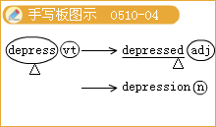
◇[例题3]
（1）Water fills the______in the ground.
A.depression B distress
C.depressions D.prosperity
[答疑编号911051005]
【答案】C
（2）When business is______there is usually an increase in unemployment.
A.vanished B.strained
C.fragment D.depressed
[答疑编号911051006]
【答案】D
4.The man next to him Was looking at his watch nervously，a woman Was coughing badly and a baby Was screaming.
他旁边的人紧张地看着表，一位妇女咳嗽得很厉害，还有一个婴儿在尖叫
cough v.咳嗽.（可加不定冠词），a bad cough咳嗽厉害
经典例句：The child was coughing all night.这孩子咳嗽了一整夜。
常用搭配：
cough down用咳嗽声阻挠 cough out咳出 cough up咳出，勉强说出
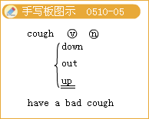
◇[例题4]
（1）Cover your mouth when you______.
A.eat B.vomit
C.cough D.couch
[答疑编号911051007]
【答案】C
（2）She suffered from______
A.slight cough B.the slight cough
C.a slight cough D.much cough
[答疑编号911051008]
【答案】C
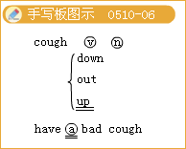
5.She then turned to the man.“so，what’S the problem?" She asked.“Well.I’ve been having a bit of a crisis.You know， lots of problems，"replied the man.“And l’ve been doing a lot of work.
她（医生）转身问道：“你哪儿不舒服?”那男人答道：“我现在有点危机，你知道，很多问题，而且我一直有很多事要做。”
crisis n.（pl.）crises危机，（疾病，生命，历史等）危难时刻
a political crisis政治危机 .
The fever has passed its crisis.
发烧已过了危险期。
The government is faced with economic crisis.
政府正面临着经济危机。
reach／come to a crisis陷入危机
in crisis在危机中
His company is still in crisis.
他的公司仍然处于危机中。
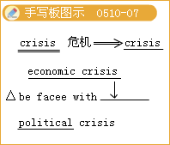

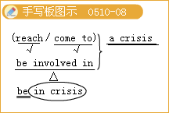
◇[例题5]
In times of______it’S good to have a friend to turn to.
A.danger B.dangerous
C.crisis D.crises
[答疑编号911051009]
【答案】C
6.A person with a sardonic sense of humour has a way of making fun of people and...
一个具有讽刺式幽默感的人有办法取笑别人……
make fun of取笑……；嘲弄……
The kids at school always make fun of Jill’S clothes.
学校里的孩子总取笑吉尔穿的衣服。
归纳拓展：
（1）与make fun of近义的短语：
play tricks Off sb.捉弄某人
play jokes on sb.取笑某人
make a fool of sb.愚弄某人
make a fool of oneself出丑，出洋相
（2）for fun／for the fun of it闹着玩地；为了好玩
have fun玩得（过得）很愉快
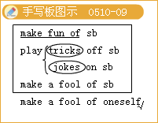

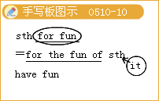
◇[例题6] 完成句子
（1）嘲笑口吃的人是很残忍的。
It’S cruel to______people who stammer.
（2）我做这些并不仅仅是为了好玩。
I didn’t do all that work just______.
（3）在这么热的天气里，到海里游泳是很有意思的事。
It is______to swim in the sea in such hot weather.
[答疑编号911051010]
【答案】（1）make fun of （2）for the fun of it （3）great fun
7.The more precise the satire，the funnier it is.
讽刺意味越浓，趣昧越足.
（1）the more…，the more…越……，越……（more表示形容词或副词的比较级）
The more you read，the more you’11 get.
你读得越多，收获就越大。
The more difficult the problem is，the more interested he becomes.
问题越难，他越感兴趣。
注意：more后面的名词经常省略。
The more，the better.
越多越好。
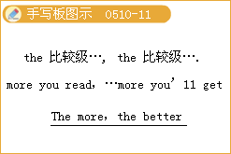
（2）precise adj.精确的，准确的
precise details准确的细节
a precise record of events对事件的准确记载
It was found at the precise spot where she had left it.
那东西正好在她遗落的地方找到了。
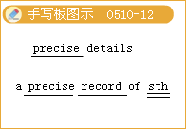
◇[例题7]
（1）The______he eats，the______he gets.
A.more；fat B.much；fatter
C.more；fatter D.much；fat
[答疑编号911051011]
【答案】C
（2）The answer is 9.532，a______calculation.
A.correct B.right
C.precious D.precise
[答疑编号911051012]
【答案】D
◇[例题8]
（1）All the signs______an early resumption of the battle.
A.point at B.point
C.point out D.point to
[答疑编号911051013]
【答案】D
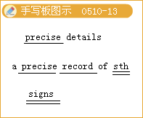
8.Satire points out faults in people，society or groups such as corporations，and makes people laugh at those faults.
讽刺揭露公众、社会、团体例如公司的不良现象，从而使观众嘲笑那些不良现象
point out（为引起注意而）指出，指明
point out a mistake指出错误
I must point out that further delay would be unwise.
我必须指明，再延误就不明智了。
相关词：point我指；仡尖端，头；点，小数最；论点，观点，
pointed尖盼；.直截了当；pointer n指示，线索，忠告；pointless无意义的，不得要领的
常用词组：
come to the point说到要点，扼要地说
catch the point抓住要点
a case in point恰当的例子
a point of view观点，看法，角度
at all points在各方面
in point of fact实际上，事实土
to the point中肯，扼要，切题
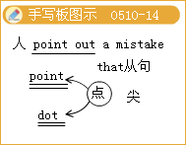

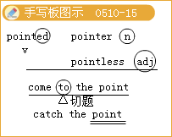

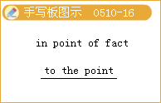
（2）My teacher______the mistakes in my composition every time.
A.point to B.point out
C.point at D.point
[答疑编号911051014]
【答案】B
9.For others，black humour is a way of facing up to and talking about，difficult subjects and it can be a very moving experience.
对于其他人来说，黑色幽默是一种大胆面对的方式，谈论难以理解的话题，而且它又给人留下非常感人的经历o
face up to敢于面对
We Chinese people are facing up to the Great Wenchuan Earthquake.
我们中国人勇敢地面对汶川大地震。
They’11 never offer you another job；you might as well face up to it.
他们绝不会再给你另一份工作，所以你还是接受事实吧。
常用搭配：
face to face面对面地
be faced with by面对…
make a face（faces）做鬼脸，装怪相
in the face of不顾，即使；在……前面
face the fact that…面对……的这一事实
can’t face doing受不了……
south—facing向南的
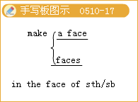

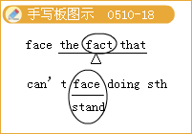

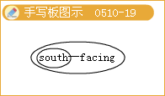
◇[例题9]
完成句子：
（1）她必须敢于面对现实：她再也不能走路了。
She had to______ the fact that she would never walk again.
（2）这家公司正面临财政危机。
The company______a financial crisis.
（3）那间窗户朝南的房子是我的。
The house with its windows______belongs to me.
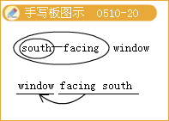
（4）她得正视她的生活已永远改变了这一事实。
She had to______her life had changed forever.
[答疑编号911051015]
【答案】（1）face up to （2）is facing （3）facing south （4）facing the fact that
10.Once there was a magician who had a parrot.
从前有位魔术师，他养着一只鹦鹉。
结构分析：who had a parrot是定语从句，修饰其前面的magician。
magician n.魔术师，变戏法的人
相关词汇：magic n.魔法，巫术；口.用魔法变出某物或使某物消失
magical 魔法的.，魔术的
归纳拓展：定语从句的复习
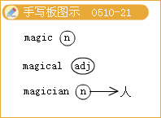
◇[例题l0]
（1）They got a ______result，and they were wild with joy.
A.magic B.magician
C.magnetic D.magical
[答疑编号911051016]
【答案】D
（2） ______is known to everybody，the moon travels around the earth once every month.
A.It B.As
C.That D.What
[答疑编号911051017]
【答案】B
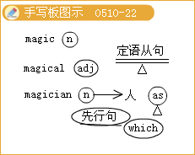
（3）I shall never forget those years______I lived in the country with the farmers，______has a great effect on my life.
A.that；which B.when；which
C.which；that D.when；that
[答疑编号911051018]
【答案】B
（4）Those successful deaf dancers think that dancing is an activity______sight matters more than hearing.
A.when B.whose
C.which D.where
[答疑编号911051019]
【答案】D
（5）Human facial eipressions differ from those of animals in the degree，______they can be controlled on purpose.
A.with which B.to which
C.of which D.for which
[答疑编号911051020]
【答案】B
（6）In the office I never seem to have time until after 5：30 p.m.______many people have got home
A.whose time B.that
C.on which D.by which
[答疑编号911051021]
【答案】D
（7）AⅡof the flowers now raised here have developed from those______in the forest.
A.once they grew B.they grew once
C.they once grew D.once grew
[答疑编号911051022]
【答案】C
11.do sb.good对某人有益
Don’t you think talking to her would do some good?
你不觉得和她谈一下会好些吗?
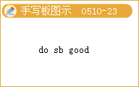
归纳拓展：
do good to sb.／do sb.good对某人有益
It is no good doing sth.做某事没有好处
do wrong to sb.／do sb.wron9冤枉某人
do harm to sb.／do sb.harm对某人有害
do more harm than good弊多利少，弊大于利
be harmful to对…有害
be good to sb.对某人友好
be good for sb.对某人有益
◇[例题ll]
完成句子：
（1）与老师的那次短暂的谈话当然对他有很大的好处。
That little talk with the teacher _____certainly.
（2）我认为你不应该去______这肯定是弊多利少。
I don’t think you should go---it’s bound to______
[答疑编号911051023]
【答案】（1）did him the world of good （2）do more harm than good

